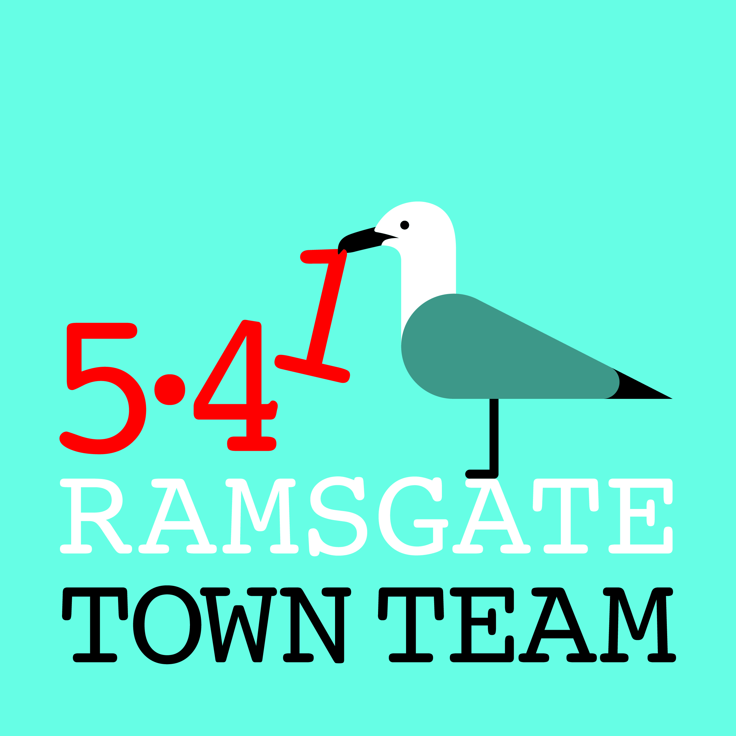
Special General Meeting, Thursday 8th February 2018 6pm

Present: Margarita Moscoso, Lesley Gray, Tony Uden, Brian Whitehead, Rob Hall, Clive Gavin, Rebekah Smith (Chair), Sue Hall, Madeline Wright, Fiona Simmons, Maria Gavin, Jo Hanchett, Pat Makinson, Tricia Austin Hartley (minutes)
Apologies: Richard Styles, Raushan Ara

- Introductions: Rebekah started the meeting by inviting all present to introduce themselves. She pointed out that she, Sue, Jo, Maria, Fiona, Pat, Madeline and Tricia, along with Richard who had sent apologies, are the current TT Trustees.

- Update on application for Charitable Status: Rebekah explained that the Town Team had called a Special General Meeting to consult with members over further proposed changes to our Constitution as part of our application for charitable status. Our original proposal, submitted in January, was returned with some queries. We have taken advice from Funding for All, a KCC-supported voluntary sector support body where the team includes a governance specialist, James Walker, who helps with applications for charitable status. She handed over to Tricia to go through the changes James has proposed to our Constitution.

- Town Team Constitution: Tricia pointed out that this version of the TT Constitution looks very different from our previous version as it is based on a different template and uses more legal language, but in fact it contains the same basic information. James Walker advises that this is the Charity Commission’s approved template, and applications in this format should meet all criteria and are likely to be approved.

Tricia pointed out that James had also made some suggested changes in the provisions of the new Constitution to make it acceptable to the Charity Commission. These are:
- Removing the provision of shopfront grants as one of the TT’s activities, as the CC sees these as conferring commercial benefits on some businesses over others (even though any business can apply), and this is not compatible with charitable status. Rebekah pointed out that the £10k originally granted to the TT for shopfront grants had already been spent, so we have the option to stop offering these. James Walker had also pointed out that if the TT wishes to undertake this work outside its charitable activities, this would be acceptable as long as this had no effect on the organisation’s charitable work.
Action: It was agreed the Trustees would discuss the options if charitable status was granted, and come back to members with recommendations.
- Changing the TT’s aim of expanding opportunities for people in Ramsgate specifically to offering education and leisure opportunities, as ‘expanding opportunities’ does not count as a charitable aim.
- Establishing the ‘members’ of the charity as its existing Trustees rather than the whole of the Town Team’s membership. James explained that this is required for the Foundation Charitable Incorporated Organisation status that the TT is applying for, but does not stop the TT from consulting its wider membership over all major decisions and any changes to its programme of work. Rebekah confirmed that the TT intended to continue to do this.
- Appointing each Trustee for a specified period of time (between one and three years). This is a formality in practice, as any resigning Trustee is eligible to be reappointed straight away if s/he is willing to stand again, so this is simply a device to ensure that there is never a time when all the Trustees resign at once. Tricia pointed out that James had allocated periods of office in order as the Trustees’ names had appeared on the original list he received, and that if anyone was unhappy about their period of office as specified she could ask him to change this.
Action: Any Trustee wishing to change their period of office to contact Tricia.

All members present stated that they understood these changes and were happy to approve them.

Margarita pointed out that the Constitution as it stands is not inclusive, as its length and language make it inaccessible to many people. Tricia suggested producing a plain-English version; Margarita suggested an audio recording of this should also be produced and publicised as available.
Action: All approved these courses of action: Committee to action.

- AGM: Rebekah pointed out that the Town Team’s AGM is due to take place on Thursday 8th March at 6pm in the Custom House (venue TBC in the light of this evening’s problems with access to the building!) All are welcome, and items for the agenda can be sent in advance to any member of the Committee.

The meeting closed at 7pm.

