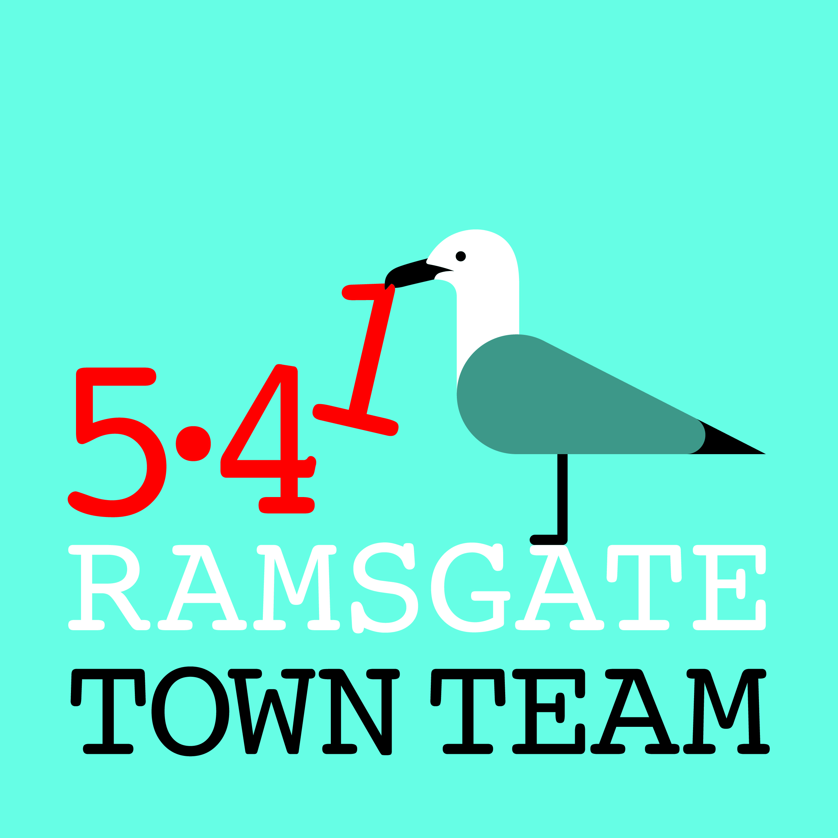 Ramsgate Town Team COMMITTEE MEETING 8.3.18

Present: Rebekah (Chair), Maria, Jo, Pat, Richard, Tricia (Minutes)
Apologies: Sue, Madeline

1. Review of AGM: Went well; all agenda items covered and ordinary members supportive; good to have new people attending. Great that new people are interested in joining committee, but still concerns re diversity (particularly re age and gender). Rebekah suggested we might consider trying to fund some sort of Youth Town Team in future.
Action: Tricia to send application forms to Lucia & Raushan. All to consider ways we might improve our diversity as a Committee.

2. Election of Officers: Jo asked if we are obliged to keep all the same positions as this is what we have advised the Charity Commission. Tricia said she thinks we are free to change this if we wish and advise the CC accordingly if we are approved, as we would about any other change after submission. Existing officers were happy to remain in post, however: this was unanimously approved

3. Shopfront grants: Pat's application for Gallery 98: applied for £480. All agreed Gallery is looking very good. Grant approved: proposed by Richard, seconded by Tricia; everyone in favour.

Harbour Fish Bar was discussed and all agreed we need to move this forward asap.

4. Empty shops: Pat mentioned again her concerns that there are artists looking for studios in the town, but they would need to be able to share premises as most are large and expensive.

Richard suggested that if the Government allocated money to coastal communities with flexibility to spend as they wish, this would be a top priority for Ramsgate. He added that he is very concerned about the state of some properties in the town, particularly in Harbour St, which are really vulnerable to fire, bad weather etc.

5. Next meeting: The next Committee meeting is on 12th April at the Custom House.

Action: Tricia to contact Dean to confirm arrangements.

