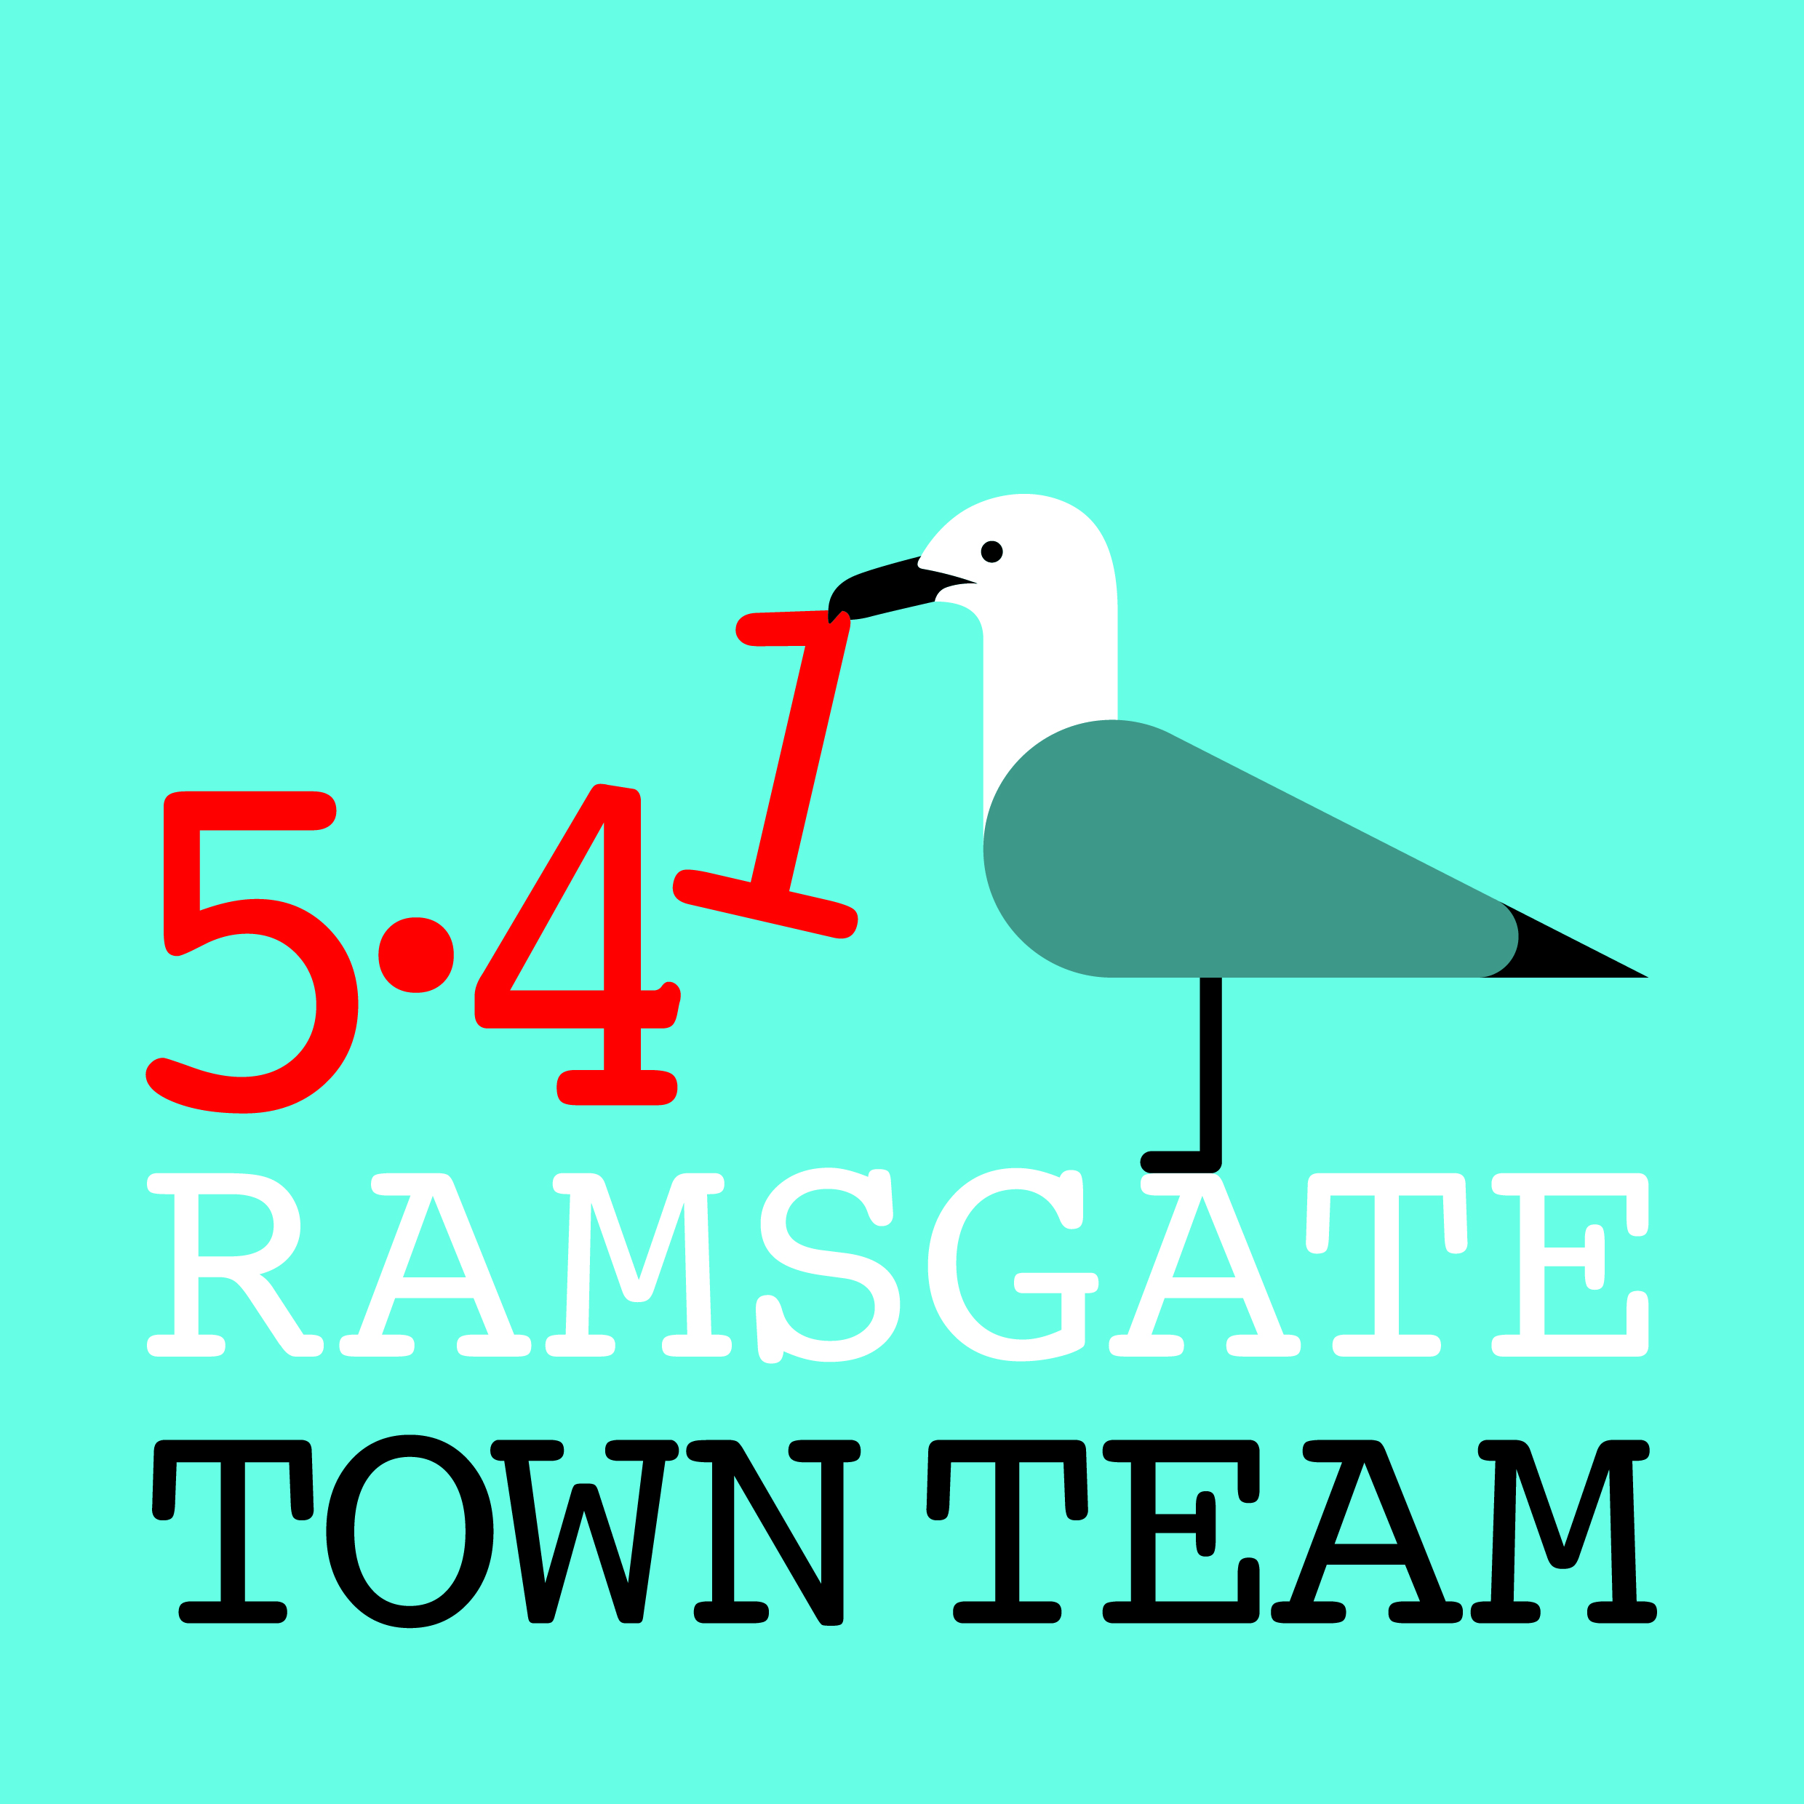
Executive Committee Meeting, Thursday 8th February 2018
Present: Rebekah (Chair), Sue, Madeline, Fiona, Maria, Jo, Pat, Tricia (minutes)
Apologies: Richard
- Minutes of the last meeting: Accepted as a correct record

- Matters arising:
2.1 CIO status: Revised Constitution now approved by Special General Meeting. If we put forms in to James Walker from Funding for All tomorrow, he will turn round within a week & submit to Charity Commission.
Action: Tricia to send information to James Friday am
NB: As noted in the General Meeting, as a CIO, we will not be able to give shopfront grants or run events as these are not charitable activities. We could, however, do these outside our charitable activities if we can fund them. (We have 2 bank accounts and so could separate out activities & funding.) Could potentially run events via RTC. Re shopfront grants, we have spent our £10k allocation, so need to discuss whether we plan to carry on offering these, and if so how.
Action: All to consider what we should do; Rebekah to put this on next meeting agenda but no final decision needed until CIO status approved.
2.2 Shopfront grant applications:
- Surin grant now approved; tenant has also offered to paint fence
- Rebekah is in correspondence with Michael’s Bookshop re finishing work on their building. Once this is done, grant will be approved.
- Pat has submitted application for 98 Harbour St to RTC as per form.
Action: Tricia to contact Richard asking him to pass application to Rebekah.
- Still on list to complete before Easter: Bodrun, Ozzy’s in Harbour St
Action: Tricia to send application forms & guidance to Madeline to print off & pass on to Bodrun; Rebekah/Maria to secure written quote & timeline for Ozzy’s, including painting, signwriting, panelling
2.3 Ramsgate ROAD/ waste management: Rebekah, Tricia & Pat meeting Neil Jones from TDC tomorrow: he has committed in writing to replacing at least 1 bin on Harbour St. Plan to discuss bins, commercial waste (including Albion House bins) etc. Action: All to investigate how bins used in other towns. Bins are missing in various places: all to report back on places where bins removed. Action: Information to be used in discussions with NJ; Rebekah, Tricia & Pat to report back to Committee.
2.4 Ramsgate Station: Planting works now complete, although minor repairs and improvements needed. Financial contribution from SouthEastern now received. Final invoice for plants and compost from Youngs awaited. Action: Tricia to chase Youngs for invoice and complete financial return to Eileen at RTC for monies received from Ramsgate Fund.
2.5 Ramsgate Recyclists: Response received from Madeline Homer on her failure to support our funding bid. It is cordial and proposes that in future all such requests go via the Funding Office, but no details of who this is or how to contact them included, and no responses to most of our questions. Action: Tricia to circulate MH’s response and her proposed reply. All to keep eyes open for potential future funding for this project.
2.6 Christmas Switch On Event follow-up: £1700 now received from RTC. Christmas trees still up in Harbour St: Rebekah has asked for them to be removed. Costings to be obtained for hanging baskets on these brackets in Spring/ Summer. Action: Tricia to email Youngs re costs of hanging baskets.
2.7 Car Parking: Rebekah has not yet sent email to TDC on behalf of TT querying new car parking arrangements but will do so. Action: Rebekah to email TDC

- AGM: 8th March 6 pm Custom House: agenda to include Annual Report, plans for next year, election of Committee, progress of CIO application.
Action: Rebekah/Tricia to do Annual Report and send round draft to Committee members; Tricia/ Maria to send invite to members; all to post as Event on FB; all to consider if any other agenda items needed and send to Rebekah/ Tricia if so.

- Easter events: NB This is another type of activity that we will not be able to run as a charity unless we can show educational benefit (but could run separately as with shopfront grants – to discuss if & when charitable status approved.)
- Face painter & balloon man booked
- People working hard at AiR workshops; rabbit going into window at weekend
- Sue seeing Lindy Sunday to see if she can do bonnet making
- Alice in Wonderland themed parade on 1st April from Sailors’ Church
- Mad Hatters’ tea party tent being run by Ramsgate Arts
Easter egg trail discussed: poor participation last year & difficult to engage young people so maybe an alternative this year? Action: To be decided by sub-committee
- AOB: Possibility of collaborative craft workshop in empty shop discussed. Rebekah has friend hiring out space in new pottery studio – will send information round.

