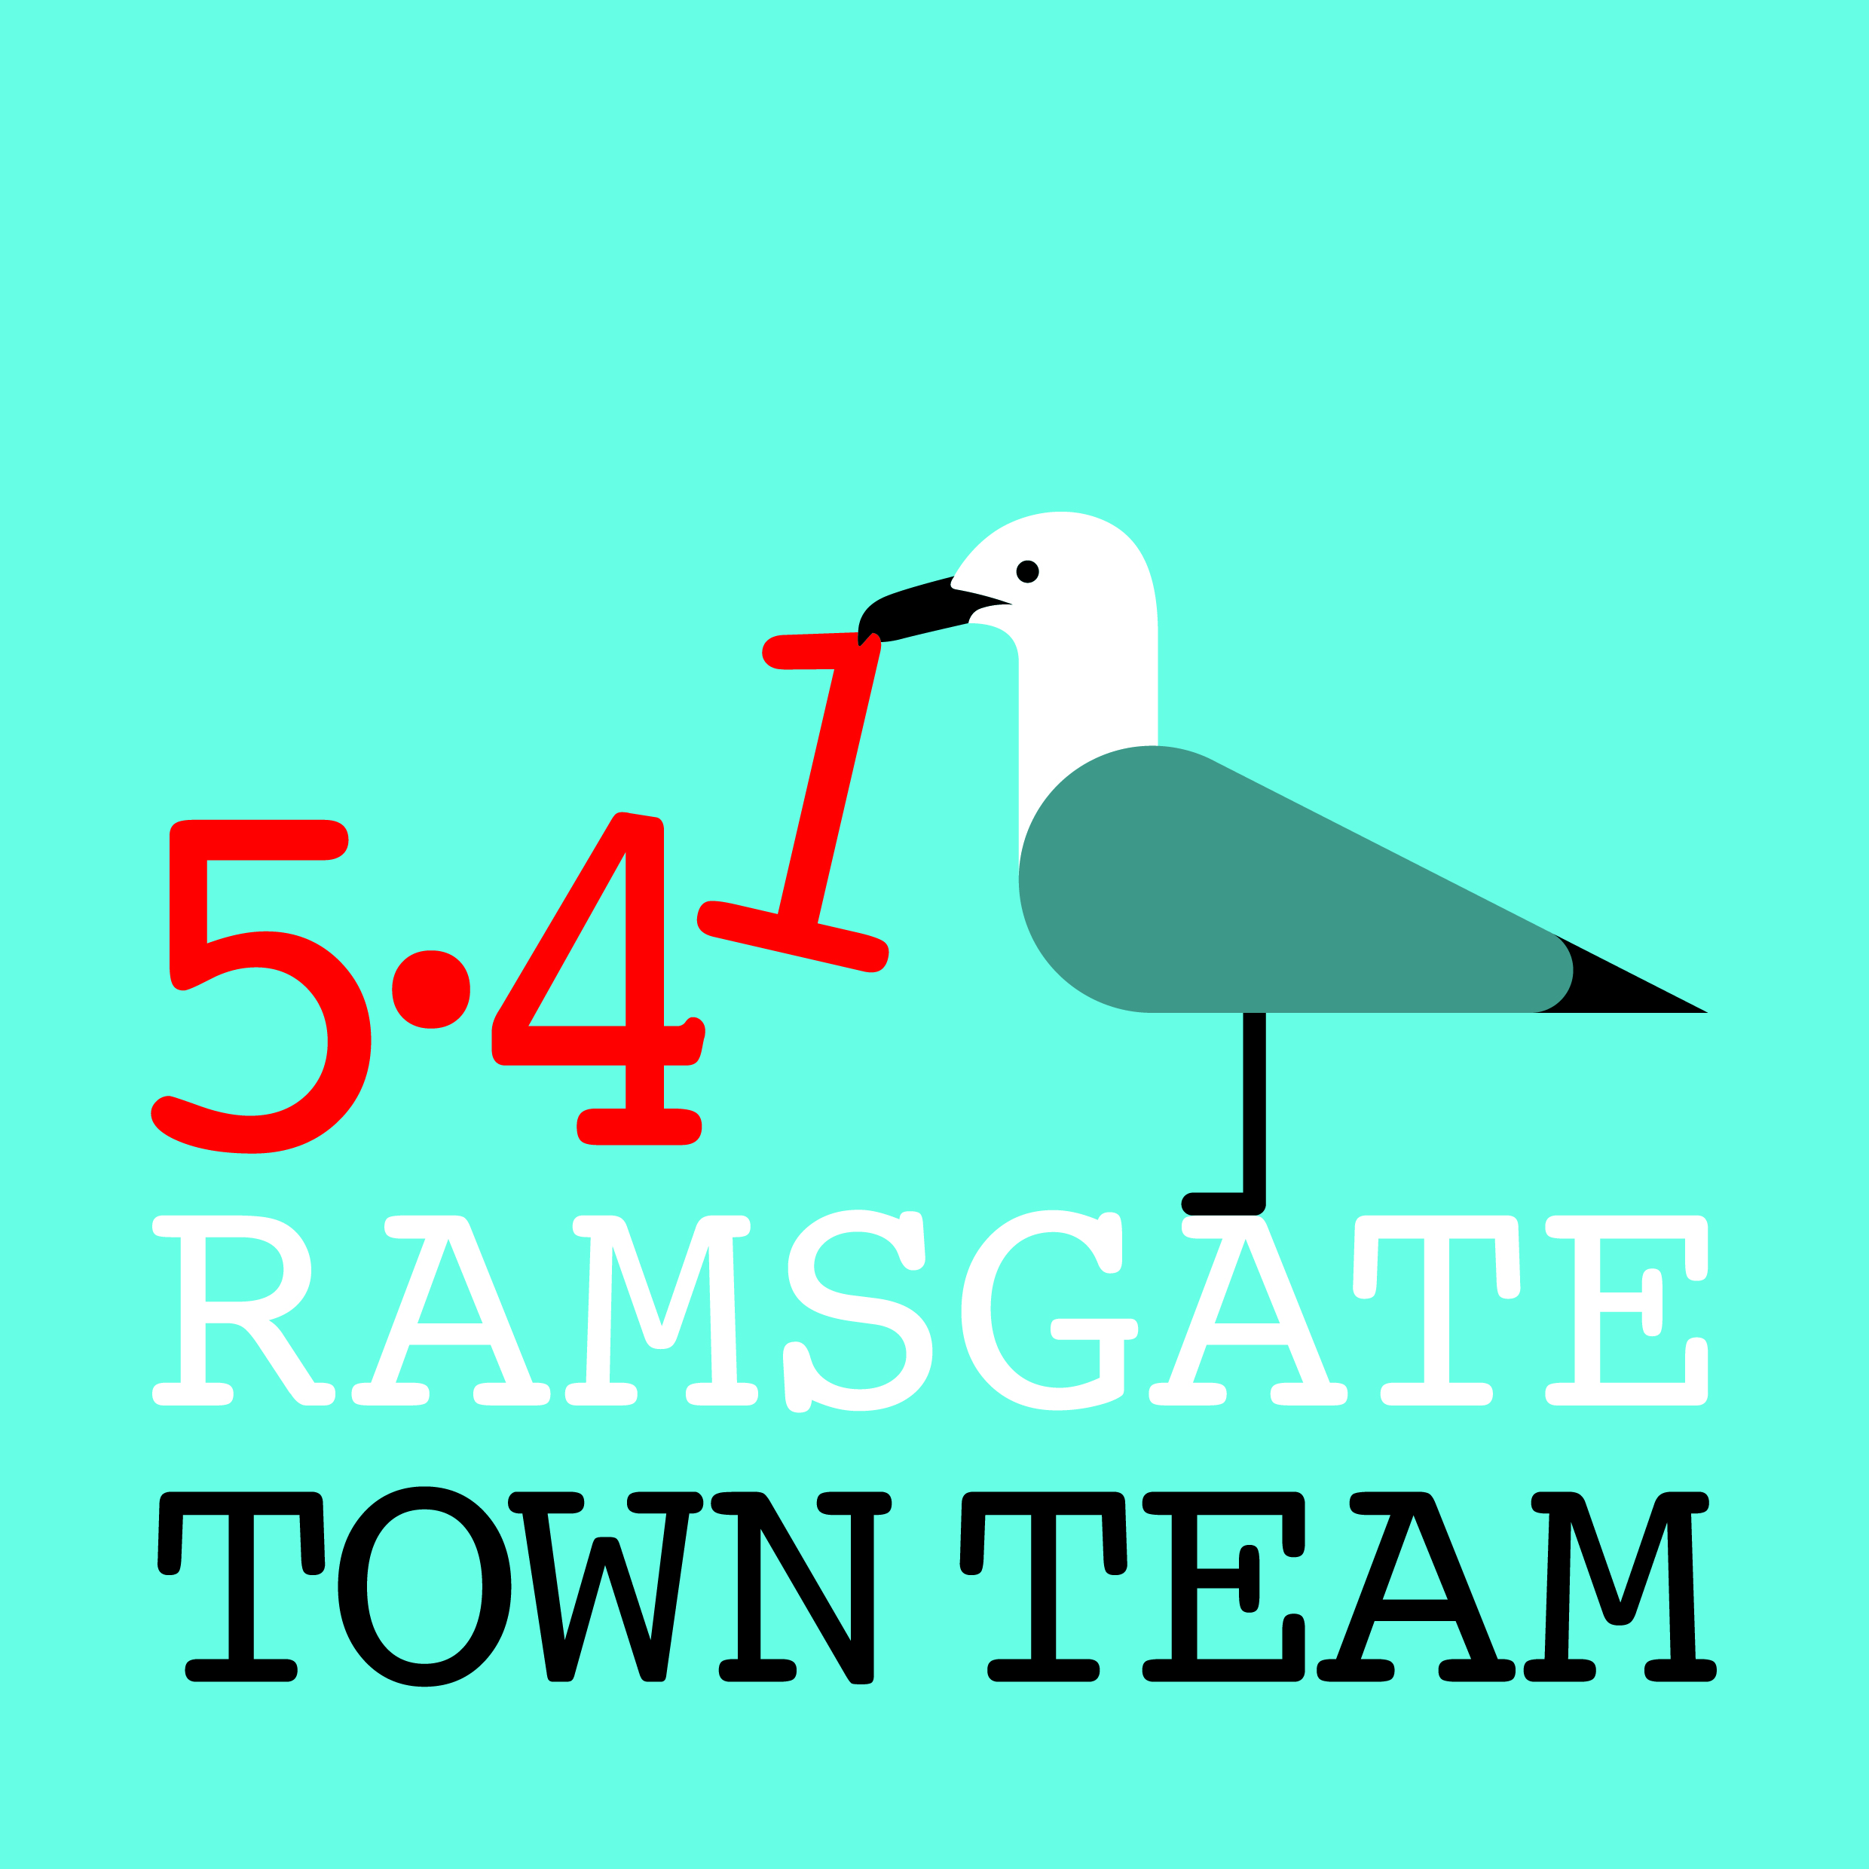 Committee Meeting, Thursday 26th July 2018
MINUTES
- Present: Rebekah (Chair), Sue, Pat, Jo, Tricia (Minutes)
In attendance: Terry & Kate for Christmas item
Apologies: Maria, Richard, Madeline

- Minutes of the last meeting held on 14th June 2018:
Accepted as correct record

- Matters arising:
- DBS checks: Emma at Volunteer Bureau processes these on Tuesday mornings & has free slots next Tuesday and thereafter.
Action: Tricia to email all re available slots & arrange bookings with Emma.
- Road maintenance (drains/ Virgin Media): Tricia forwarded photos of drains and pavements after Virgin Media work to Richard who has sent them to Paul Valek, Highways Manager at KCC, with request for urgent action.
Action: Richard to report back at next meeting on any progress
- Spice time credits: Tricia has investigated: looks as if we would need to pay the organisation to set up a scheme for us, so might be better to consider something already in existence – eg LETs Scheme credits or Shopper Points.
Action: To add to agenda for discussion at next meeting.

4) Feedback from events & activities since last meeting:
- Carnival, 22nd July: This was highly successful; Addington St float engaged 150 people throughout, picked up 21 bags of litter en route & spoke to many families
- Bollard painting, 15th July: Good job done by all; shame about the cigarette litter! Several passers-by gave their details & expressed interest in helping next time.
- Presentation to Ramsgate Rotary Club, 10th July: Tricia did this: worked well. Group interested in jointly funding large Victorian planters; also made some useful contacts. Invited to do similar presentation to Inner Wheel in October
- New uses for town centre premises: We continue to explore possibilities for empty town centre premises – eg Age & Sons or Jazz Rooms as possible art studios. Will obviously need substantial funding to support this if it proceeds. Initial Expression of Interest submitted for DCMS funding but needs 20% match & minimum grant is £3m so unlikely to be able to go ahead with this. Other options being investigated.

5) Regular Updates:
- Station: Some plants (mainly out in taxi area) have been stolen or died in the heat so need to replace in Autumn. Jackie Young has advised on suitable planting. There has been some vandalism to leaflet dispenser: Chris Barton from RTC is looking at this & hopes to be able to repair it.
- Litter & waste management: Rebekah has sent in complaint to TDC re public toilets and litter following many complaints from guests. Some addressees have responded individually but most responses unhelpful. Rosanna Taylor-Smith (Cabinet Member for Op Services) pointed out that providing toilets is not statutory requirement, tho difficult to see how tourism will thrive without them! EE commercial waste in High St: Pat has had response from manager of Maidstone office asking for details of the problem is. She explained bags go out on Saturday afternoon for Biffa and they’re not collected until Monday morning. She added photos of leaflets that had been blown all over town. Commercial waste discussed: Could TDC’s new trade waste service do this better? Jo uses MPL & recommends them as very reliable and reasonably priced. Action: Pat to keep the group informed. No Ifs, No Butts campaign: New campaign proposed to focus on cigarette litter following our experiences in Queen St when bollard painting: public awareness campaign (particularly re putting butts down drains, using The Sea Starts Here stencil idea) linked with badging scheme for licensed premises, takeaways, betting shops and the like who agree to keep their frontages clean. Ramsgate Fund bid to be submitted to offer all premises that commit to cleaning their frontages a freestanding ashtray bin and brush/ closed dustpan to assist with cleaning. Window stickers for participating businesses to be bought with TT funds. Thorley Taverns and/or other sponsors to be approached to support public awareness campaign, possibly via bus shelter advertising. Action: Rebekah & Tricia to submit RF bid, contact Thorley Taverns & report back.
- Harbour Street: Hanging baskets now installed: they are rather high up, but Hellings (who produced extension pieces for the Christmas tree holders free of charge) advise that it could be unsafe to lower them and feedback is good. Some spare baskets (5 or 6) as not all holders can be used, so need to decide where we want these. We have contract with Youngs to look after baskets: should be cheaper than we budgeted for as there are fewer baskets and season has already started. Action: All to consider where spare hanging baskets might be used and feed back to Rebekah/ Tricia Bollard: Richard is chasing this but reports it is still not agreed. Paul Messenger has offered approx £3k from his KCC Councillor’s grant towards the cost.
- Partnerships: FORS are now working on the East Cliff fountain with East Kent College. Albion Gardens are looking much better following the work of Margarita Moscoso’s new group. Mark Dewey will look after fountain and waterfall for RTC.
- Wayfinding: Richard reports that KCC have approved all highway sites and SE Trains have approved their monolith, so we are only waiting for TDC. Richard will give TDC 2 weeks and then set the contract in place. They will have a further 8 weeks before they cut down the old sites and replace with new. Rebekah pointed out we still have £17.5k to pay from the TT’s account towards the new signage.
- Charitable Status: Tricia has rung Charity Commission again, who apologised but said they are still processing applications from Jan/ Feb. They advised that if we are submitting applications for which charitable status is required we should contact them further to see if our application can be fast-tracked.
6) Plans for future events:
- Community Summer Parade, 29th July: We need as many people as possible there as there has been low participation in workshops and weather may not be good. Items for parade can be picked up from AiR.
- Six-monthly open TT meeting: Agreed this would be Thursday 11th October.
- Christmas Arrangements: Rebekah reported that the budget has been slashed but enough money for important items ie Santa, land train, rides and switch-on. Discussion with Terry (Father Christmas) and Kate: Terry felt grotto in Harbour St worked well: grotto was lovely & previous year was wet & cold! However, it was very busy and some children did not get a turn: can we improve things this year? Possible changes discussed: someone on door taking money & someone just outside grotto taking names? Terry & Kate may be able to provide extra ‘elves’. Chaperone in grotto important; everyone needs occasional refreshments! Action: Jo volunteered to be Mother Christmas in grotto; Rebekah to liaise with Terry, Kate, Jo and Madeline to ensure there are plenty of people to help. Timings: Perhaps 1.30-5.30 pm with break for light switch-on at 4ish? Should we ask children to book 5-minute slots (eg on Eventbrite)? Action: Rebekah to liaise with Madeline and decide how best to manage this. Terry mentioned that he raises funds for school in Ghana and asked if we can have a donation box to support this. All approved this idea. Action: Kate to check if Terry’s DBS check is still current and let Rebekah know. If not, TT to pay for re-registration Christmas lights: Christmas Switch-On will be Sunday 25th November this year. Richard reports that:
  - There will be new lights for Harbour Parade to link harbour display to centre.
  - Harbour Street will get additional motifs for some Christmas tree holders; the rest will get trees and better LED lights.
  - The town tree will get a full & expensive dressing this year; Newington & St Lawrence will also get trees.
  - All the festoon lighting will be upgraded. The colour theme this year will be blue and warm white (looks gold in colour).
  - TDC are not going to test all the yacht lights.
  - RTC has approved Aurora Borealis display for second week in December but awaiting demonstration and Fireworks Policy information from TDC before final decision. Parade to take place in same week if possible.

7) Any Other Business:
- Phone boxes: The 2 phone boxes in front of Wetherspoons belong to TDC. Rebekah has contacted them to ask if they can be transferred to RTC for community use. BT website shows huge range of community uses from defibrillators and bank machines to art galleries and libraries!
Action: Rebekah to chase TDC and report back.
- Arts symposium: Rebekah attended this and made some useful contacts.
- Fish Festival: Terry Askew did this on the harbour crosswall a few years ago. Jo has been asked if TT can put some money into reviving this idea. Perhaps the TT could apply for events funding from RTC on Terry’s behalf? Might Wetherspoons sponsor it? They donated £2.5k to the Ramsgate Festival & did not want recognition.
Action: Tricia to check with Eileen Richford what money there is in RTC Events pot and what period it relates to. Item to be added to next TT meeting agenda.
- Shopfront grants: Michael’s Bookshop has now sent pictures through: all approved payment. No progress on Ozzy’s. Although our shopfront grants pot is spent, we can carry on funding these if needed via our unused pop-up heading.
Action: Rebekah to chase Ozzy’s
- Next meeting: Thursday 13th September, followed by open meeting for full membership on Thursday 11th October.

