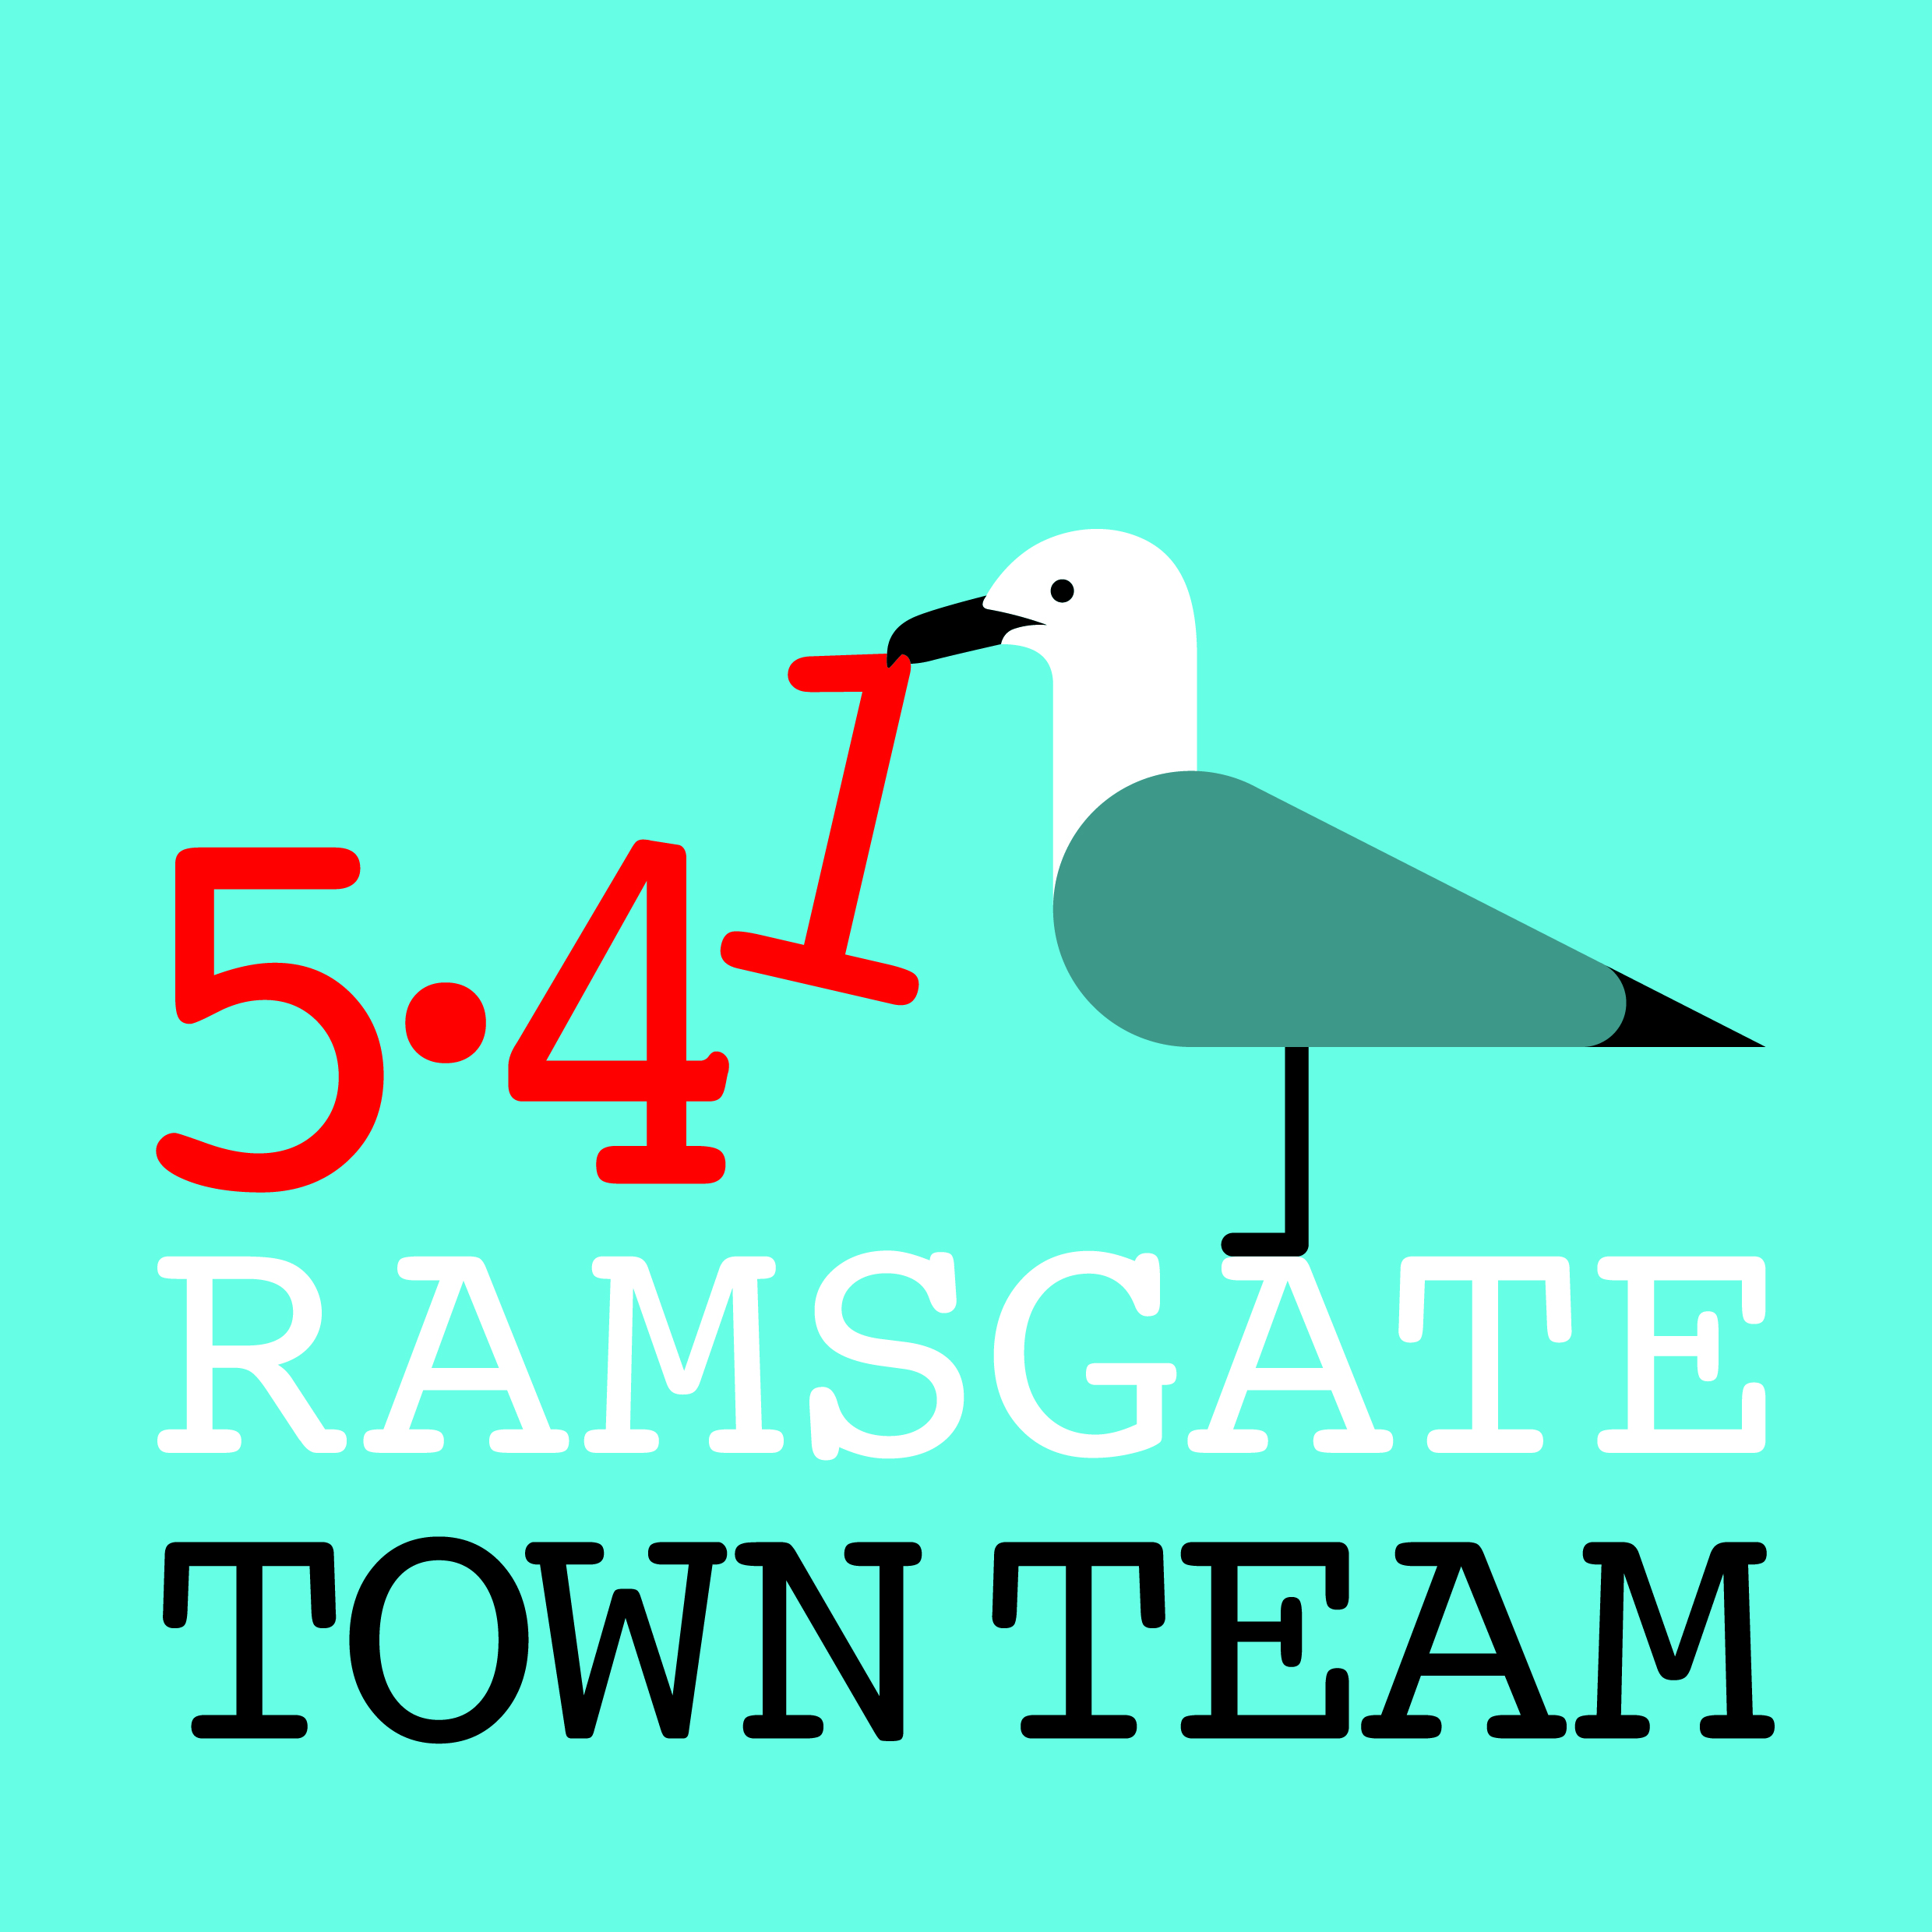 Committee Meeting, Thursday 25th July 2019
MINUTES
- Present: Rebekah (Chair), Jo, Madeline, Chris, Pat, Becky, Tricia (Minutes)
Apologies: None

- Minutes of the last meeting held on Thursday 13th June 2019: Approved

- Matters arising not on the agenda: Rainbow Steps: TT Volunteers weeded & tidied up but washing by hand didn’t work: needs pressure washer.

- Quick work programme updates:
- Wayfinding: Chris has tightened up sign at car park. Extra post on Kent Steps approved.
Action: Rebekah to chase Richard about Kent Steps.
- Station: Tony Ovenden (TDC Cllr and staff member at station) has now taken over planting & maintenance of station planters.
- Litter Forum: Good meeting last week attended by Craig Mackinlay and Jo who spoke about letting agents’ responsibilities re waste management. Still big problems with street litter, commercial bins, recycling: complete review needed. Discussion took place on possibility of running community can recycling scheme.
Action: Jo & Tricia to investigate options for aluminium recycling.
- Events: Rebekah applying for events permission for Xmas Light Switch-On event & discussing parade with Madeline. Addington St group would like to run a Xmas Fair on Spencer Square.
- Pugin Steps: Possible tiler identified. Royal Harbour have worked really well: teacher produced resources & made her own tile; all completed evaluations. Chatham & Clarendon not yet submitted designs: have until 2nd August, after which designs will be judged.
- Summer decorations: Chris has now installed hanging baskets in Harbour St. Hooks are too high: Richard approved use of chains to extend if needed. Chris meeting with Youngs to discuss watering. Jim Brady from Harbour Bazaar has paid for Harbour St bunting.
- Summer clean-ups/ painting: Possible clean-ups/ painting in Sept? Ramsgate Society coastal clean-up Sunday 14th October. Action: Dates in September to be canvassed by email

- Funding & finance:
- Future High Streets Fund: Unsuccessful. Bid submitted to Heritage High Streets for £1m. Timescale for response uncertain.
Action: Rebekah & Tricia to check at CCT meeting & circulate info.
- Other funding bids: Ramsgate Fund bid submitted today for more Victorian-style planters. Action: Tricia to circulate.
Awards for All: Becky suggested meeting with Pat & Tricia to draft.
Action: Meeting 9 am on Tuesday 13th August.
- Other financial matters: Pat tidying up & checking information on accounts, starting from Maria’s figures.

- Car parks: Leopold St car park in very bad state & generating lots of complaints; Mill Lane at Margate in much better condition. Trevor Kennett has stated that 30,000 PCNs @£35 each have been issued = £1050,000, which cannot be spent on anything else. Gavin Waite also stated at recent HAZ meeting that TDC has lots of parking revenue.
Action: Rebekah to write suggesting using some of the funds to improve Leopold St & other Ramsgate car parks.

- Any Other Business:
  - Granville Theatre: Heritage Lab (Rob Kenyon) have put in EoI to become Asset of Community Value. Sylvie Bolioli (Film Festival) has suggested cross-organisation group (possible CIC) which TT may be invited to be part of.
  - Shelters: Need for help cleaning shelters in wk beg 5th August.
Action: Becky to write to Richard requesting help from 1 member of Lengthsmen team to help clean shelters & also do Rainbow Steps.
Action: Tricia to contact Jasmin to arrange training for 2 Lengthsmen to use new cigarette butt vacuums & then cascade to volunteers.

7.3 Relationship with TDC: Tricia recently emailed Adam Littlefield urging him to get TDC to work properly in partnership with community groups & use their skills.
Action: Tricia to circulate email with minutes

- Date of next meeting: September meeting to be held on 19th September to avoid Madeline’s birthday. October meeting is due to be public meeting: dates to be canvassed by email.

