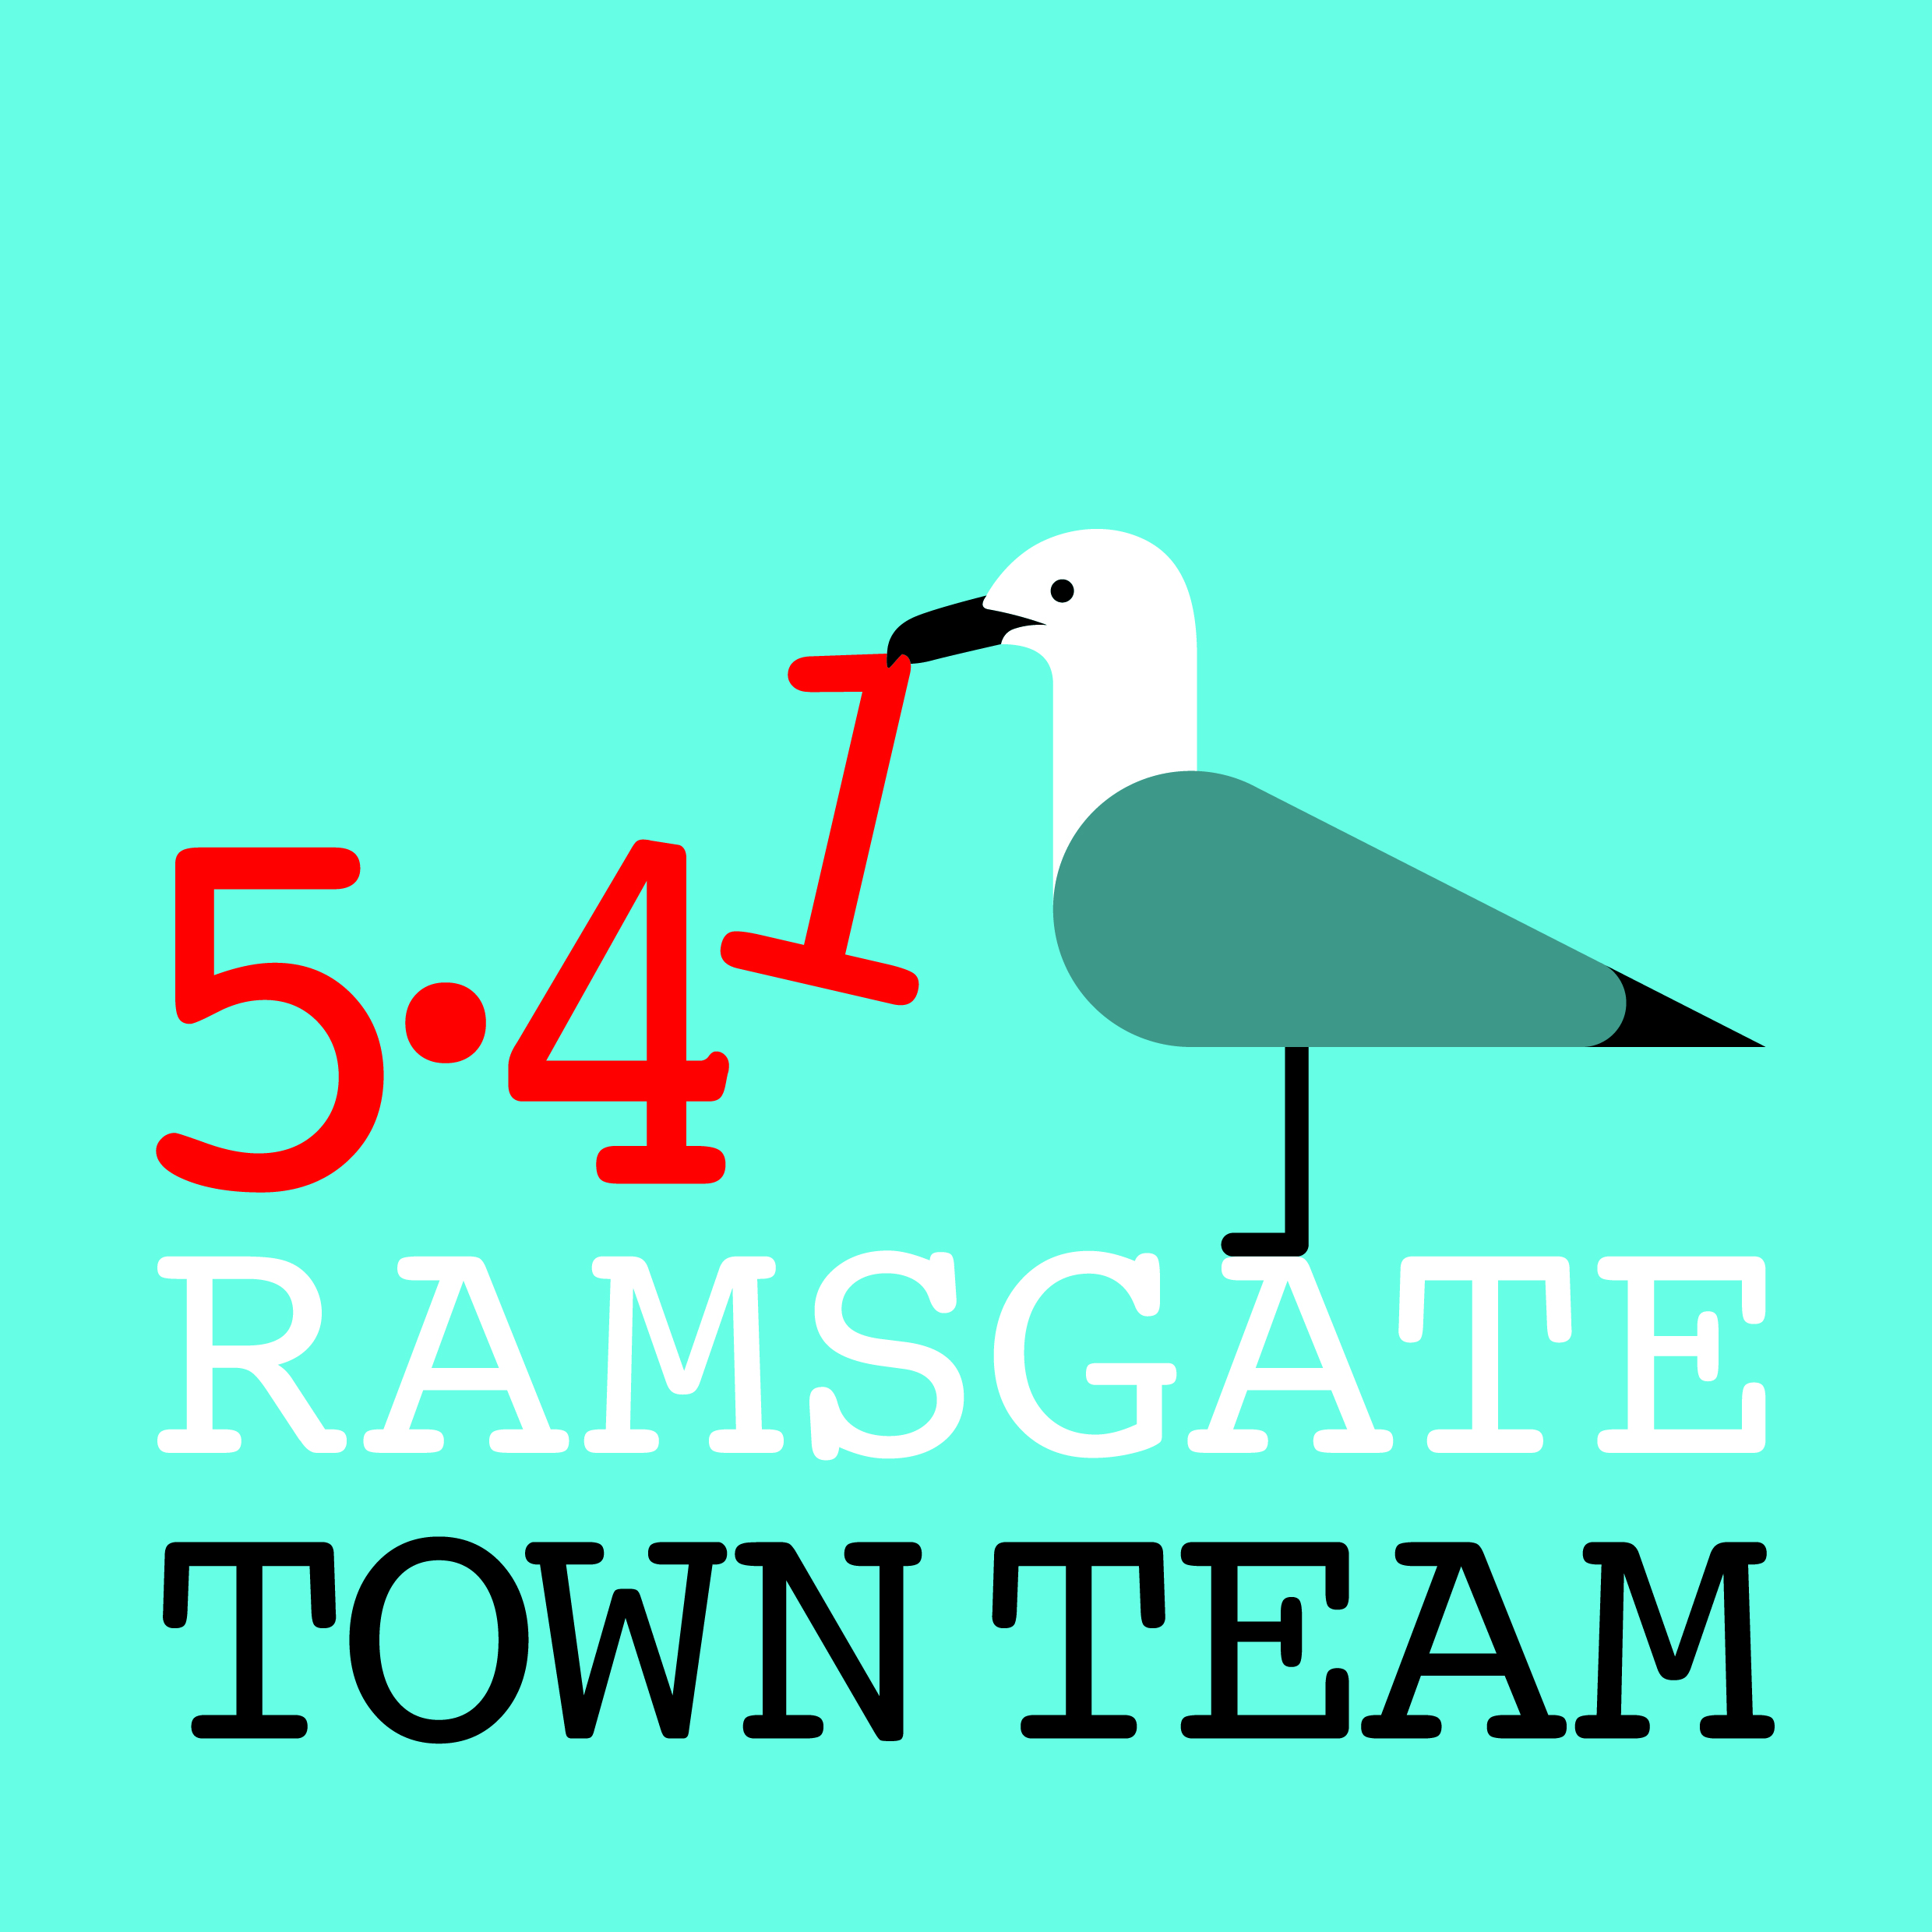 Committee Meeting, Thursday 19th September 2019
MINUTES
- Present: Rebekah Smith (Chair), Madeline Wright, Chris Barton, Sue Hall, Tricia Austin (Minutes), Becky Wing
In attendance: Maxine Morgan
Apologies for absence: Jo Hanchett

- Minutes of the last meeting held on Thursday 25th July 2019: Accepted as correct record

- Matters arising not on the agenda: 3.1 Summer decorations: Hanging baskets have been maintained, though Chris never managed to speak with Youngs about adjusting their height. All agreed that trailing plants would look better next year. Action: Chris to discuss with Youngs

- Committee Membership: Discussed. Maxine attending this evening with a view to joining Committee.

- Finance and Funding: Books now up to date & accountant paid. Balance around £18k but approx. £8k is restricted funds for planters & Pugin Steps. Action: Tricia & Becky to look at funding bids when time permits; Maxine to look at Tesco bags fund.

- Town Centre: 6.1 Future High Streets Fund: Coastal Communities Team submitted £25m Expression of Interest in Feb for major works with TDC & told we were unsuccessful. Fund now extended so Ramsgate now included; we have £150k to work up a bid (paying lawyers, surveyors etc). Will not know result until next Summer earliest. 6.2 Historic High Streets (HAZ) Fund: Submitted this small bid in interim for minor improvements to shopfronts etc in Conservation Area. TDC refused to put in matched funding, even in kind, reducing possible bid to under £1m. We know we were successful but not yet how much we will get. Harbour Fish Bar is on list for improvement: owner now lives in Canterbury: Rebekah has left info with Fish Bar operators & Tricia has messaged owner. Maxine suggested contacting Thorley Taverns re revamping the Royal. Action: Tricia/ Rebekah to try to contact Fish Bar owner again & contact Phil Thorley. 6.3 Horizon Fund: New Lottery fund for historic sites. Bid being submitted for harbour area. Very competitive so may not succeed but can resubmit. 6.4 Karen Constantine’s town centre group: Group including traders & Police meeting to discuss town centre problems. Police trying to address antisocial behaviour. Extra police officer & 4 more PCSOs being employed. Concerns re street drinkers & young people. Maxine has tackled street drinkers re their language.

Discussion ensued on Charlotte & Albert Courts and Harbour St pedestrianisation.

- Quick work programme updates:
  - Christmas Switch-On: Taking place Sunday 24th November. Lantern Parade a week later with Snow Queen theme. Funding from RTC reduced but can manage. Santa available; elves popular & would like to involve them again again.
Possibility of using Cosi van as grotto discussed, maybe in Charlotte Court if can get it in, or tent if not)? Lighting options for C/ Court discussed – possibly solar? Possibility of something after switch-on for adults discussed – Screaming Alley?
Action: Becky to discuss with Richard
  - Other Christmas activities: Rotary Club have approached Rebekah for help with sleigh going round streets for 3 or 4 evenings. Makes several thousand pounds which they are willing to share: could help get things going in Charlotte Court?
Action: 2 people have towbars and are keen to work with them. Rebekah to pursue this.
  - Pugin Steps: Project reaching final stage now. 90+ designs received: will use those not selected for tiles for other things later & run exhibition of work done.
7.3 Planting/ maintenance: Orbit have offered help with planting/ weeding/ painting on one of their staff volunteer days. Kent Steps, Abbotts Hill and/or flower beds in York St. all possibilities. Waiting to hear back from Gary Storer at Orbit re dates.
Action: Tricia to chase Orbit

- Dates for October public meeting/ November & December meetings:
To be discussed & agreed online. November date possibly to be open meeting.

- Any Other Business: 9.1: Heritage Lab bid: Rebekah & Tricia have received request for letter of support for Architectural Heritage Fund infrastructure bid: Rob Kenyon has sent draft letter. Agreed we need to know: 1) what would be covered? 2) who is/ would be involved? 3) would this pay salaries? 4) have they talked to Ramsgate Society & other heritage groups? Action: Tricia to message Rob and write supporting letter if questions answered satisfactorily

