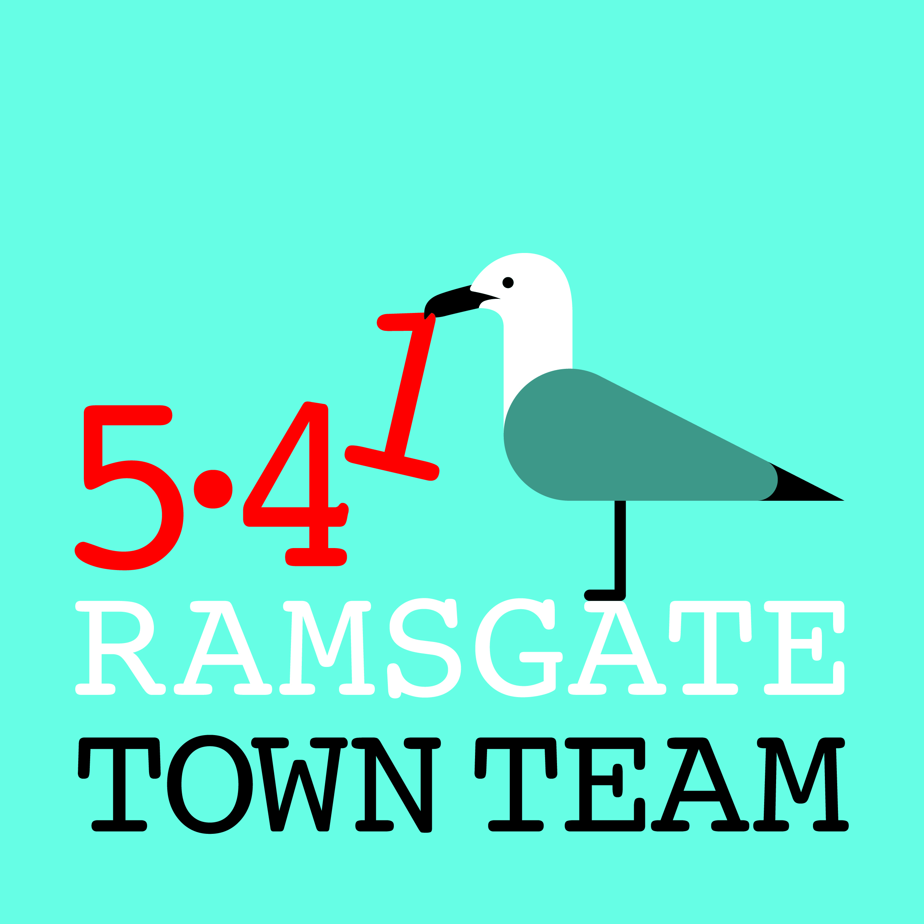 Committee Meeting, Thursday 18th October 2018
MINUTES
- Present: Rebekah (Chair), Jo, Sue, Madeline, Richard, Pat, Tricia (Minutes)
Apologies: Maria

- Minutes of the last meeting held on 13th September 2018:
Accepted as correct record

- Matters arising not otherwise on the agenda: Consultation responses submitted as planned, except KCC waste consultation which is due by 1st November.
Action: Tricia to circulate responses sent in with minutes and respond to KCC.

- Charitable status: Options discussed:
- Richard suggested Registered Society status might be useful as the town needs a Credit Union. All agreed that maybe this should happen separately.
- Madeline suggested CIC status might work for TT, but members were concerned that the TT is not a business.
- Madeline further suggested that a hybrid status exists where organisations can apply for up to £5k of charitable funding without registering as charity.
Action: Tricia to liaise with Madeline to find further information & circulate
- Tricia pointed out that if we stay as we are we can work with partners to submit funding proposals for which we do not otherwise qualify, as we’ve done recently with the Litter Innovation Fund with Ramsgate Town Council.
Agreed: We will:
- stay as we are for now
- set up a website Andy King/ Keith Ross)
- publicise ourselves more
- start 5.41 club and review in a year’s time
Actions: Tricia to write to Charity Commission with our response; Rebekah to contact Keith Ross/ Andy King to get quotes for website.

5) Forthcoming events:
- TT open meeting, Thursday 8th November: Agreed to run this 6-7 pm followed by Committee meeting. Event clashes with a Project Motorhouse event but people will be able to come to TT meeting & go there afterwards Action: Tricia to revamp her Rotary/ Inner Wheel PP presentation for meeting

- Christmas event preparations: Power cables are being installed along Harbour St. Will be 8-10 with motifs on Harbour St, Harbour Parade & pedestrianised area of Queen St. 10 ft Xmas tree in town centre, Newington and St Lawrence/ Station. Action: Tricia to contact Lesley Stevens re tree at Station
Laser show will run from 8th December 4pm – 10pm. TT & Ramsgate Society will fund extra days to cover 2 weekends at £250 each. Boats will also be illuminated. Action: all to promote Christmas events
Extra funding approved for switch on event; hope to give around £700 back to Council for extra budget. Features will include:
- Land train to run again
- Grotto will be at 26 Harbour St
- Looping the Loop workshops for children to make presents for parents
- Workshops at AiR for lantern parade
- Miss Ramsgate court will sell raffle tickets
- Popcorn & candyfloss stall
People will be needed on day to help marshal. Action: All to let Rebekah know re availability; all to promote Christmas events
- Two-minute updates:
- Station: Planters doing OK. Chris Barton doing repairs to leaflet display. Ramsgate Recorder (new quarterly magazine) is launching 1st November & will be included.

- Litter & waste management:
- Next Litter Forum meeting is 7th November. Chris Barton from RTC to attend on behalf of Richard, plus Rebekah, Pat & Tricia from TT.
- No Ifs, No Butts campaign: following refusal of funding from RTC, Rebekah & Tricia met with Phil Thorley from Thorley Taverns who has committed his pubs to participating and offered us £300 sponsorship. Rebekah has been in touch with Goose and Wetherspoons who are interested. RTC has indicated it may be willing to match-fund if some funding is found from other sources.
Action: Tricia to contact Eddie Gadd; Litter Forum members to be asked to approach pub landlords they know/ live near.
- Adopt A Street: approach to be piloted offline in 10-12 streets in Nov/ December.
- Bins: Still no sign of most of the bins we were originally promised. Bin outside Argos is due to be replaced, however.

- Harbour Street:
- Bollard: Richard reported that Paul Messenger has offered funding for traffic survey to generate evidence to justify bollard to KCC.
- Harbour Fish Bar: Rebekah has written to Mrs Emily Kemekki, registered at Companies House as landlord of the building, offering to go halves on refurbishment & repainting, but no response received.
Action: Rebekah & Tricia to talk with tenants again
- Christmas preparations: Madeline reported that there will be a new version of the cone trees down Harbour St for Xmas which will tie in with the new lights. Horse & Groom and Harbour Bar are interested in Christmas trees/ lights which could extend along rest of street and into alleyway to Charlotte Court.
Action: Richard, Rebekah and Madeline to liaise with RTC team on this.
- Partnerships: Tricia spoke at Inner Wheel meeting on 17th October. Members interested in possibly nominating the TT as their local ‘charity’ next year. Secretary of IW agreed to be on our mailing list & keep members informed.
- Wayfinding: Orders all done & signed off by KCC; info has gone to TDC but no response. Signs being manufactured now & should start appearing in November.
7) Any Other Business:
- Refill: Tricia has contacted the national Refill organisation (which badges establishments willing to fill up water bottles and provides an app for visitors to find them), and they are keen to work with us. This could be an asset to the town, especially for its links to our Walking & Cycling Friendly status etc.
Action: Tricia to go back to them and find out more.

- Virgin Media/ UK Power Networks: Tricia & Richard have been in touch again with KCC Highways about VM’s work in Ramsgate and the mess being made of pavements. Richard has re-sent VM photos from June. UK Power Networks have destroyed pavement outside Custom House which Richard is pursuing.
Action: Richard & Tricia to continue pursuing this and report back.

