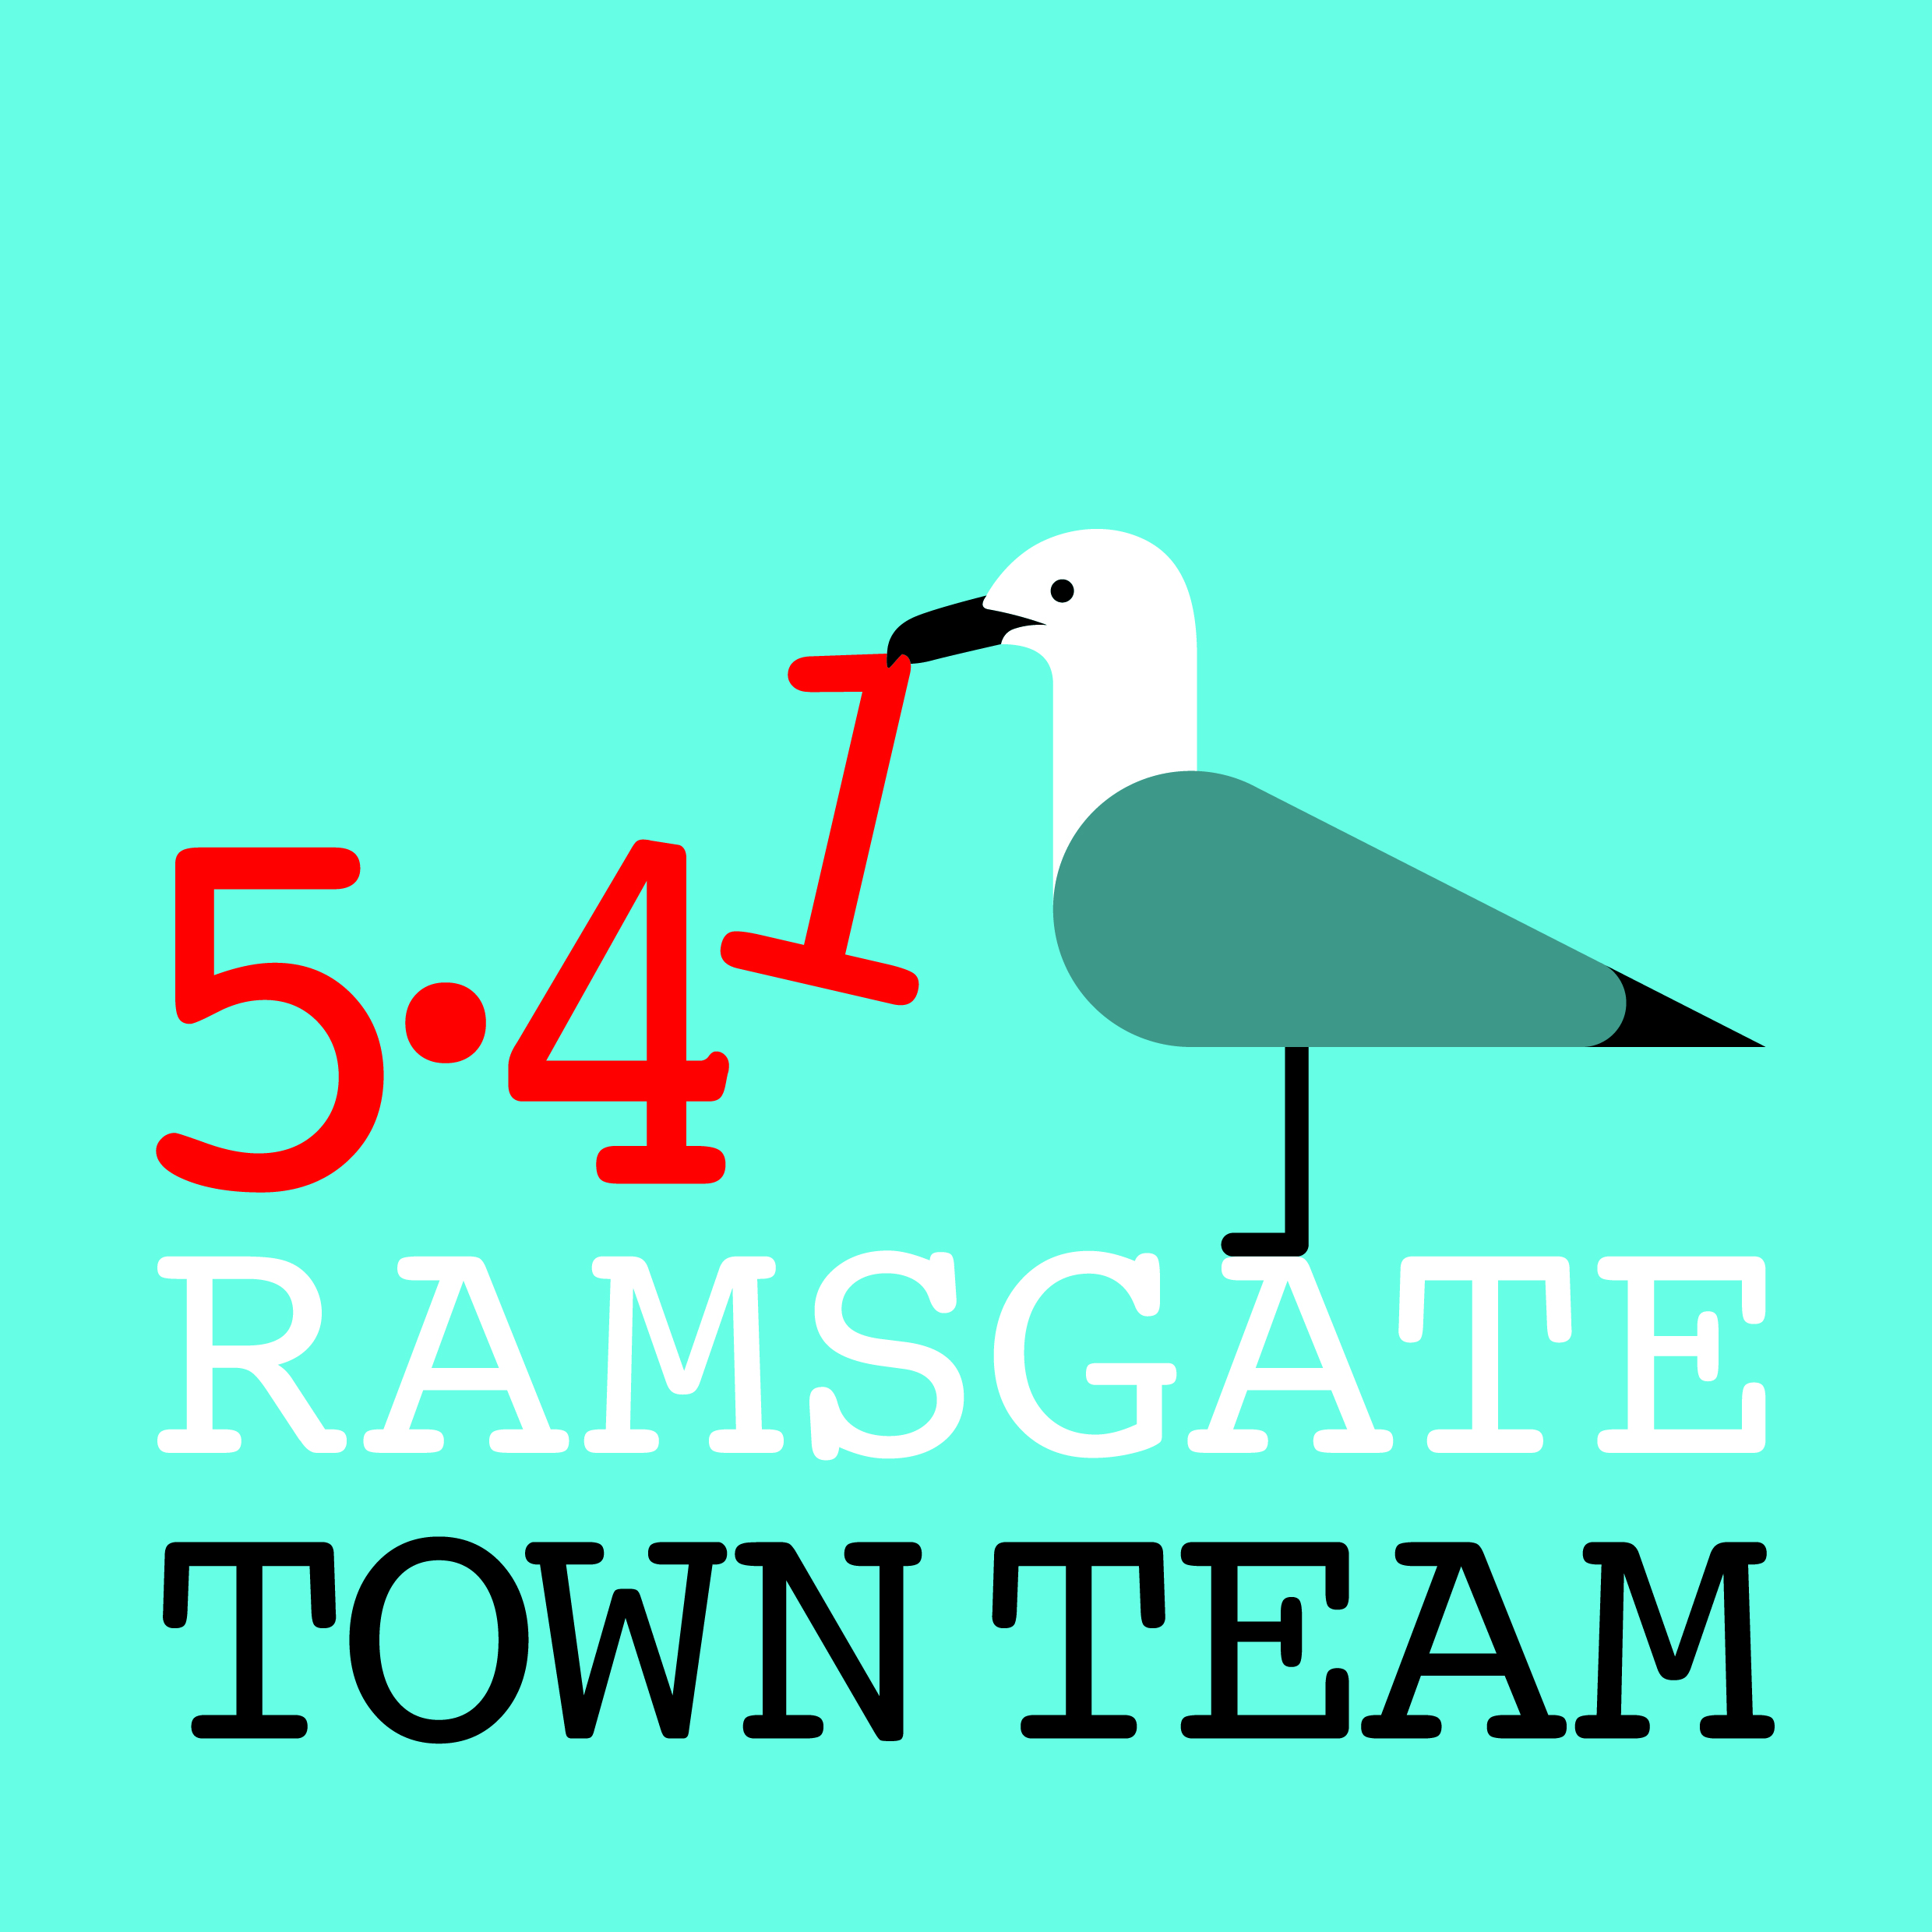
Committee Meeting, Thursday 18th January 2018
AGENDA
Venue: San Clu Bar, Comfort Inn, Victoria Parade, Ramsgate Time: 6-8pm
- Apologies: Maria Gavin

- Minutes of the last meeting (Special General Meeting held on 14th December 2017): Accepted as correct record

- Matters arising: None

- Application for charitable status: Could not be submitted before Christmas as everyone’s signatures required. All forms now complete and can submit as soon as Fiona’s signature obtained. Charity Commission is warning of 12 week turn-round period. There is option to add in special circumstances.
Action: Tricia to submit asap and add special plea for speed in hope that we can get charitable status in time for Easter events (see below).
- Updates on RTT activities:
- Shopfront grants:
  - Michael Child has sent in application: shop looks better but is work complete?
Action: Rebekah to send application round & decide by email.
  - Jo has given forms to Surin.
  - Rebekah has given forms to Costas from Village Grill, plus Gary Wells the signwriter’s number.
  - Pat still plans to submit application.
  - Madeline does not need to apply as Rob Daley from Graphical Signs has offered to do AiR’s shopfront for free, and also do seasonal displays.
- Ramsgate Station: Work now complete on planters, but still waiting for South Eastern’s £800 contribution, ashtrays and response on wayfinding.
Action: Rebekah/ Tricia to chase SouthEastern
- Harbour Street:
- Schoolwear Centre currently closed because of roof problems. Landlord paying £16k for repairs starting 4th Feb.
- Someone who has bookshop & cafe in Folkestone is reported to be interested in Celandine Hall.
- Ozzy’s: Maria has £500 quote to replace tiles with tongue & groove boarding.
Action: Rebekah to discuss with Ozzy & make plans for when weather improves
- Planting: Tricia has 8 planters at home with foam beads ready to put in. We still have money in budget for further work in Spring.
Action: Tricia to buy more compost & plants for planting up planters from Young’s at Broadstairs and ask them to invoice RTC.
- Sign on road: This has been damaged & then disappeared. All to report on Fix My Street if not in place after 10am, including Sundays. Madeline will suggest to traders putting their A boards in the road if sign for road end is missing.
- Raising bollard: After last Town Promotion meeting RS talked with Paul Messenger who made a point of saying how impressed he was with what TT does. RS suggested he & Karen C should get together to fund bollard: she recommended the Grizzly hydraulic bollard from Green Gate Access Systems - http://www.solargates.co.uk/latest-news/grizzly-hydraulic-bollard - cost approx £5k. Rebekah has written to them about this & emailed Paul Valek on 1st Dec who sent on to Schemes project manager. Should have 20 working day turn-round. RS confident that 2 Councillors will do this.
Action: Rebekah to keep members posted.
- It was also pointed out that a sign on Turner St. is needed.
Action: Rebekah to consider and pass information on.
Ramsgate ROAD/ waste management issues: Streets have been filthy over Christmas with many visitors complaining. Seems to be no co-ordination between street cleaning and bin collections. Big bins outside Wetherspoons are working but are expensive. Large Some businesses need to get their waste collected more often. Some large commercial bins have appeared in places where they shouldn’t be – eg Albion House bins by East Cliff lift. Rebekah put letters round to all businesses re keeping their shopfront area clean; got 1 aggressive response from business in King St but others very positive.
- Public meeting: Tricia contacted Lin Fairbrass who agreed this is v disappointing & is happy to meet with us to discuss.
Action: Agreed that constructive public meeting should be held. We need a plan for meeting and topics to discuss. Need a user-friendly venue like AiR where people can sit round tables rather than in rows in confrontational style. Perhaps invite people who come up with sensible suggestions on ROAD etc to a pre-meeting to discuss an outline plan? Tricia to email asking for comments and possible dates.
- Ramsgate Shelters: Several major incidents this month. CCTV being upgraded. Rebekah has done crime report for damage done on 16th at 9.45pm: good CCTV of 6 young people, including 2 girls. Jo has also reported to police this month. Police know these gangs.
- Ramsgate Recyclists: Still planning to raise funds for this; 1 application submitted & waiting to hear. Still waiting to hear back from Madeline Homer re what happened on Place Based Lottery bid.
Action: All to keep eyes open for possible funders; Tricia to share response from MH when it arrives

- Date for AGM: Thursday 8th March at 7pm, preceded by Committee meeting
Action: Tricia to send this date to members with minutes of the December meeting and notification re CIO application, and then formal notification 21 days in advance on Facebook & as reminder to members. Plan for AGM to be agreed at next meeting.

- Any Other Business:
- Easter plans: RTT usually has stall at Handmade Fair on Easter Sunday, but lantern parades have been so successful in getting community involved that Rebekah has applied to do Easter Parade from Sailors’ Church to turning circle at end of Harbour Parade on Sunday 1st April. Theme will be Alice in Wonderland but also use April Fool’s theme. RS has applied for permissions and will pay from Town Promoter budget. Making (eg Mad Hatter hats) has started at AiR; different elements of the Alice story planned for various points along the route. Volunteers to dress up and act as marshals will be needed. Action: Rebekah to let members know re next planning meeting.
- Car Parking: Cannon Road now to be free car park on Saturdays rather than Leopold St: further from town centre but could be a help to businesses in High St/ Chatham St? Would larger businesses (Wilko, Poundland etc.) contribute to having Leopold St free on Sats?
Action: Rebekah has half-finished email requesting clarity re Mill Lane car park in Margate and whether free parking on Saturdays & for Council staff will be maintained at TDC’s expense. She will circulate for comment before sending.
Funding Forum: Tricia trying to set up FB page to share information on funding between groups: work in progress!
- Town Centre news:
  - Someone interested in eel pie shop on High St for gallery/ café.
  - There will be no RTC/ TDC floral budget in future. Young’s Florists will be badly affected: Jackie Young reports they will be closing Westgate branch and concentrating on Broadstairs.
Action: All to think about how and where we may be able to help fill the gap. Might traders contribute towards floral display costs in future? To discuss at future meeting.
- Committee membership: Constitution requires Committee members to attend at least 6 meetings per year unless circumstances are exceptional. One Committee member did not attend at all last year and another attended twice (February and May), but both have expressed desire to continue on Committee and be nominated as Trustees for CIO application.
Action: Members concerned to be included in CIO application and encouraged to attend future meetings. If they have not resumed attendance when CIO application is approved, TT to invite them to stand down in favour of other interested parties who may have more time to commit.
- Next meeting: Thursday 8th Feb 6pm; location TBC

