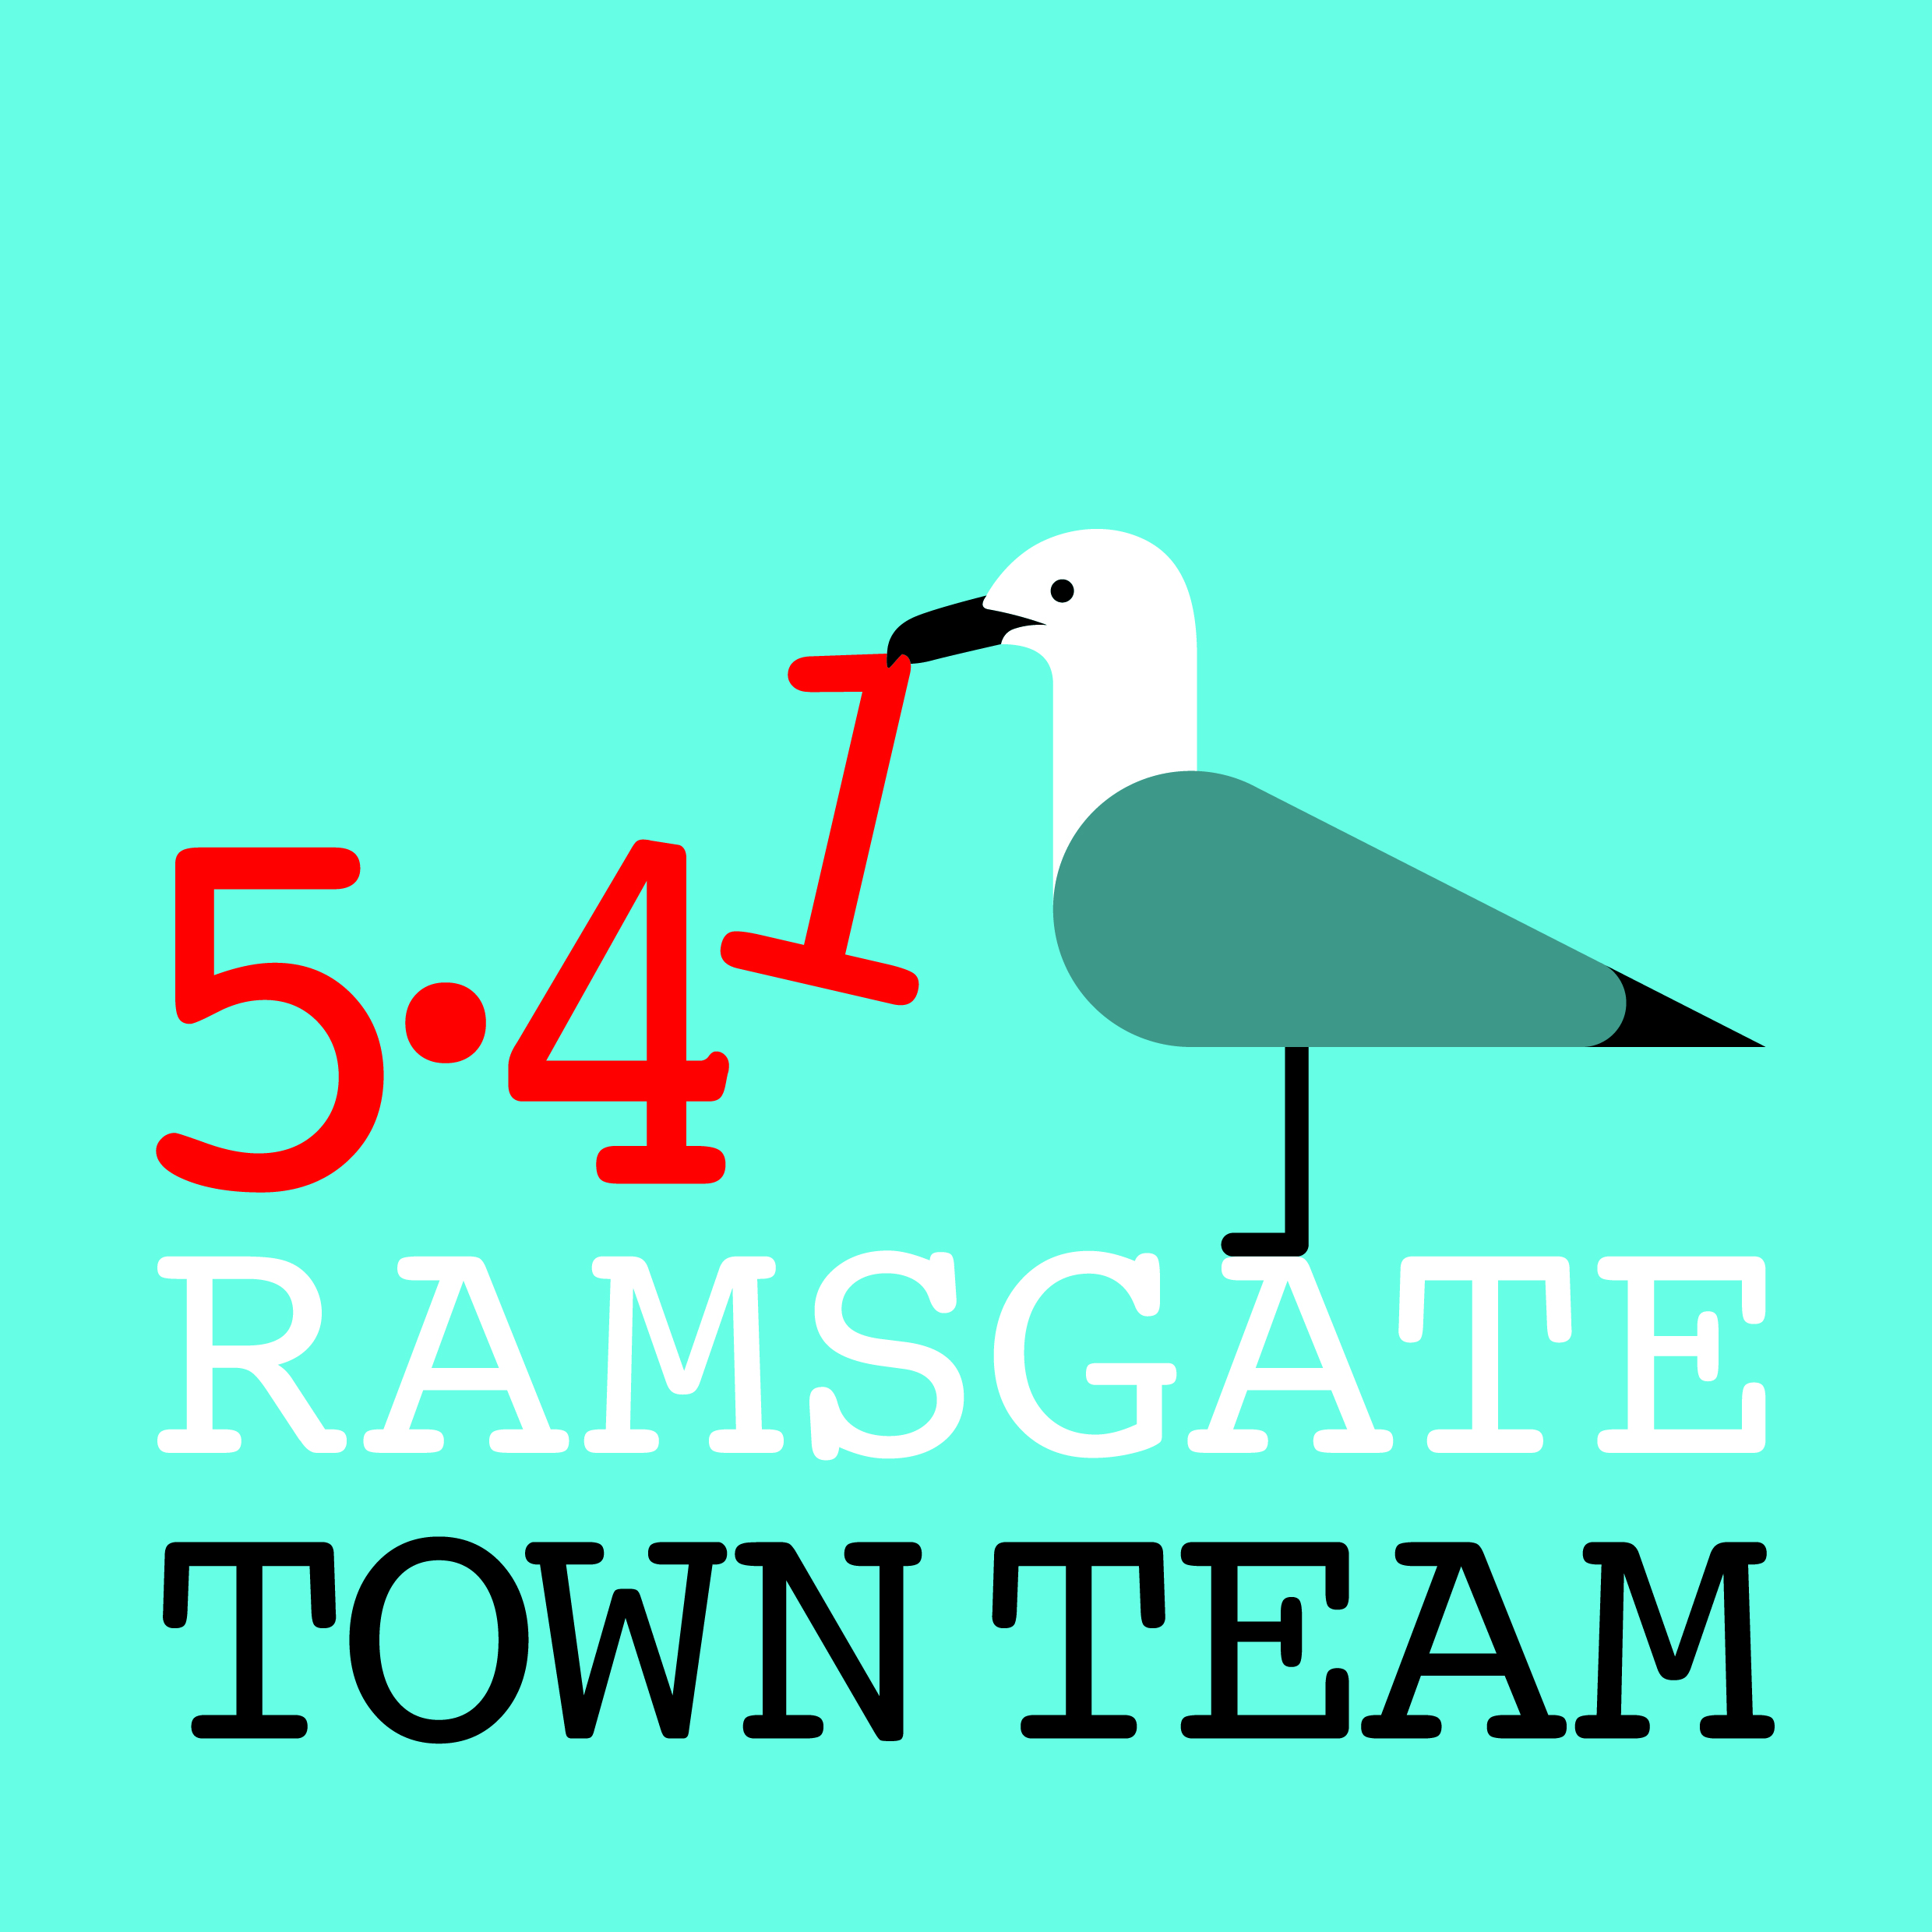 Committee Meeting, Thursday 16th May 2019
MINUTES
- Present: Rebekah Smith (Chair), Jo Hanchett, Sue Hall, Pat Makinson, Chris Barton, Tricia Austin Hartley (Secretary)
Apologies: Madeline Wright, Becky Wing

- Minutes of the last meeting held on Thursday 14th March 2019:
Accepted as correct record.

- Matters arising not on the agenda: None

- Membership: Chris was welcomed to his first official meeting as a member of the Town Team. Chris has done a huge amount to support the TT’s efforts, including being in 4 places at once for the Spring Clean and putting up the pictures on the Rainbow Steps on Bank Holiday Monday.

Thursday meetings may now clash with TDC for Becky, but she remains keen to contribute.
Rebekah mentioned she is trying (again) to persuade Maxine to join us. Jo suggested Emma Lynch may be also interested in joining the Committee. For gender balance it would be useful if we could co-opt another man to the Committee – perhaps a licensee?
Action: All to consider possible other people who might join us. No urgency as we have 9 members and our maximum number is 11.

- Work programme update:

  - Wayfinding: All in situ but new fingerpost still needed at top of Kent Steps. Rebekah has quote for this but Chris will investigate options for making it locally. Chris to declutter fingerpost; Town Team to paint lamp-post. Cast ironwork on steps also to be painted as part of Pugin Tiles project.

  - Litter Forum/ Spring Clean/ Road Reps / No Ifs, No Butts:
- Litter Forum met last week & 3 members of TDC Enforcement Team attended. Next meeting in July with Craig Mackinley. Next main focus is work with letting agents so Tricia will be in touch with Jo for advice.
- Spring Clean highly successful: >750 volunteer hours, > 435 bags of litter collected. Jo Edgington who participated has set up Ramsgate Litter Pickers Facebook group to run future events. St Lawrence Cubs doing Beach Clean on Ramsgate Main Sands on 11th June at 6.15 pm. Ramsgate Society planning another seafront pick on 13th October.
Action: Tricia to send Spring Clean report round. Rebekah, Tricia & Chris to liaise re litter picking equipment for Cubs’ event.
- Road Reps: new scheme (formerly Adopt A Street) just launching & recruiting volunteers across Ramsgate, using Andy King’s new website. Reps will act as liaison people with TDC re fly tipping and to ensure new residents know about waste & recycling system.
Action: All to mention scheme to litter picking enthusiasts they know!
- 12-15 pubs now have No Ifs, No Butts stickers.
Action: All to take stickers round to pubs, ensuring they have ashtrays/ buckets outside and making note of person’s name who agrees to take part. Tricia to send list of pubs already signed up.

  - Easter Parade/ Events: Went well but Sue was missed. Bonnet workshops went brilliantly but Easter egg hunt did not: mismatch re ages of children and promoting small businesses so needs rethinking next year. Promotion needs different approach. Jo suggested working with a supermarket to get slips into shopping bags rather than send home from school in book bags.
Action: Rebekah to contact schools to ask how best to engage children. All to consider how to promote parades in future.

- Pugin Steps/ Rainbow Steps: Pugin Steps planning application submitted but some issues with local residents. Rebekah has met with them: useful in some ways as provoked discussion & thinking about project. Company identified who can produce tiles but quote will use up nearly whole budget.
Action: Rebekah to continue liaising with residents & tile company.
Rainbow Steps: Chris & Rebekah have put children’s work up on Steps and cleared & weeded base. 1 more picture to put up.
Action: Chris & Rebekah to liaise to put up remaining picture.

- Summer decorations: planting, hanging baskets, bunting?
Becky keen on bunting and will pay for it from her RTC Cllr’s allowance. Permissions will be needed. Chris advises anchor points all tested. Would Crafty Poppies help make bunting? Could AiR help?
Hanging baskets in Harbour St need planting & maintenance.
Actions:
- Tricia, Rebekah, Becky & Chris to liaise re bunting and report back
- Tricia to approach Youngs for price for hanging baskets
- Rebekah to approach Harbour St businesses, Central Harbour & E Cliff Cllrs for contribution to costs

- Funding & finance:
- Future High Streets Fund: No news on this yet. New Heritage High Streets Fund to be launched which may be possible for King St. Meeting tomorrow with Louise Askew from TDC. If we get through to next stage of FHS we may not be considered for HHS.
- Reaching Communities Bid: Becky & Tricia to meet soon to come up with ideas & come back to group.
- Other financial matters: £16k in bank account but 2 x £3k spoken for.

- Support for other community groups:
  - AiR: Madeline has run centre for nearly 4 years and is overstretched. She applied to Reaching Communities for next 5 years but recently heard this was not successful. AiR is growing and working well but desperately needs paid staffing so Madeline can step back as her health is not good. She is submitting further bids but welcomes suggestions meanwhile.
Action: Tricia to ask to see Reaching Communities bid & look at funding options to support half-time manager post/ consider possibility of including Air in Town Team’s Reaching Communities bid?
  - Insurance: Many vol groups now asking Town Team to cover their work.
Action: Rebekah to approach Richard & Peter C re RTC covering the groups.
  - Facebook group: Should we have a FB group for Rebekah all voluntary groups to post their minutes etc? Discussed.
Action: Rebekah to consider and come back to group at next meeting.

- Any Other Business:
- Harbour Street: Good news: Several empty shops now bought/ leased. Bad news: continuing ASB including recent stabbing. Our work with TDC Community Safety team evaporated when Jessica Bailey moved roles.
Action: TT to maintain watching brief and liaise with TDC Cllrs and RTC.

- Street Trees for Ramsgate: New group established by Joseph Dance. Keen to work with us and RTC. Becky & Tricia attended first meeting.
Action: TT to keep in touch and seek to link into work of this group.

- Fire Station: Architects appointed; plans drawn; accessibility a problem.
Action: TT to maintain watching brief & continue to insist on importance of building manager and widest possible community access.
- Abotts Hill Steps: Jo reported that Emma wants to paint remaining panels. RTC can provide barriers to protect site if needed. Action: TT to approve this and Rebekah/ Jo/ Chris to liaise with Emma.

- Nick Dermott book chapter: Rebekah & Tricia reported having had input into final chapter for Heritage England book. Concerns re looking back rather than forward as in the brief.

- Name change: Tricia reported that she is in process of reverting to her maiden name of Austin. Her email/ FB addresses will remain the same.

