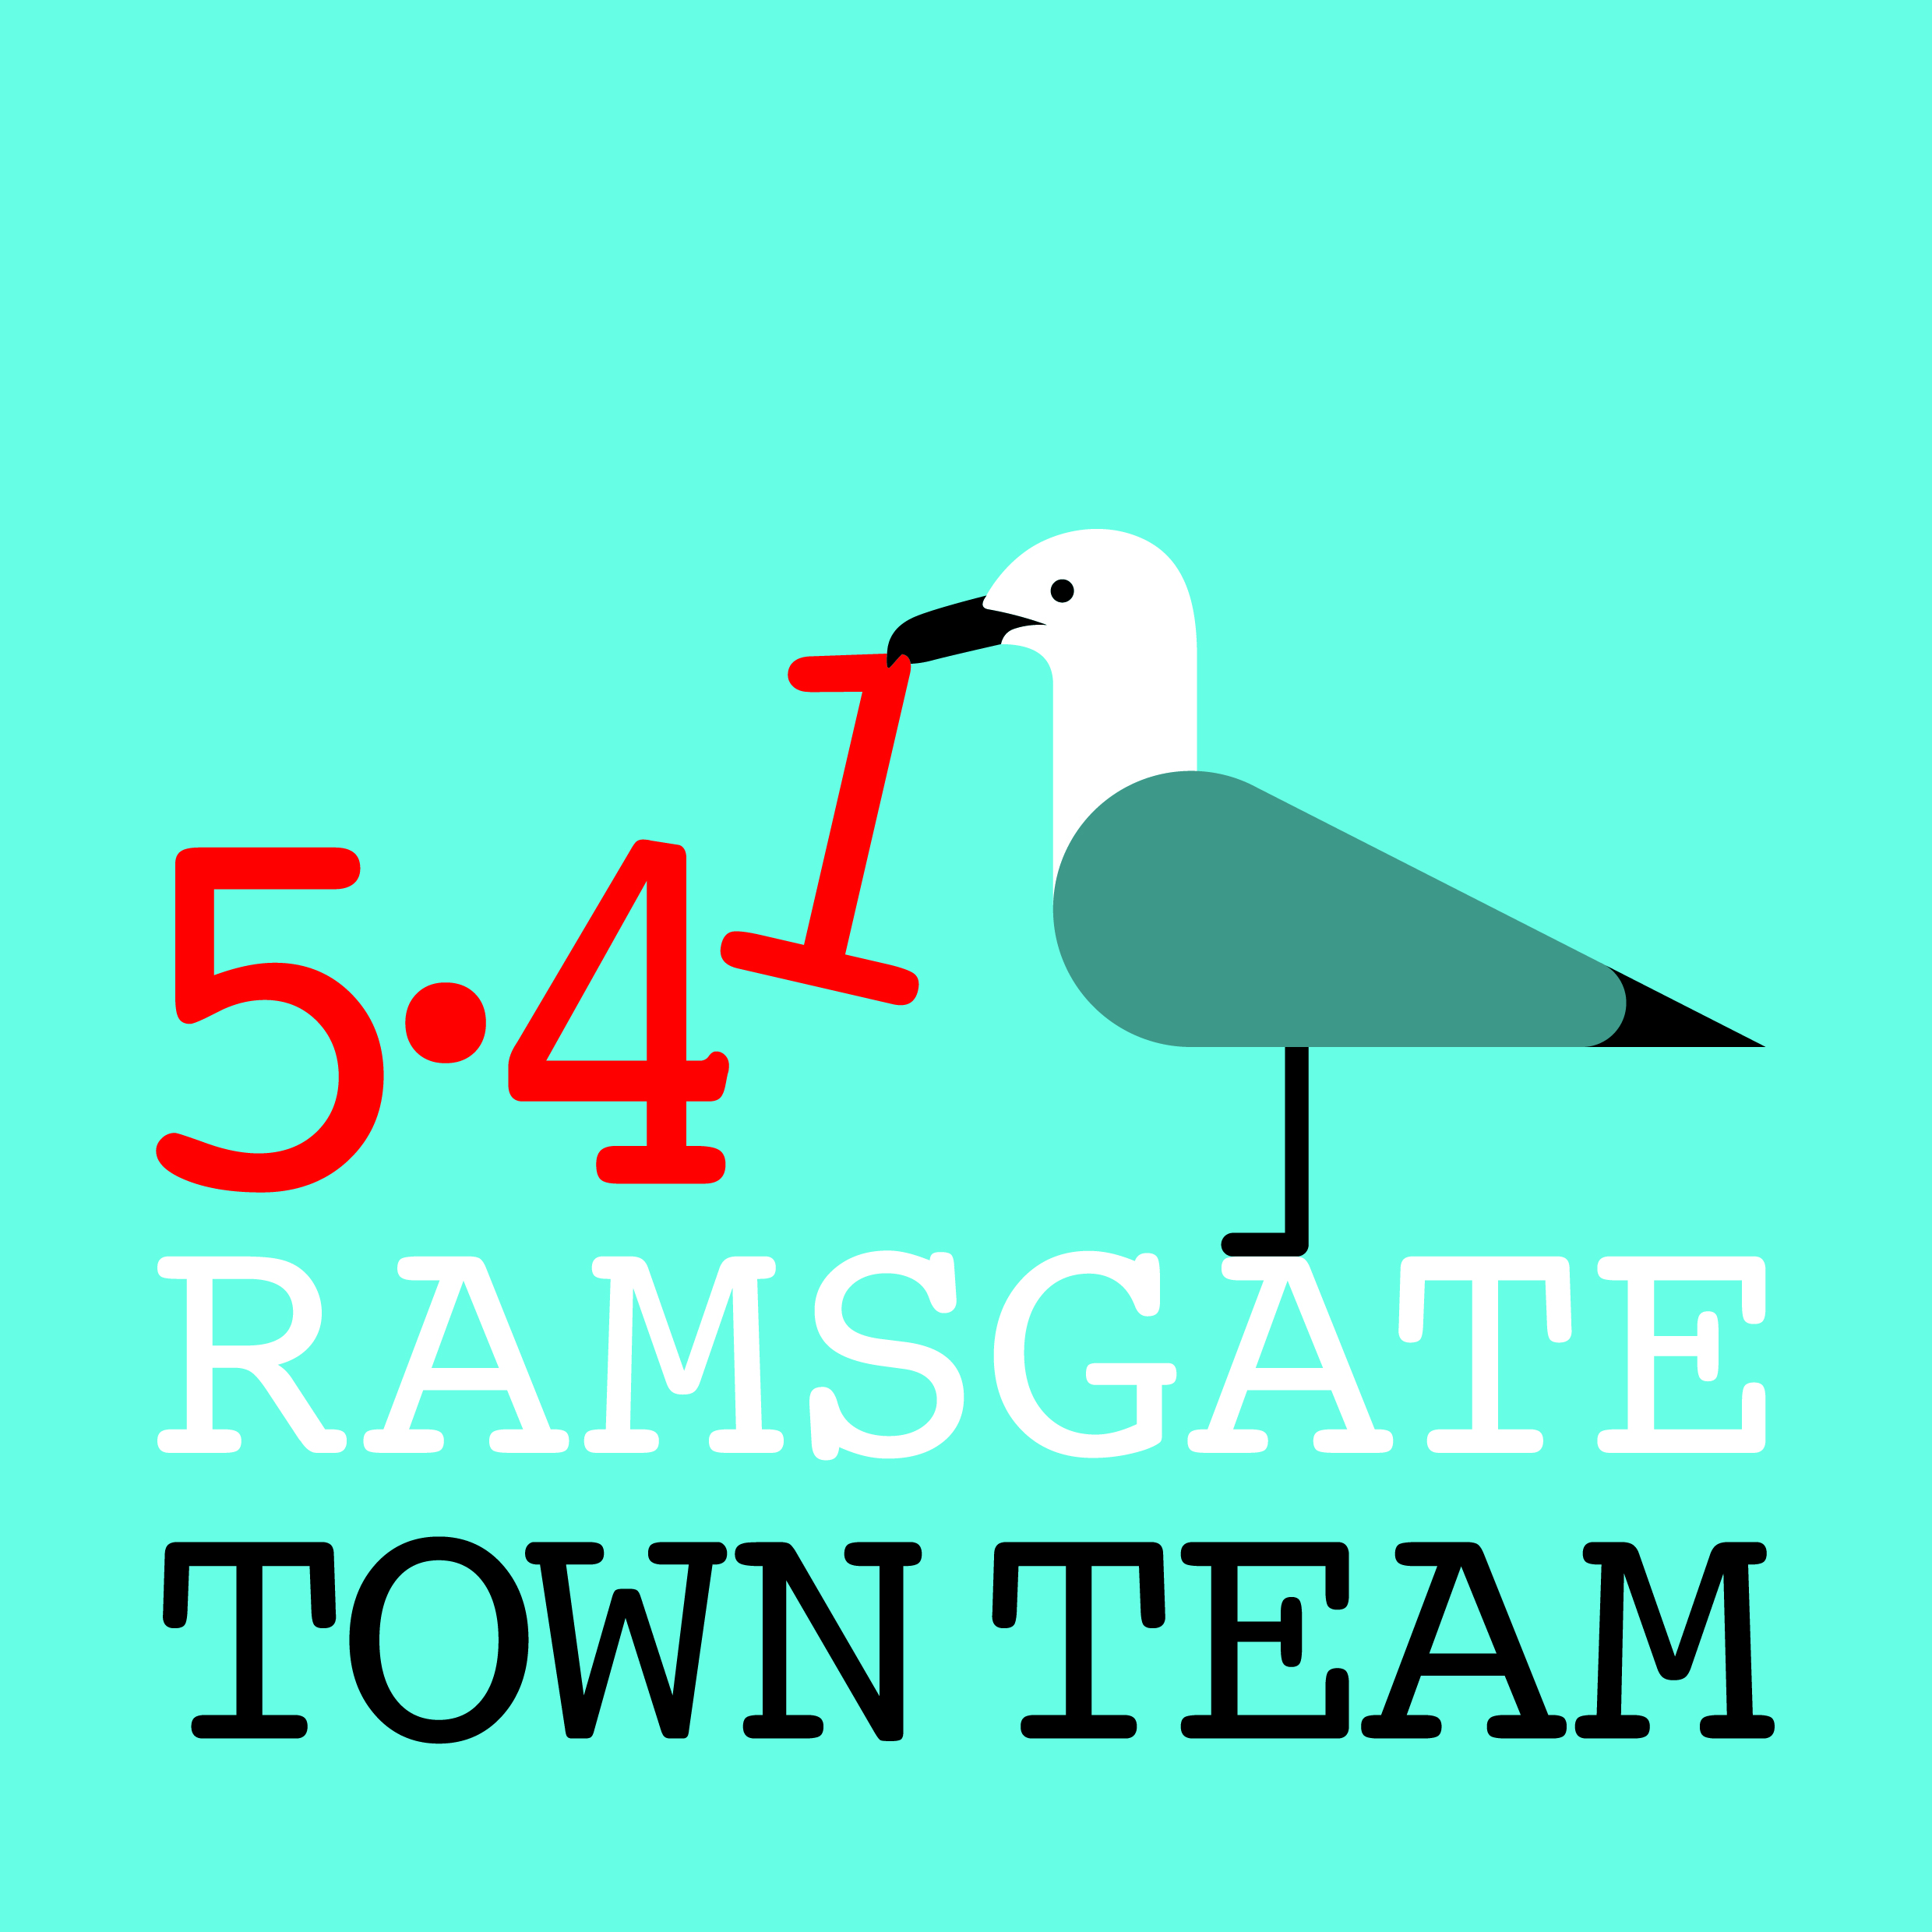
Committee Meeting, Friday 15th February 2019
MINUTES
- Present: Rebekah Smith (Chair), Sue Hall, Pat Makinson, Richard Styles, Tricia Hartley (Minutes); Chris Barton (Observer)
Apologies for absence: Jo Hanchett; Maria Gavin

- Minutes of the last meeting held on Thursday 10th January 2019:
Accepted as a correct record

- Matters arising not on the agenda:
- Wayfinding: Nearly all the monoliths & fingerposts have now been installed. Most feedback has been positive.
Action: Richard to send invoice for £17.5k to Rebekah

- Funding & finance:
4.1: Treasurer’s Report/ Accounts:
- Pat reported that she is still working on 17-18 accounts but has nearly completed Maria’s list & about to start on new invoices. Missing cheque book (now found) may shed light on missing items.
Action: Pat to send any queried reimbursement amounts and dates of payment to members to confirm amounts paid and for what
- Richard suggested that in future RTC could pay for items for TT and TT reimburse the Council. This will generate 1 invoice which will make accounting simpler; also RTC can claim back VAT on certain items.
- Sue and Pat agreed to be central posting place for paper and email receipts in future

4.2: Future High Streets Fund:
- £675m Government funding announced in October. EOI has to be submitted by TDC: only 1 application per area of our size.
- TDC now has to decide if Margate or Ramsgate will be focus. Richard pointed out that RTC would deliver a Ramsgate-based project, whereas with Margate TDC would have to deliver project itself.
- Cross-party group is making decision: Lin Fairbrass representing Ramsgate. Decision to be made by end of day on Monday.
- Partnership aspect is v important. Rebekah has been canvassing for support from local businesses and has received many positive responses. Letters of support also received from eg Craig Mackinley, Historic England, Orbit Housing (NB good track record of investment in Hastings: can provide evidence).
Action: All business members to send letters of support to Rebekah

4.3: Ramsgate Fund:
- Ramsgate Fund bid for Welcome to Ramsgate traditional Victorian planters was successful - £3,200 available which should cover 4 or 5. Broxap are most likely supplier.
Action: Tricia to contact Rotary & Inner Wheel to see if they want to contribute to further planters with their logo on
- Paul Valek in KCC Highways is supportive; St Nicholas at Wade just done something similar. Locations to be agreed with Chris/ RTC lengthmen team: entrances to town or entrances to town centre?

4.4: 5.41 Scheme:
- 5.41 advert now published in Ramsgate Rocks Action: Tricia to send round info & standing order form to members & supporters when sending invitation to AGM
Discussed possibility of flyers for Easter event: all approved
Action: Rebekah to order these

4.5: Other funding sources:
- Reaching Communities proposal to be considered. All to keep eyes open for other possibilities.
- New projects update:
- Pugin Tiles Project: Historic England have now paid in £3000 for this project. Chris has looked at risers on steps & thinks installation shouldn’t be a problem. Rebekah has been in touch with schools & will meet after half term. Students to research best materials etc. & produce more tiles than initially needed for replacements. TDC Conservation Officer has not responded yet on this.
- Rainbow Steps: Rebekah has had first new paintings in from Newington School today. Arranging for display to go up in York St Gallery; Madeline has offered longer display period at AiR. Rebekah has put in funding request for Rainbow Parade.
- Big Spring Clean: Events being organised. Main chine-to-chine event run by Ramsgate Society on 14th April; East Cliff Group doing 5 Saturdays in 5 local ‘grotspot’ areas; Western Undercliff group doing 23rd March; other groups TBC.

- Other updates:
- Chris: Delay in company taking Christmas decorations down. Once done, will start getting brackets sorted out for hanging baskets.
- Harbour Fish Bar: Chris to call in re bracket & try to initiate conversation about refurbishment of outside of building (again!)
- Manston: Tricia will submit response before this evening’s deadline & will circulate to members.

- AGM arrangements: To be decided by email.

- Any Other Business:
Membership: Maria’s health has not improved and she has indicated a wish to resign. Members agreed to accept her resignation with reluctance.

Becky Wing has expressed interest in joining the Committee: all present approved her membership.

