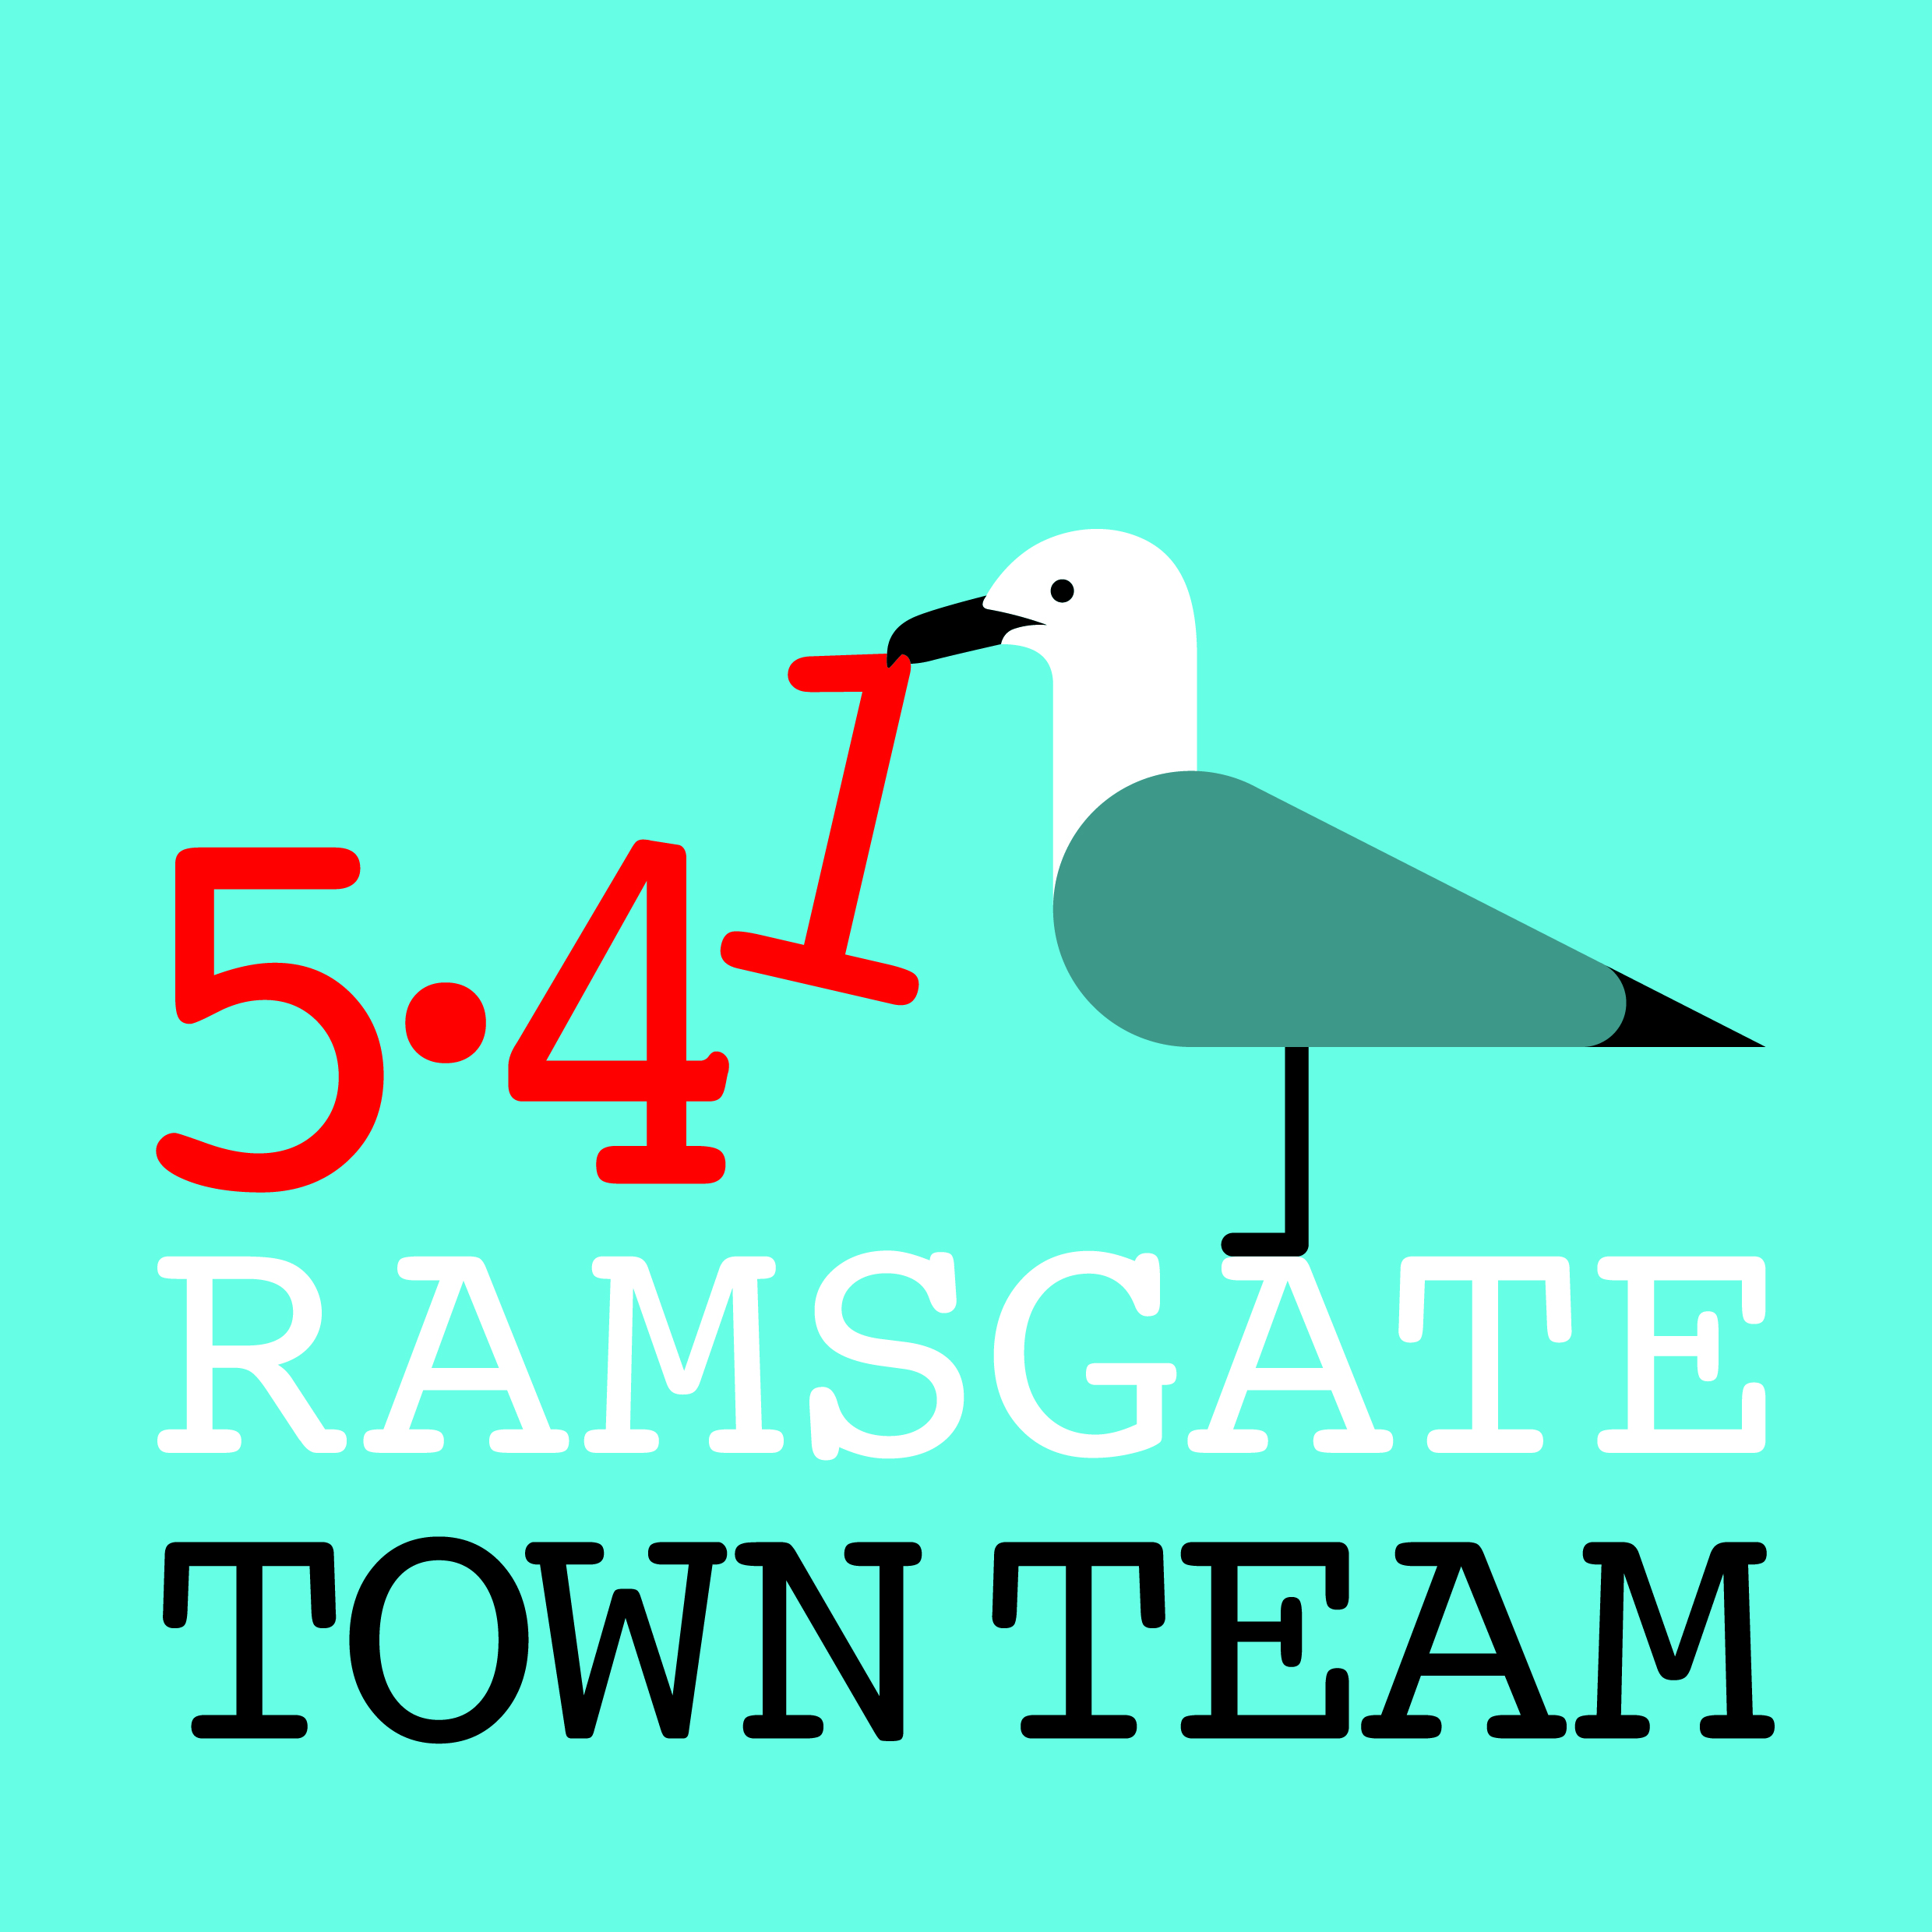 Committee Meeting, Thursday 14th October 2019
MINUTES
- Present: Rebekah Smith (Chair), Jo Hanchett, Sue Hall, Madeline Wright, Chris Barton, Pat Makinson, Maxine Morgan, Tricia Austin (Minutes)

- Minutes of the last meeting: Accepted as correct record.
Action: Tricia to circulate town centre bids.

- Matters arising not on the agenda:
  - Fundraising: Bids not done yet as everyone has been busy. Actions: Maxine to pick up on Tesco bags fund; Rebekah, Becky & Tricia to meet Tuesday 22nd October to write Awards for All bid
  - Town Centre: PC Darren Green now antisocial behaviour officer for Kent Police – in process of interviewing people around town centre – Can be contacted on 10006@kent.police.uk
  - Charlotte/ Albert Courts: Artist (Rodney) who created brick sofas in Albert Ct has offered to do repairs for £400.
Action: All agreed to go ahead: Max to ask when he can do this.
Madeline suggested doing event built round repairs, cleaning, planting – maybe afternoon teas with Corby’s/ Gerry’s? Businesses to be asked if they can contribute to cost. Housing Association (People for Places) own flats & have access but ownership still sits with TDC.

- Finance and Funding: We have approx. £18k in bank account but approx. £9k is restricted (must be spent on specific things eg Pugin Steps, planters.)

Madeline thanked RTC members for supporting funding for AiR. David Green was incorrect in suggesting AiR had application in previous year.
Action: Madeline to contact Eileen to correct record.

- Forthcoming events:
- Halloween: Event to take place on 25th October: to be advertised on social media on trial basis. (If we charge £3 we get £2+ back via Eventbrite.) Becky will pay for face painting & crafts via Addington St events funding. Children will get a sweet at each business on map: all businesses to be encouraged to buy at wholesale rates from Mr Simms. All come to AiR to get map, get face painted, do crafts. More crafts at Cosi/ tent outside. Wilko have given luminous skeletons. Rebekah spent £130 on props & ordered other items. Arches also doing event on 1st Nov: we will put leaflets re this in children’s bags.
- Christmas Switch On: Taking place on 24th November: all to be available if possible. Cozi possibly to be grotto. Most people available except the amazing Sue! Rebekah has ordered everything needed.
Action: Separate meeting to be arranged
- West Cliff Christmas Fair: 1st December 10-4. 20 stalls confirmed using indoor venues (plus Nelson Cres if dry). Also kicking off Advent Doors on Nelson Cres 6-8 pm to raise funds for Winter Shelter.
- Lantern Parade: 1st December starting 4 pm. Fourth year this year. Lantern workshops throughout November. 4 schools involved.
Action: Volunteers to go to AiR at 3.30 pm with hi viz.
- Other events: Carol Service in Charlotte Court: To do on late night shopping start date 12th Dec: most boats will be lit up by then & Archive will do Xmas Fair. Horse & Groom will put up some stalls.
- Christmas Tree Festival St George’s: Setup 4^{th-} 5th Dec: runs 6th – 15th.

- Arrangements for open meeting: To be postponed til AGM in March

- Any Other Business
  - Beach Club: Possible facility in car park next to Beach Retreat. Could use storage containers. Pat has contact with someone wanting to open sustainable coffee shop on car park in container but TDC have been unhelpful. Car park contact given to Tricia is Rebecca Glaiser – Rebecca.glaiser@thanet.gov.uk. Could be mixed use (including winter activities) – arts, ice rink, zipwires, rock climbing, surf school, café, dog walkers’ retreat? Could RTC take over car park?
  - 20 is plenty: Quite controversial but many places have this in place now, including several in Thanet. RTC supportive. Becky to register us & find out more.
  - Town beds: Becky getting advice on planting: Irene Seijo advises bigger plants that can’t be stolen and have better chance of survival.
  - Cosi van Tutti: Plans under discussion for launch in New Year in Fire Station.
  - Farmers’ Market: Open area at bottom of Fire Station is possibility for this.
  - Green Hub in Addington St: Under discussion: members to be kept informed.

- Date of next meeting: Thursday 14th November.

