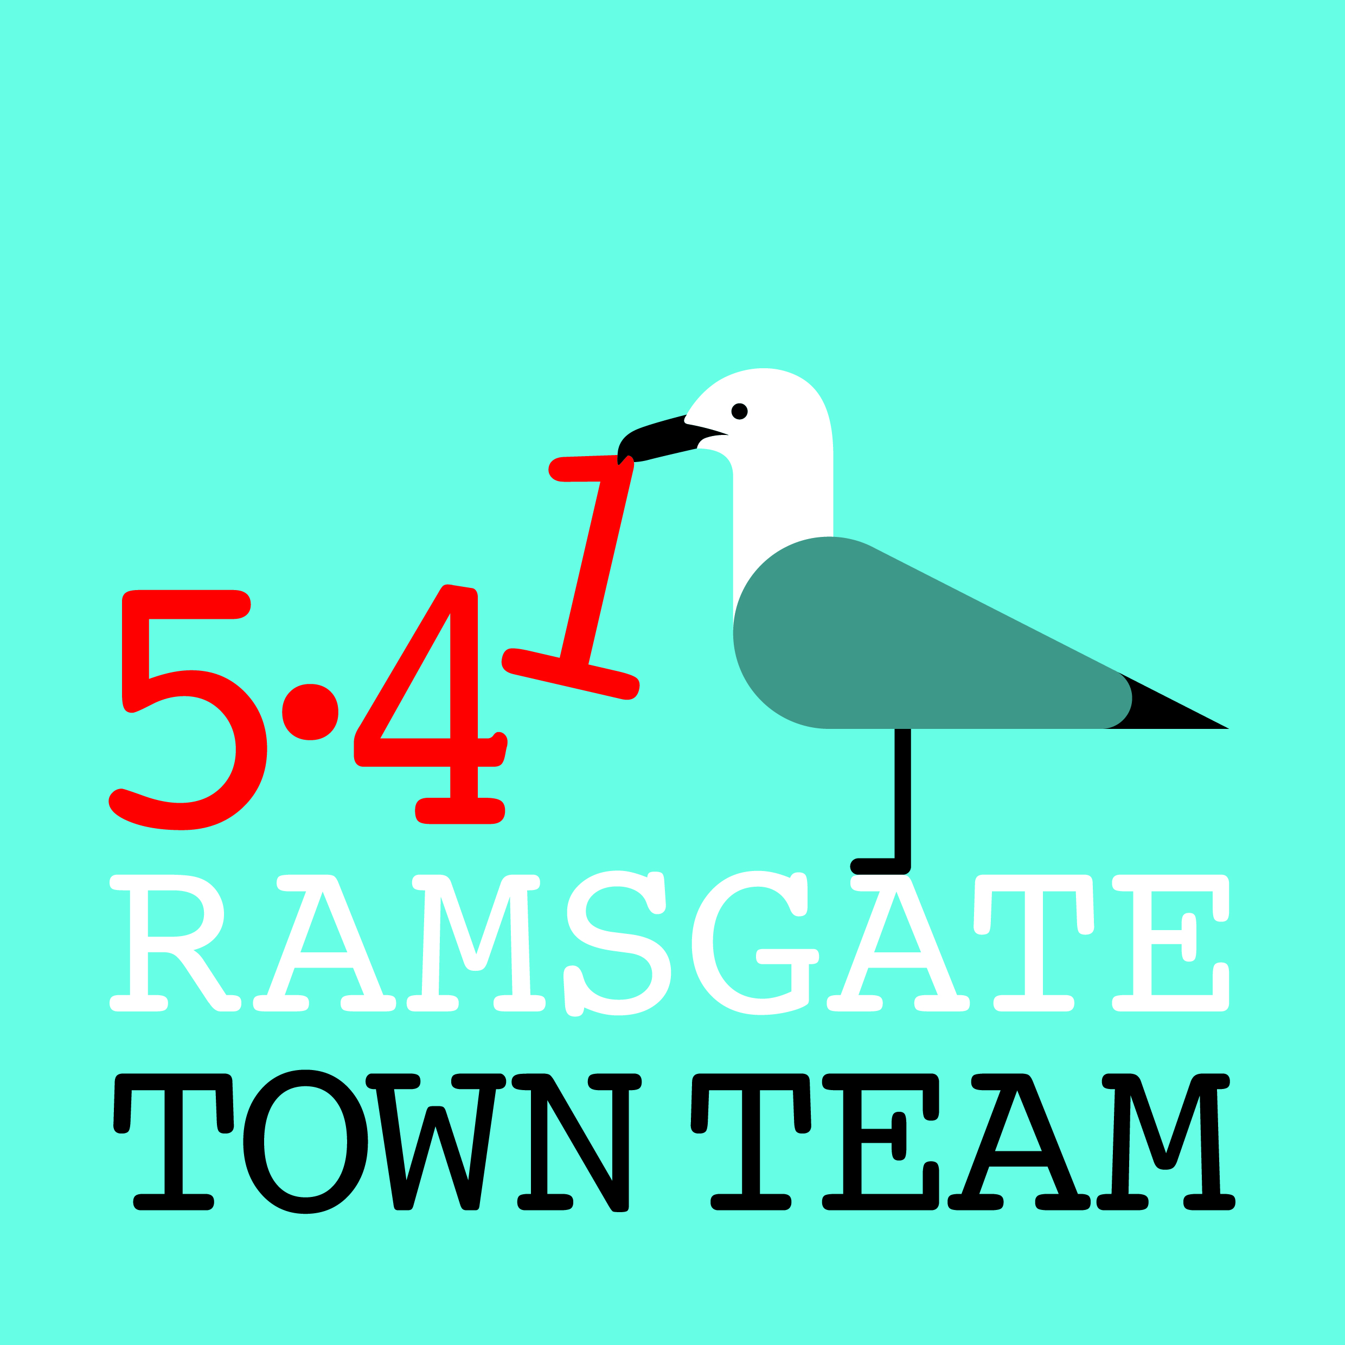
Committee Meeting, Thursday 14th June 2018, 6-8pm
Minutes
- Present: Rebekah Smith (Chair), Jo Hanchett, Sue Hall, Richard Styles, Pat Makinson, Tricia Hartley (Minutes)
Apologies for absence: Maria Gavin
Rebekah explained that Maria is unwell at present and would like to take a break from TT activities for a few months. All present sent their love to Maria and looked forward to having her back with us as soon as she feels able.
Pat offered to pick up the duties of Treasurer in Maria’s absence, and Sue & Tricia will manage any membership matters between them.
Action: Pat to contact Maria re accounts; Rebekah to help as needed. Tricia to contact Maria for updated membership list to promote bollard painting to members.

- Minutes of the last meeting held on 10th May 2018: Approved as correct record

- Matters arising: None not already on agenda

- Updates:
4.1 Volunteer Fair 6th June:
- V busy event but not enough space so v squashed. Would be good venue for a Ramsgate-only fair. We had 5.41 & Ramsgate ROAD leaflets and pictures from our Annual Report on our stall, staffed by Sue, Maria, Tricia & Rebekah. Rebekah has sent thanks to Emma at Volunteer Bureau.
4.2 Spring Clean Month/ litter & waste management:
- 2 clean-ups took place over Bank Holiday weekend. Newington was successful thanks to support from school who recruited 6 families; East Cliff less so – only Rebekah, Tricia & 1 resident plus her child. Addington St group doing clean-up in several streets on 15th June, working with a school.
- Next meeting of Litter Forum we run jointly with TDC is on 28th June.
- Town Team now has 10 x litter pickers, pairs of gloves and hi viz.
4.3 Ramsgate Funding Forum:
- Forum has launched on Facebook & is receiving positive feedback.
Action: All to encourage contacts in vol groups to join. (NB Jo advises we should not add people since GDPR.) All to share anything relevant to funding.
4.4 Harbour Street:
- Deep cleaning: RTC maintenance team can do more deep cleaning in Harbour St and other areas the TT recommends, but Richard pointed out that time is also needed in outlying areas. NB There are stains on Harbour St pavement from frying oil etc which will not come out with deep cleaning.
- Crime & antisocial behaviour: Police presence higher at present, partly as result of series of several serious crimes in town. Task Force working with youth in town centre. Richard has invited Jessica Bailey to come & talk with RTC. Problems with reporting and classification of crimes discussed.
- Harbour Fish Bar: Rebekah has met with Ozzy and asked him to get freeholder to contact her re external building improvements. Action: Rebekah to chase Ozzy; Jo to check Land Registry.
- Symphony: Richard v concerned re young family living above shop as no fire escapes/ breaks, basement full of furniture etc. Roof no better than next door. Richard has informed Gavin at TDC who is sending someone to check.
- Bollard: Did not get onto Joint Transport Board agenda for 7th June as they wanted more info. Paul Valek does not want this so not being helpful. Some businesses also not keen (Bodrum, Cooper Bradshaw, Taylor Meats). Richard has sent picture of van driving down street wrong way to illustrate problem.
- Christmas: Richard reported that larger & brighter lighting approved for Xmas tree, Harbour St & town centre as RTC has increased budget. Our battery lights could decorate town centre trees; Richard offered RTC’s cherry picker.
- Hanging baskets: Rebekah has met with Graham Hellings who is making (free of charge) 18 extensions to brackets to take hanging baskets.
  - Community Payback:
- Jo met again with Ian Craig, who says if we are commissioning them he needs to use our insurance. Richard happy to help get the right insurance in place.
Action: Jo and Richard to liaise over PLI for Community Payback
  - Wayfinding:
- Everything now signed off & due to go to Planning Committee very soon. Monolith at Station needs amendment to remove walking time to West Cliff.
Action: Richard to ensure this reference is removed.
- Rebekah getting quotes for signage for harbour arches: becoming more complicated however, & unlikely to get planning permission as things stand.
  - Charitable Status/ 5.41:
- Still heard nothing despite James from Funding for All chasing. If haven’t heard by end of June we will chase again.
- 5.41: Waiting for charitable status to launch. Teresa Smith busy with her 5.41 project: should be no conflict of interest & could help us publicise our scheme.
  - Events:
- Richard reported on kite flying event at Walmer: variety of different kites and Parish Council bought cheap kites to give out to children. Would be worth considering this type of event for Sands or Government Acre in 2019. Could complement Kite Surfing championships here in August. Town Team could apply to RTC Events Fund to support this/ Wetherspoons might sponsor it?
Action: Richard to find out costs and invite Kent Kite Flyers down to advise.
- Summer Parade is on 29th July: Working with Addington St, AiR, Ramsgate Arts etc on litter & plastic pollution theme, making sea creatures out of discarded items. Artists running workshops at Glo Hub, Brunswick St, and in Newington plus workshops at AiR, so hopefully reaching out to young families.
Action: All to contribute rubbish to Madeline’s boxes outside AiR!

- Date for bollard painting: Sunday 15th July 10 am – 3 pm (or until finished if earlier). Ordinary members to be invited to join us.
Action: Tricia and Sue to liaise over contacting members

- DBS checks: Rebekah suggested that we should all probably have DBS checks as we are now working with children. Some Committee members have these but they may have expired, so probably best for us to apply for checks for everyone. Action: Tricia to check out best provider for this.

- Any Other Business

- Blocked drains: Tricia advised Richard that we have compiled a list of blocked drains which she will forward to him for discussion with Paul Valek at KCC.
Action: Tricia to forward list to Richard; Richard to contact Paul V.
- Virgin Media: Tricia asked if Richard could also pursue with Paul V the making good of pavements after Virgin Media work. She had been advised that any temporary tarmac should be replaced with materials as close to the originals as possible; this has not yet happened. Richard suspects that Virgin expect they can get away with not doing this in Thanet. He is happy to write to Paul V if members send him photographic evidence.
Action: All to email photos of pavements damaged by Virgin Media to Richard.
- Pleasurama: Discussion took place re current works: possible temp car park?
- Spice time credits: These are credits for volunteer time which can be ‘spent’ at attractions: some London attractions involved. Broadstairs TT may have taken this on. Paperwork looks very complex, however.
Action: Rebekah to email info to all Committee members; Rebekah to email Kerry from Broadstairs TT to check if they’re using it and whether they can advise us. Tricia offered to take a look at admin and see if it is manageable.

