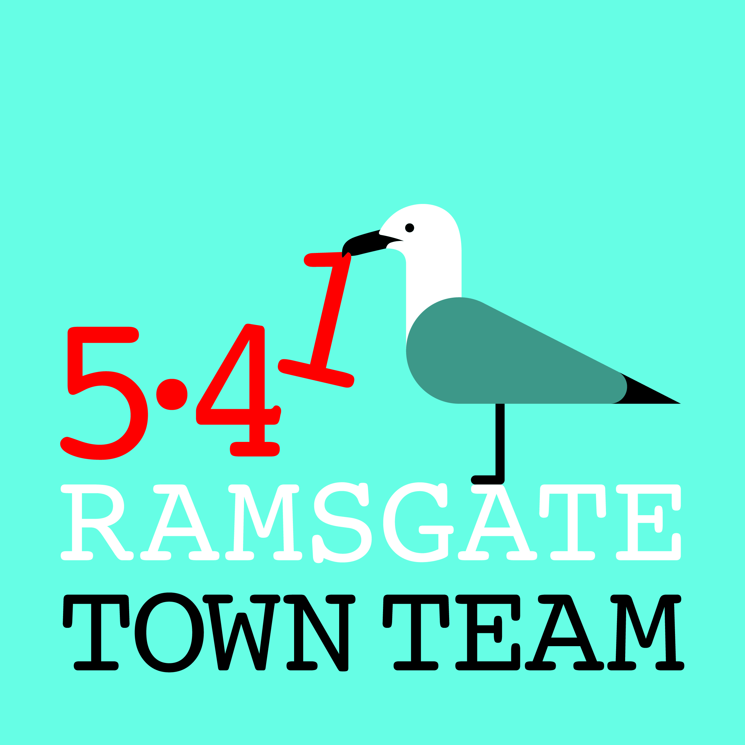
Committee Meeting, Thursday 13th September 2018
- Apologies for absence: Maria Gavin, Madeline Wright, Richard Styles

2) Minutes of the last meeting held on 26th July 2018: Accepted as correct record

- Matters arising:
- DBS checks: Most people had theirs back; Jo & Rebekah still waiting. Emma from Volunteer Bureau says they have arrived unusually promptly!
- East Cliff Fountain: Work still seems to be going on with East Kent College but unsure when it is expected to be finished.
Action: Rebekah to get in touch with Andy from FORS to get an update.
- Christmas: RTC staff setting up festoon lights in town centre. We need bigger trees and brighter lights (100 per tree) for Harbour St holders. Becky Wing suggests making Christmas trees with rubbish to install around town.
Action: Events Group to continue working on this and report back. Rebekah to check if Christmas tree lights can be plugged in this year.

- Feedback from events & activities since last meeting:
- Kite Surfing Championships: All went very well but Active Ramsgate had to organise much of it. Taster sessions very popular. Hoping to host it again next year but RTC will not be able to give as much sponsorship as this year. Beach Club idea worth reviving: Rebekah has evidence that £25k funding is left at TDC for this & has some prices from container companies. Paula Harbidge at Thanet Tourism is keen. Toby at Harbour Bikes suggests there may be grants available to extend the walkway along to Broadstairs.
Action: Rebekah to follow these up and report back.

- Regular Updates:
- Station: Some minor vandalism to plants but generally OK. Sue regularly replenishing leaflets and Maggie from Information Centre now being very helpful. Chris Barton from RTC will repair leaflet holder within next week.
- Litter & waste:
  - No Ifs, No Butts campaign: Funding refused by RTC on basis that public money should not ‘subsidise’ private business. Tricia & Rebekah seeing Phil Thorley from Thorley Taverns on 18th September & will report back.
  - Litter Forum applying to Litter Innovation Fund for Adopt A Street. Action: Tricia to send round minutes of Litter Forum meeting 110918.
  - Commercial waste: Pat reported that situation has improved.
  - Ramsgate Society cleanup: Another seafront cleanup is planned on Sunday 14th October 10-1: meet at Clock House at 10 am.
- Harbour Street:
  - Sign improving safety, but bollard still not sorted out: KCC objecting on safety grounds and asking for consultation in town centre.
  - Ozzy’s: Freeholder is Emily Ann Kemekki of Margate (2 addresses: one on Companies House & one on electoral roll; not listed in phone book.) Action: Tricia/Rebekah to write offering support for improvements.
- Wayfinding: Progress still very slow, but Jacob Amuli has now approved sign at station as long as Network Rail approve.
- Charitable Status: Just had notification that our application has been turned down. James at Funding for All mystified as he used same wording that was approved for another Town Team. He advises us to appeal – but CC’s objections to our activities seem extensive, so we need to take time to think this through. Action: Tricia to forward letter and all to discuss on FB: decision on whether to do so to be made before October public meeting.
- Consultations for possible TT response:
- Manston DCO: Agreed to discuss on FB whether TT should respond on this.
- Kent County Council waste sites: KCC proposes to levy additional charges for ‘non-household’ waste, which may increase fly-tipping. Action: Tricia to draft response on behalf of TT
- Ramsgate Port TDC petition: Ramsgate Action Group’s concerns discussed. Action: All to sign petition (NB needs to be on paper copy – see Tricia)
- Local Plan: Agreed we should respond on this highlighting Ramsgate’s potential Action: Tricia to draft response using Richard’s comments to RTC as basis and circulate for comments & improvements

7) October Members’ Meeting arrangements: As next proposed meeting date clashes with TDC meeting where questions on port will be raised, agreed to move our meeting back so Committee and ordinary members can attend TDC as observers if they wish.
- Action: Tricia to canvass for new date via Facebook page

8) Plans for future events: Christmas Lights Switch-On, Sunday 25th November:
Action: All Committee members to save date & be available to help if possible.

- Any Other Business:
- Fundraising: Charity Commission refusal means we need to think differently in short term about funding. Agreed to start applying for small-scale funding – eg Lottery tickets are raising approx £10 every 4 weeks at present - & investigate larger funds.
Action: Tricia & Rebekah to investigate options/ apply for supermarket bag funds.
Creative Civic Voice Fund: Might have been possible source of funding for TT but Addington St group have been in touch asking for our support for their bid.
Action: Rebekah to respond in support of Addington St group.
- Ramsgate Ruta Tapa proposal: Possible new initiative involving eateries to draw in more visitors, similar to idea proposed by Lucia Xavier at our last AGM
Action: Tricia to forward information; Rebekah to follow up with planning group

