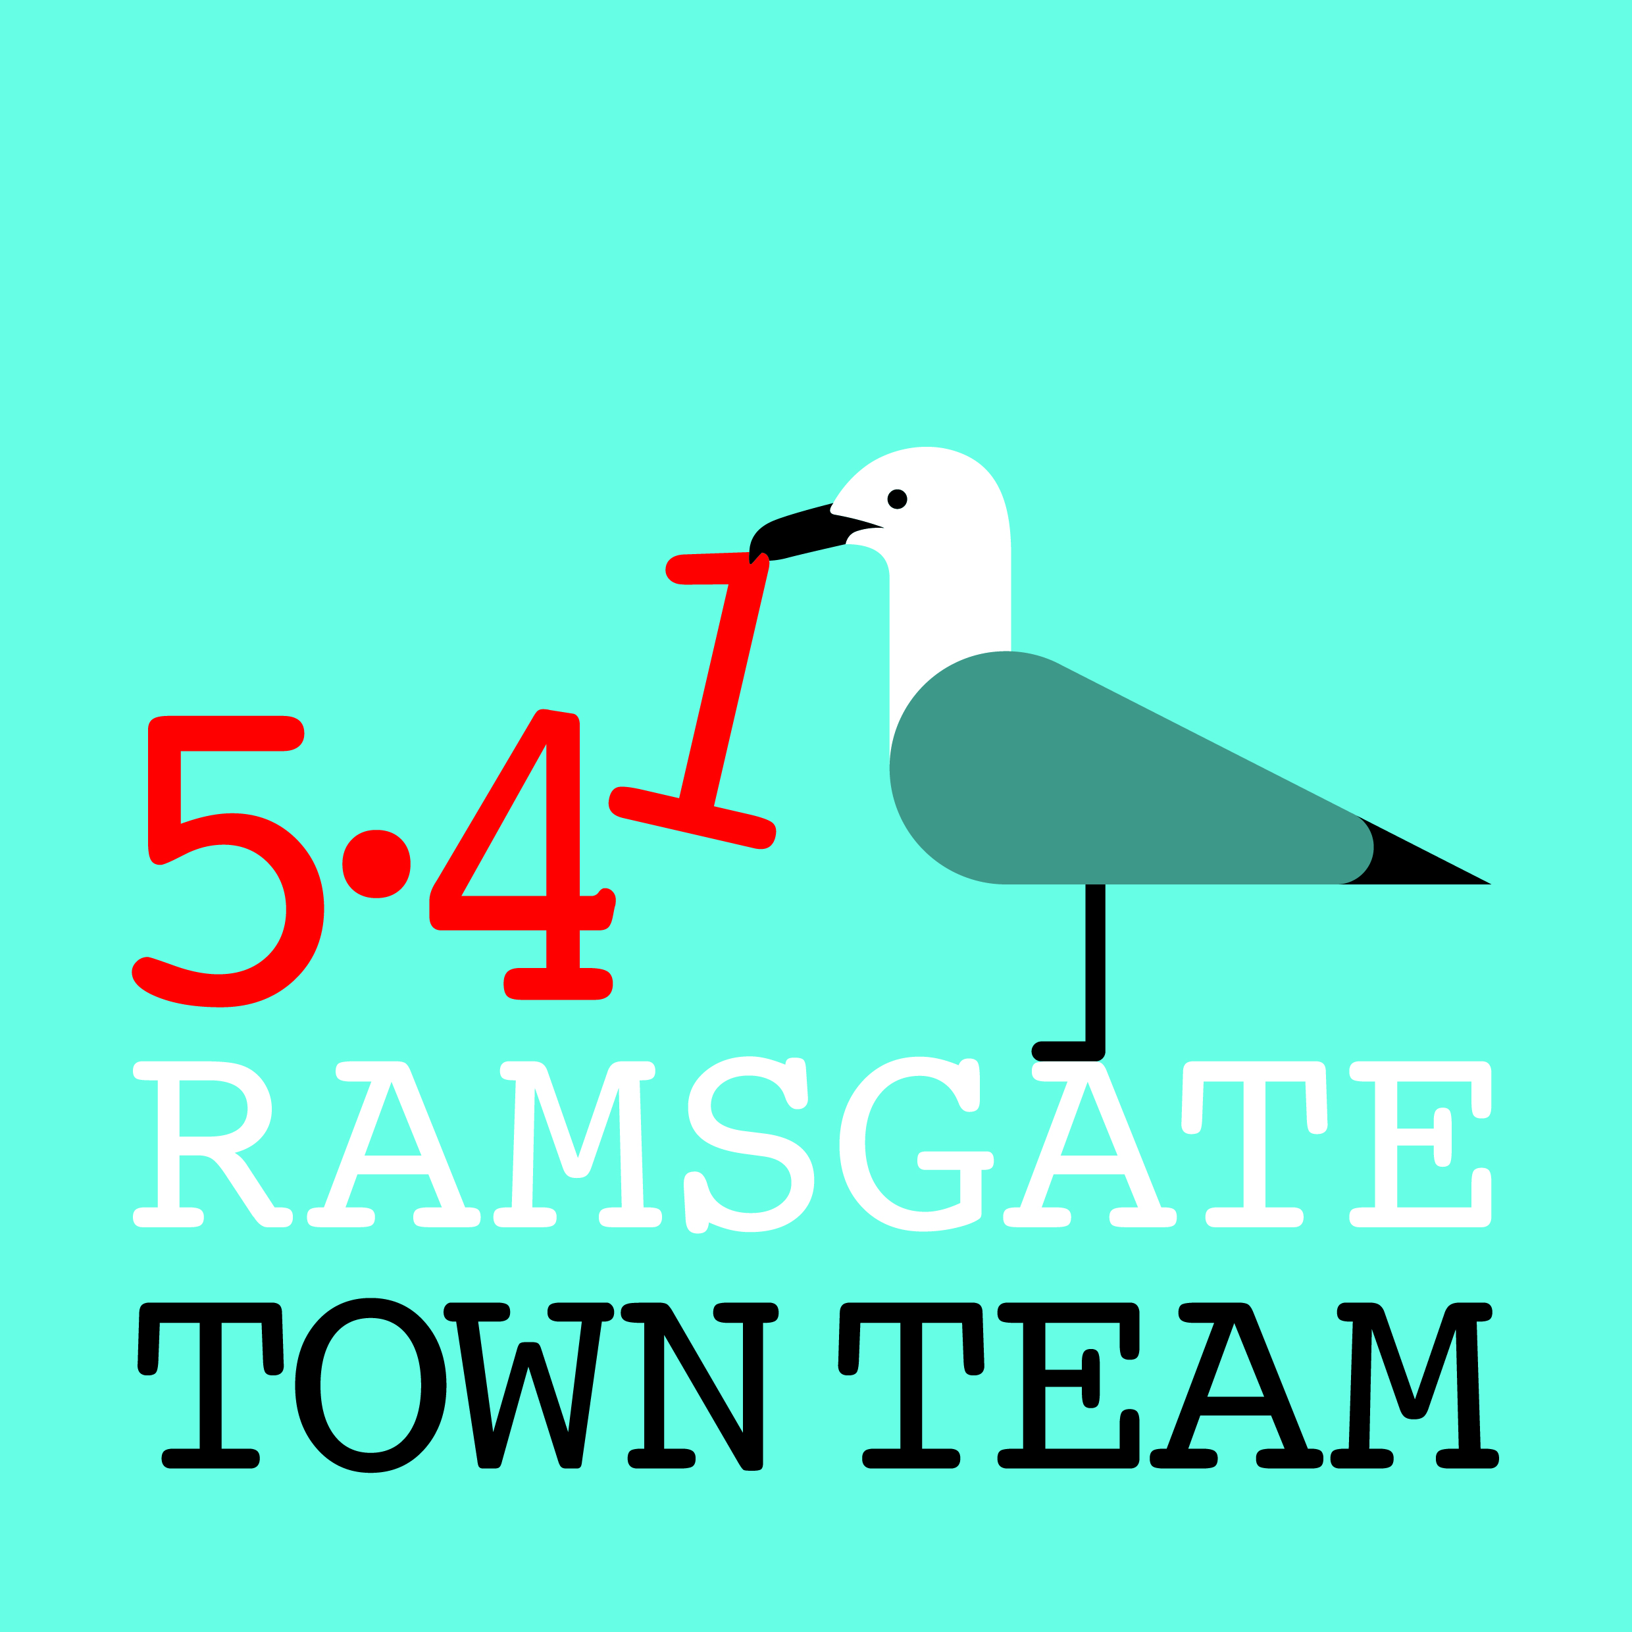 Town Team Committee Meeting 12th April 2018
MINUTES
- Present: Rebekah Smith (Chair), Maria Gavin, Jo Hanchett, Sue Hall, Richard Styles, Pat Makinson, Tricia Austin Hartley (Minutes)

- Apologies: Madeline Wright

- Minutes from March Committee meeting/ AGM: Accepted as correct record

- Matters arising:
- Harbour St:
- Bollard: Most traders have said they support having an automated bollard. Richard is sending out a SurveyMonkey questionnaire as part of negotiation with KCC. Paul Messenger & Karen Constantine are contributing & RTC is paying the rest.
Action: Richard to progress this asap & get agenda slot on next Joint Transport Board meeting.
- Taxi office: TDC’s planning decision was overturned by Sec of State. Landlord has now submitted plans for flats above & basement consulting rooms. RTC Planning Committee supports flats & basement use but has objected to label of ‘Taxi Office’ for phone-based private hire facility and to inclusion of waiting room.
- Planting: Planters being installed outside businesses next week. Other planting plans may need support from TT funds (see later on agenda).
- Wayfinding:
- Progress happening but very slow: waiting for TDC response. Rebekah in contact with businesses in Arches re ladder signage for them.

- Shopfront grants:
- No further applications received. Need to progress work on Ozzy’s as soon as weather improves. (Rebekah & Tricia have had lengthy correspondence recently with Ben Morton on this.)
Action: Rebekah to contact Ozzy asap to discuss.

- Evaluation of Easter events:
- Events were very successful: over 100 kids involved in various ways & 52 people joined parade. Need to start earlier next year as kids didn’t get around all the shops. Madeline was off sick but AiR team were amazing!
- Particular thanks to Sue & Rob who worked on our tent all day & Jo who was there most of day. Sue has bunting etc donated for tent next year.
- Would like more people in next parade (this summer). Music also needed next time – jazz band? Sea Scouts?
- Want to reach hard-to-reach people more next time round eg through rubbish monster plans. RTC have provided just under £4k events funding for this: 4 seasonal parades to bring community of Ramsgate together. Very supportive comments re this project at RTC Committee meeting.

- Funding:
- Meeting with Madeline Homer: Rebekah & Tricia saw MH to follow up TDC’s failure to back our Place Based Social Action Lottery EOI. MH apologised and outlined improved TDC system for supporting community bids via Funding Officer Clive Bowen. CB will send us criteria for assessing bids for TDC support which we can share.
- Thanet Community Lotto: Rebekah was tasked with doing this but easier if we leave until we have charitable status. Other organisations suggest they are not getting much out of it as yet, so not a priority.
Action: Rebekah to pursue when we hear from Charity Commission.
- Ramsgate Funding Forum: An action from previous meeting was for Richard to buy FunderFinder for us to share across Ramsgate.
Action: Richard to purchase & let Committee know when done; all then to assist in publicising its availability to community groups.

- Litter & waste management steering group:
- First meeting held 14th March with Gavin Waite, Neil Jones & Jasmin Vickers from TDC, two Ward Councillors and reps from 8 community groups in Ramsgate. Rebekah, Pat and Tricia represented TT. Meeting useful & constructive.
Action: Tricia to send meeting minutes go Committee members.
- Pat pointed out that the space at back of Argos is bad again: there is an alleyway & people flytip. Need to mention alleyways at next meeting of litter steering group.
Action: Tricia to put this on agenda of next meeting.

- Town centre work programme:
- Bollards in Queen Street: We will need a work party for this as there are 15 of them! All members and friends to be invited to take part. Date TBC once weather improves. (Possible dates to be discussed on RTT2014 group.)
- Parking: Inadequate parking for town centre flats is cause of some of the parking problems we suffer. Pat pointed out that for many years it has not been accepted good practice to refuse to provide parking spaces for town centre properties, as even people without cars want the spaces. But TDC rule is people living within 800 metres of the town centre do not qualify for parking places: can this be challenged?

- Quick updates:
- Harbour St: We have funds carried over from our bid to RTC to spend on Spring planting (hanging baskets and barrier baskets). If we ask Young to do the planting and look after the baskets over the summer period (14 weeks) it will cost more than we have so would require contribution of perhaps £400 from TT funds. Richard suggested that RTC may be able to contribute further towards these costs. Members suggested traders may also be willing to make a modest contribution. Agreed to go ahead with Youngs and discuss further the best way to cover additional costs
- Christmas trees: It was agreed we need better lights for our large and small Christmas trees for next year. Richard reported that Town Clerk at Broadstairs has offered us their old lights as they have bought new ones. Richard suggested St Lawrence and Newington should have trees.
- Richard pointed out that Ben Morton at 26 Harbour St has commercial lighting from his business so it might be possible for us to work with him to light up beautiful trees across the town – eg Queen St near Halifax, Meeting St car park. Would be worth looking at battery operated systems as mains lighting can cost up to £3k.
Action: Richard/ Rebekah to discuss and approach Ben if appropriate.
- Station: Tricia reported that a few plants from the station displays have been stolen. Members approved purchasing replacements from Youngs.
Action: Tricia to approach Youngs for replacement plants.
- CIO Application: Tricia reported that we have heard nothing further from the Charity Commission.
Action: Tricia to keep members informed.

- Committee membership:
- Fiona has not attended again & not sent apologies. Tricia to contact her inviting her to consider her position on the TT.
- Interested people: Jon Hanchett, Raushan Ara, Lucia Xavier, Becky Wing
- Response: Invite all to attend next meeting as observers inc Janice; Tricia to send forms to all and invite to come along and observe & fill in forms.

- AOB:
- Crafty Poppies: Concerns raised by Crafty Poppies group that money they raised was not paid into British Legion account by Clive (man who is running Battles for Victory event at Ellington Park.)
- Membership: Good idea to have message on our FB page encouraging people involved in community groups to join our general membership.
Action: Rebekah to post message re membership.
- Bollard painting: Need to get on with this when weather improves & invite other volunteers to join us. Dates TBC via RTT 2014/ next meeting.
- Maria: Reports from Cliffsend of people walking up & down streets with drones looking at back gardens with view to burglary: all to be aware.
- Ramsgate Recyclists: Busy Bs: recent offer of £245k for premises upped to £280k via Miles & Barr? Jo to keep members informed on this.

