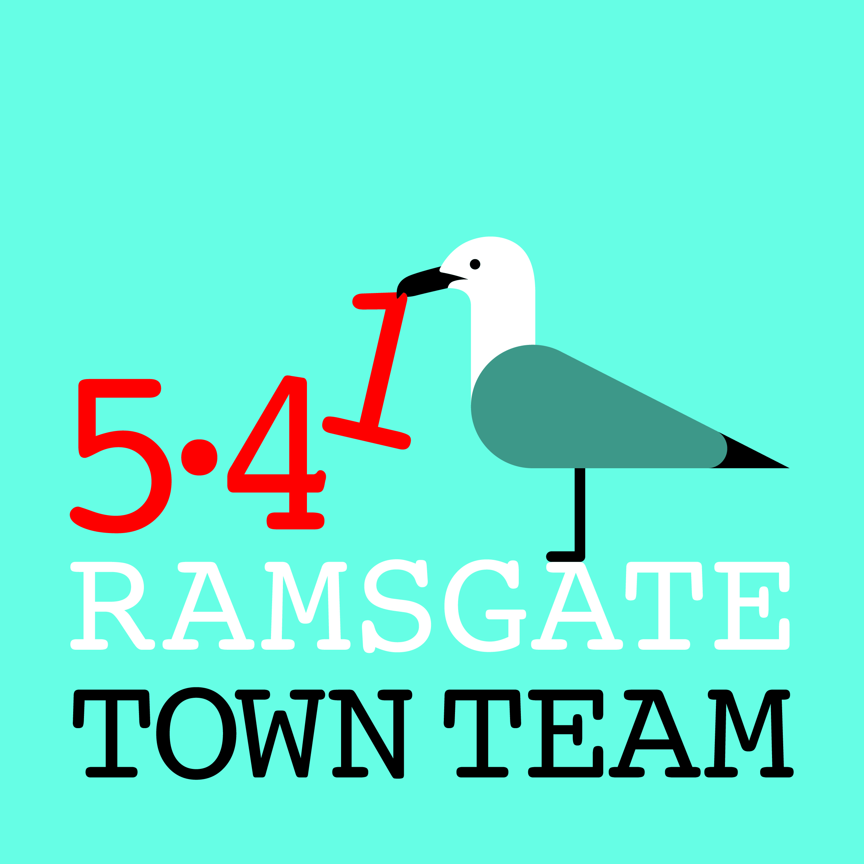
Committee Meeting, Thursday 10th May 2018
MINUTES
- Present: Jo Hanchett (Chair until 6.20 pm), Sue Hall, Madeline Wright, Pat Makinson, Tricia Hartley (Minutes), Rebekah Smith (Chair from 6.20 pm)
In attendance: Keith Makinson (guest), Raushan Ara (observer), Janice Gibbs (observer)
Apologies for absence: Maria Gavin, Richard Styles, Becky Wing (will observe at future meeting)

- Minutes of the last meeting held on 12th April 2018:
- Approved as correct record

- Matters arising:
- Pat reported that the space at back of Argos has finally been cleared.
- Shopfront grants: The Committee agreed that that no further shopfront grants will be issued, except Harbour Fish Bar, for which we have already set money aside. If something exceptional comes up we will consider it on its merits.

- Harbour Street:
Harbour Fish Bar: Keith Makinson talked members through his sketch for possible refurbishment of the Harbour Fish Bar. His comments included:
- Ideally modern deep fascia should be removed and old fascia shape restored.
- A mural/ trompe-l’oeil painting on blank front wall could be effective.
- Steps to flat at side of shop look hazardous: do they comply with planning?
- Dustbin by steps must detract from trade: can it be hidden? Rebekah suggested new Ramsgate lengthsman and 2 apprentices should be able to make enclosure for bin.
- Pavement needs visit from deep cleaning machine & should then be cleaned daily.
- Sliding folding doors to open up frontage (as at Peter’s Fish Factory) could work.
- Some work also needed inside: black & white tiles on counter need replacing; false ceiling should also be removed and replaced.
- Raushan pointed out that Ozzy does not own building but is leaseholder; current manager Mehmet is sub-letting from Ozzy.
Keith was thanked for his helpful contribution and will be kept informed re progress.

Pedestrianisation: Bollard is now on agenda for next Joint Transport Board meeting in June. Most traders approve, but Taylor Meats objecting.
- Pat pointed out that many drivers do not believe restrictions apply on Sundays.
- Madeline suggested putting planters or A frame signs down middle of road to discourage people from driving down, as happens in many other places; Rebekah was concerned as might impede emergency access.
- Some enforcement is now happening re parking.

Planting: 8 planters now out in street. Some other traders would like them but we would need new source, as Kevin Cromeeke has no time to make more.
- 18 hanging baskets now ordered but Christmas tree holders need modifying for them. Rebekah is in touch with Hellings Fabrications about this.
Action: Rebekah to liaise with Hellings, action this and report back.
- Richard has suggested RTC may be able to help with additional costs of planting.
Action: Tricia to liaise with Richard re possible further RTC contribution to costs.

Other initiatives: Madeline reported that there is now Facebook page for Harbour St traders and communication improving, so should be easier to get initiatives going.
- Rebekah pointed out that installing bunting for summer has been discussed, but traders need to do this as Town Team has already funded other initiatives. Town Council is looking to buy cherry picker which would reduce cost of installation.
Action: Sue and Madeline to liaise re plans and costs for bunting.

- Ramsgate ROAD/ litter & waste management
Waste Management Group: Joint community/ TDC group held its second meeting on Tuesday 8th May with 2 TDC officers and Rosanna Taylor-Smith (new Cabinet member for Operational Services) in attendance.
- Plans under way to do targeted clean-ups (see below), pilot Adopt A Street scheme and improve provision of public bins, including possible business sponsorship.
- Jo pointed out that many traders bought bins previously but had them taken away by TDC, so may be reluctant to get involved in bin sponsorship scheme!

Spring Clean Month: Following success of Ramsgate Society cleanup on Sunday 6th May with 50 people litter picking along front, May has been designated Spring Clean Month.
- Addington St group are doing Vale Square & surrounding area (dates TBC)
- Newington Cllrs with primary school & community centre are doing alleyway by school & area around school & community centre on Saturday 26th May 10-12
- TT will do Belle Alliance Sq, Camden Road etc on Monday 28th May 11-1.
Action: Rebekah & Tricia to liaise re promoting on FB & putting up notices beforehand.

- Work with Community Payback
- Jo reported back on her meeting with Ian Craig, organiser of Community Payback scheme. They are keen to help with graffiti removal, but if this is on private property TT would need to get written permission from house owners beforehand.
- We would also need to provide paint, rollers & dust sheets as required. Rebekah suggested planned replacement container in Albion Gardens could store these.
- Ian would want to use our public liability insurance: could this be a problem?
Action: Rebekah & Jo to liaise with Ian on this.
- Jo reported that there is a graffiti removal machine at Manston Depot which is reputed to be standing idle as no-one is trained to use it!
Action: Jo & Rebekah to liaise with Richard to find out situation with machine & whether RTC ground staff and/ or Community Payback could be so trained.
- Community Payback could also help with painting bollards, painting wall by lift with anti-graffiti paint, using wipes to clean bins, cleaning & repainting electric boxes etc (NB We may need to do this last ourselves as we are unlikely to get permission.)
Action: Rebekah to check re insurance; Jo to pick up graffiti wipes from Rebekah.
Action: Rebekah & Tricia to liaise re buying more hi viz jackets.

- Updates:
Wayfinding: Tricia reported back from Coastal Communities Team meeting where she asked why Wayfinding had moved from the TT to the CCT as fits better with TT. This was explained as result of previous CCF bid having included wayfinding. Tricia had suggested revisiting this after current round of signage finalised: CCT agreed.
- Tricia read out Richard’s written update on wayfinding to the meeting: “The various designs and drawings for the overall planning permission have been completed and the overall scheme will be sent to TDC very soon. The hold up about sign No 1 at the station has been resolved by applying for and getting listed consent for the sign. I will have to run the sign applications past the Council before entering them under the RTC banner. If businesses want to sponsor a sign in a certain location, it can be done as a subsidiary application to the original scheme.”
- Rebekah reported she had talked to Harbour Arches businesses re ladder signage, but this is expensive (c. £5k: £220 each if everyone signs up) & may be unaffordable for some. RTC have provisionally agreed to pay for planning permission.

Ramsgate Station: Sue, Jo and Tricia did a Sunday morning recently to put the remaining plants in the planters. They are looking good, though still getting full of cigarette ends & chewing gum!
- Sue has offered to collect rainbow maps from the VIC to replenish the leaflet display

Events: Raushan pointed out that many events are happening on seafront: would be good to have things happening in the town too over summer/ on Bank Holidays.
- Pat pointed out market brings people into town on Fridays & Saturdays. Food fair & French market worked well in past. Jo suggested Morris dancers next May Day.
- Madeline suggested we need a strategy for events, working together with other groups and looking at what’s already happening. Events subcommittee needed to work out what can realistically be done & share responsibility with partners.
- Madeline, Sue, Raushan and possibly Jo/ Pat volunteered to be on subcommittee. Action: Madeline & Raushan to gather Harbour St traders to help with organising.

Ramsgate Recyclists / Funding Forum/ Coastal Communities Team: Rebekah & Tricia put forward proposal to CCT to bid for refurb of 3 or 4 key town centre buildings for community use: Busy B’s for Ramsgate Recyclists, Schoolwear Centre for business centre as per Richard’s previous proposal, Jazz Rooms for studio space & café and Poundland for pop-up shop/ community use. Tricia offered to write bid. Didn’t go any further as project was not ‘shovel-ready’ & very little time left before deadline.
- Nick Dermott from TDC then put forward 11th-hour proposal to turn Smack Boys building into hotel. Project was no more shovel-ready than the TT’s but came from TDC so could be progressed much more quickly!
- These discussions led to agreement that CCT would revert to its original Terms of Reference and become broader forum for organisations seeking major funding.
- TT still has Ramsgate Funding Forum FB page ready to go – just needs activating. Several interesting opportunities coming up so now could be good time to do this.
Action: Tricia/ Rebekah to liaise and activate the FB page.

Charitable Status: Still nothing back from the Charity Commission although we have passed the 8 weeks they used to allow for processing applications.
Action: Tricia to chase this via Funding for All.

- Membership/ GDPR: We need to contact all ordinary members to get their permission to continue contacting them occasionally. Various forms of words are available so this should be fairly straightforward. Jo pointed out that we also need to check whether we need to register with the Information Commissioner’s Office: this costs £35.
Action: Tricia to check out ICO registration and liaise with Maria re contacting members.

- Date for bollard painting: Postponed to June as May is busy with litter picking! Possible dates to be discussed by email/ social media.

- Any Other Business:
- Rebekah mentioned that we need to replace pictures on Rainbow Steps which have been badly defaced: cost will be approx. £25 each. Committee members approved this expenditure.
- Sue reminded members that we also need to refurbish, remove or replace the bee pictures on the High St hoardings. Agreed to discuss this at next meeting.
- Tricia read out additional notes sent by Richard, who was unable to attend:
  - Floral improvements: the palms will be placed out in to the streets in a couple of weeks. It may be possible for businesses to sponsor a palm for a year in future or perhaps add a memorial plaque for a limited period, but the scheme has yet to be thought out and assessed.
  - The RTC ground team has been out and about, but if there any areas that need tidying, please let us know and we will take a look.
- Margarita Moscoso had asked if the TT would help her new Albion Gardens regeneration group rebuild damaged historic wall into gardens opposite top of Abbotts Hill. Members agreed this should be done without delay.
- Tricia reminded members that we planned to add decorative urns to top and bottom of balustrade leading from this wall down to the corner of Harbour St, so work might perhaps all be done at same time – possibly by Parish lengthsman & apprentices?
Action: Tricia to speak with Richard about this work.

