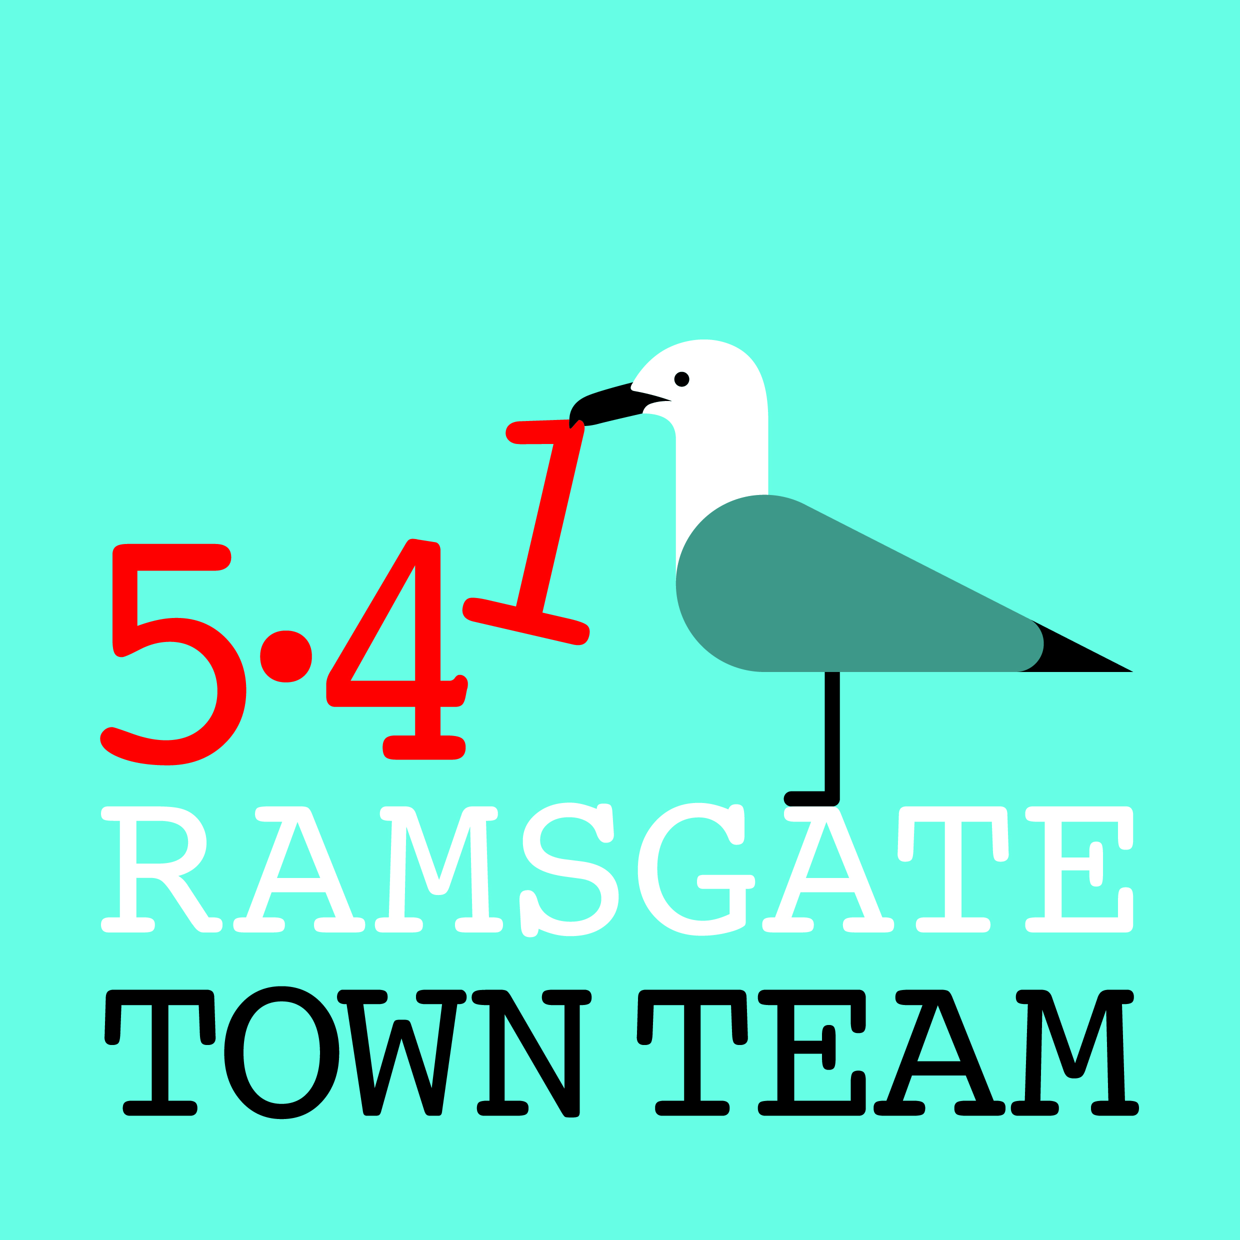 Committee Meeting, Thursday 10th January 2019
MINUTES
Venue: Custom House, Harbour Parade, Ramsgate Time: 6-8pm
- Apologies: Richard Styles, Maria Gavin
Present: Rebekah Smith (Chair), Pat Makinson, Jo Hanchett, Madeline Wright, Tricia Hartley (Minutes); Chris Barton, Cllr Peter Campbell (Observers)

- Minutes of last meeting held on Thurs 18th October 2018: Accepted as correct record

- Matters arising: None not on agenda

- Review of Christmas events & arrangements: Christmas switch-on event went v well. Popularity of Santa again caused long wait times; 26 Harbour St was good venue for this but unsure what will happen next year. Helterskelter popular; popcorn & candyfloss made most money. Elves’ workshops went well. Snow machine worked better this year. Finance: Budgeted for £4.5k but came to under £3k in end: good value.

Lantern Parade from AiR was great success: around 200 people participated

- Wayfinding update: Finally we have monoliths around town! Considered possibility of using teal colour from monoliths to link some features in town in future. Rebekah also trying to get ladder sign for Ramsgate arches but these are expensive.

Final monolith outside station is waiting to be installed: SE v slow as need permission from Network Rail, insurance etc, but progress in last week. Will be installed in next 3 weeks along with finger posts. Funding: £12.5k from RTC, £17.5k from Town Team (£5k secured from KCC), £25k from TDC via Destination Management Plan

As previously agreed, responsibility for Wayfinding will now return to TT from CCT.
Action: Tricia & Rebekah to confirm this at next CCT meeting.

- Pugin tiles project: New project: young people from sec schools to design tiles working with 2 local ceramicists (Viv Yankah & Nigel Cunningham) & fix onto risers of Kent Place Steps. Pugin Society keen to include this in Pugin Trail; KCC Conservation Officer & Father Simon at St Augustine’s supportive.

Rebekah pitched project to Historic England who awarded us £3k; if RTC agree to install & share maintenance there should be no other costs. 34 steps; each will require at least 12 tiles: risers all different heights so will be complex. Hope to start in next 3 months.
Action: Rebekah to discuss with Richard re RTC staff installing tiles

Sustainability for project important. Possible rolling programme at Visitor Centre showing designs discussed - could move on to prints, fabrics etc.
Action: All to think about possibilities for future work & feed back to Rebekah.

- Funding & finance: Once Wayfinding signage paid for, bank balance will be about £12-13k, so new funding sources needed.
- 5.41: Ready to launch scheme now: discussed how best to do this.
Action: Tricia & Rebekah to write articles for Kathy Bailes, Ramsgate Recorder, Community Ad magazine; Tricia to send out to all members & supporters. Agreed to take out Ramsgate Rocks ad (half page ad £68; full page £120).
- Sources of funding: Rebekah & Tricia to look at grants (Reaching Communities etc.) Important to show groups working together: our Funding Forum encourages this. (NB Several new members joined after mention at Fire Station meeting.)
- Coastal Communities Team: Terms of Reference suggest it should be more inclusive: can offer opportunities to engage people/ groups.
Action: Rebekah & Tricia to continue to encourage this at CCT
- Thanet Lottery: Only sold 5 tickets so far, but this brings in £130 a year. (I person recently won £25 but donated their winnings to the TT!)
Action: TT to continue to promote Lottery support when opportunities arise.

- Other updates on RTT activities:
- Ramsgate Station: Christmas tree looked good & helped build partnership. Planters still attracting rubbish in gaps. Chris offered spare plants from Madeira Walk.
Action: Tricia & Chris to liaise re planting these
Putting a piano in the station (as in London stations) suggested.
Action: Tricia to suggest this to station manager/ SE Trains contacts
- Harbour Street/ town centre:
Antisocial behaviour again a problem in Harbour St; Karen Constantine arranging meeting this week. Chris pointed out that Daily Grind should have toughened glass Action: Chris to raise as health & safety concern via RTC
Christmas trees now down & in storage; waiting for Lumalight to come for motifs, then hanging basket brackets going along Harbour St.

Rising bollard: street survey contractors want 1 camera to see Harbour, High & Queen St traffic. Richard liaising. Madeline offered a week’s footage from AiR. Hoping survey will highlight problems re night-time parking & heavy evening/ night-time traffic with potential to damage paving/ drains (eg Poundland)
Action: Rebekah to liaise with Richard & Madeline to assist survey contractors asap
High Streets Fund/ Task Force: New DCLG fund with £650 m for large grants: potential to apply for Corridor of Hope proposal turned down by Ramsgate CCT – eg old Poundland building; potential for recording studios, business space, repair cafe Actions: 1) Rebekah/ Tricia to have closer look at funding & examine creating Task Force. 2) Rebekah to send link re old Poundland building.
- Litter Forum: Next meeting Weds 16th Jan
No Ifs, No Butts: Stickers now arrived & will be distributed to pubs, cafes & betting shops that agree to participate. £300 sponsorship offered by Thorley Taverns.
Action: All to make contact with local cafes & pubs that may wish to join scheme.
Adopt A Street: Andy King working on beta version of website. Articles written for Community Ad Mag etc to encourage people to volunteer as Street Reps
Big Spring Clean: Keep Britain Tidy’s national Spring Clean runs from 22nd March to 23rd April & Litter Forum plans series of events around Ramsgate, including tackling known ‘grotspots’ and running at least 1 cleanup in each Council ward.
Action: All to suggest places needing attention & put Tricia in touch with local groups

- Date & arrangements for AGM: Next meeting Feb (14th or 21st TBC); AGM 14th March
Action: Tricia to check rooms for 21st Feb & send out AGM invite to members

- Any Other Business:
- Fire Station meeting: Well attended. Residents’ meeting would also be useful: discussed how we can engage people who aren’t part of established groups to gather their views. Ageless Thanet have done well engaging men – how?
- Rainbow Steps: 5 years since artwork done with schools so needs renewing. All 9 Ramsgate infant & junior schools want to join new project. Rebekah has secured York St Gallery on 3rd April to exhibit original works. Artwork to be up in April & railings painted in May. Hope to do Rainbow Parade linked to this.
- Van Gogh: Potential to make more of his short stay in town: bust going up in Spencer Square; links established with VG museums in rest of Europe. Possibilities discussed: now copyright on his letters so could we create booklet? Could children recreate his drawings? Could we work with International Film Festival to make short film? Possibility of Van Gogh trail with hotspot points along route etc. Madeline suggested VG project to decorate alleyway from Harbour St through to Charlotte Court.
Action: All to feed ideas through to Rebekah.

