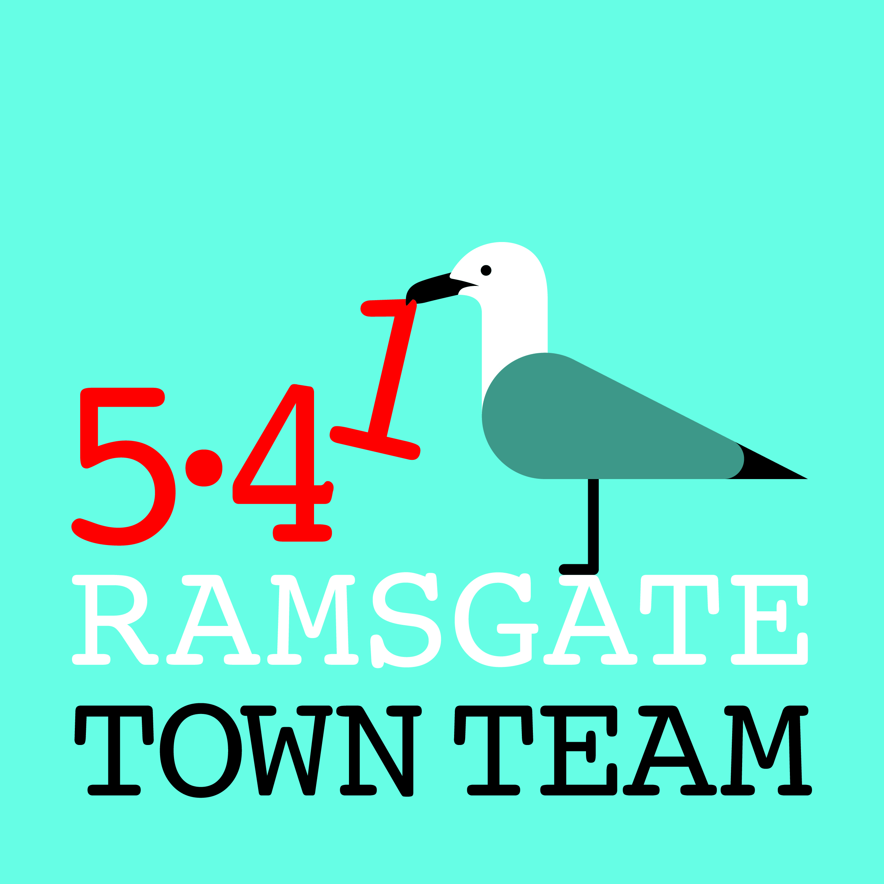

Minutes of Ramsgate Town Team AGM held 8th March 2018

Present: Rebekah Smith (Chair), Maria Gavin (Treasurer), Clive Gavin, Mark Pawlowicz, John Davis, Richard Styles, Raushan Ara, Madeline Wright, Tony Uden, Pat Makinson, Jo Hanchett (Vice Chair), Lucia Xavier, Tricia Austin Hartley (Secretary)

Apologies: Sue Hall, Brian Whitehead, Sandra Ferguson, Becky Wing, Jo Rymill

1. Introductions: Rebekah welcomed everyone; a round of introductions followed.

2. Annual Report 2017-18: Rebekah explained that Town Teams were set up in 2014 to help revive coastal towns. Our mission is to help make Ramsgate a great place to live, work and visit. The Annual Report outlines the past year's activities.

1. Harbour St: We have worked hard in Harbour St, with mixed success. We have improved railings, bollards and signage; more shops are occupied and several shopfronts improved; the stop sign is working and people are enjoying the traffic-free street. However, empty, semi-derelict buildings remain; installing a moveable bollard is taking far too long; night-time disruption continues sporadically.

Richard commented that Harbour St is perhaps the most important road in the town but also the most run-down. The town centre traffic system is not fit for purpose and regularly abused. RTC would like to take over management of the town centre, streetscape etc from the two principal Councils. They would also like to acquire some of the larger buildings to break down into smaller units, as large buildings with high rents are hard to fill. Raushan suggested we should be giving small businesses incentives to come to Ramsgate, as our high rents and rates are off-putting.

Pat asked when these changes might happen. Richard said RTC was working on this but it needed a change of mindset in the other Councils. Tricia suggested budget pressures might motivate them to pass some responsibilities to Town Councils soon.

Lucia stated that we have only 13 parking enforcers for the whole of Thanet, who rarely seem to visit Ramsgate. We also do not seem to see the FIDO and Thresher cleaning vehicles very often. Richard pointed out that RTC has a deep cleaner, part-owned by the Town Team, and suggestions of where it is needed are welcome.

2. Station: The Town Team has worked with SouthEastern to undertake planting at the station as part of the overall refurbishment programme. A leaflet display holder has been installed in the booking hall and a direction-finding monolith is planned.
3. Ramsgate ROAD (Ramsgate Residents One A Day): This scheme was set up in September and has proved popular, with nearly 400 people now signed up. This has led to other work on litter and waste, and a meeting with TDC is planned next week.

4. Wayfinding: Rebekah reported that a specialist company will install new signs to mark the route from the station to the town centre and to highlight places of interest. Richard confirmed that this will include signs on the front and both cliffs; it will replace all old signage and can be added to in future. Jo asked about planning permission costs: Richard confirmed that RTC has to pay, but receives 50% discount.

5. Events Working Group: Rebekah outlined the success of the Christmas lantern parades and explained that as yet only certain families are engaging with these, so the Town Team's plan is to expand this in future by working with schools, youth clubs & community centres, so that a wider range of people are involved. (A funding application to RTC has been submitted and will be considered on 28th March).

6. Shopfront Grants: This has been highly successful and over 15 businesses have benefited so far. The £10k funding originally allocated has now been spent, but the Town Team is committed to working with the Harbour Fish Bar to improve its appearance as part of the gateway to the town. After this is complete, the Committee will decide whether to continue giving grants, which would have to take place under separate funding in future if the TT becomes a charity.

7. Partnership Work: Rebekah pointed out that the TT tries to help link up groups working for the good of Ramsgate. Tricia gave the example of the TT's new Funding Forum, which aims to help groups know about funding opportunities and encourages them to collaborate in bidding for funds. Richard expressed appreciation for Rebekah's efforts in bringing businesses together through the Small Business Group, and the Town Team's role in acting as a conduit to the Town Council.

Jo congratulated RTC on its efforts with the Madeira Crescent waterfall and lighting, which look great. Richard said RTC would like to be able to do more. He had recently visited Frome, where the Town Council operates differently, with no party politics. He felt there was potential for Ramsgate to operate more like this.

2. Application for charitable status: Rebekah confirmed that our application had been submitted and we expect to hear back in about 6 weeks. She explained that our main reason for wishing to become a charity is to be able to apply for a wider range of funding. Members will be kept informed.

3. Membership/ Election of officers: Around 40 people have signed up as members of the TT, although many more are involved in ROAD and follow us on social media, so our reach is wider. Members were asked to encourage friends and neighbours to join as members, particularly if they do any sort of voluntary work in Ramsgate.

Tricia outlined the process for appointing the Committee at the AGM and office-holders (Chair etc) at the Committee meeting. She apologised for leaving Jo's role of Vice-Chair off the list. All Committee members were willing to continue and were reappointed. The Committee meets monthly and welcomes new members. Lucia and Raushan expressed interest and Tricia agreed to send them application forms.

4. Plans for 2018-19: As outlined in the Annual Report, these include:
Ramsgate Recyclists: This project would train young people to refurbish bikes, furniture & white goods for sale, using some bikes to set up a hire fleet. It would operate like Broadstairs Town Shed, with older volunteers supported by a paid manager. Partners including Royal Harbour Academy, East Kent College and Charlton Athletic want to work with us. Bringing in funding for this is a priority for 2018-19.

Town Centre: We plan to continue work to improve the streetscape in the town centre, including painting and planting. Tricia pointed out that we will be looking for volunteers soon to help us paint the 15 bollards in lower Queen Street. Lucia asked if plain black bollards were safe or whether a stripe of gold or white would help avoid accidents when visibility is poor. Rebekah agreed the TT would investigate this.

Richard pointed out that all streetlights in Ramsgate are due to be replaced with LED lights shortly. He announced that a standard type of streetlight had been agreed on, comprising lanterns with black-painted columns; all concrete other designs will be removed. RTC will contribute £7-8k. Members welcomed this development.

Pugin tiles: To enhance the Pugin links in the town, the TT hopes to involve local school students in designing Pugin-style tiles to decorate the risers on Kent Steps. Funding, perhaps from the Arts Council, will be sought for this project.

Parades/Litter & Waste Management: Plans for these had already been outlined.

5.41: The 5.41 scheme asks individuals/ businesses to commit £5.41 per month to support TT activities. Once charitable status is secured, the TT would hope to claim Gift Aid on donations and businesses could claim tax back.

Website: Rebekah explained that RTC has kindly allowed the TT a page on its website up to now, but the TT hopes to set up its own website soon as it will make it much easier to communicate with members and share information.

5. Any other business: Lucia pointed out that in Japan each town has unified theme that all businesses adopt, and asked if we something like this might work in Ramsgate. Rebekah responded that a boat theme had been tried in the past but had not been popular with traders, but might work again if done differently.

Raushan suggested action on empty buildings should be the first priority for all of us.

6. Date of next meeting: Tricia pointed out that the next formal General Meeting would be held in September, but that the TT would be in touch meanwhile to keep members informed and ask for volunteers to help with projects.

