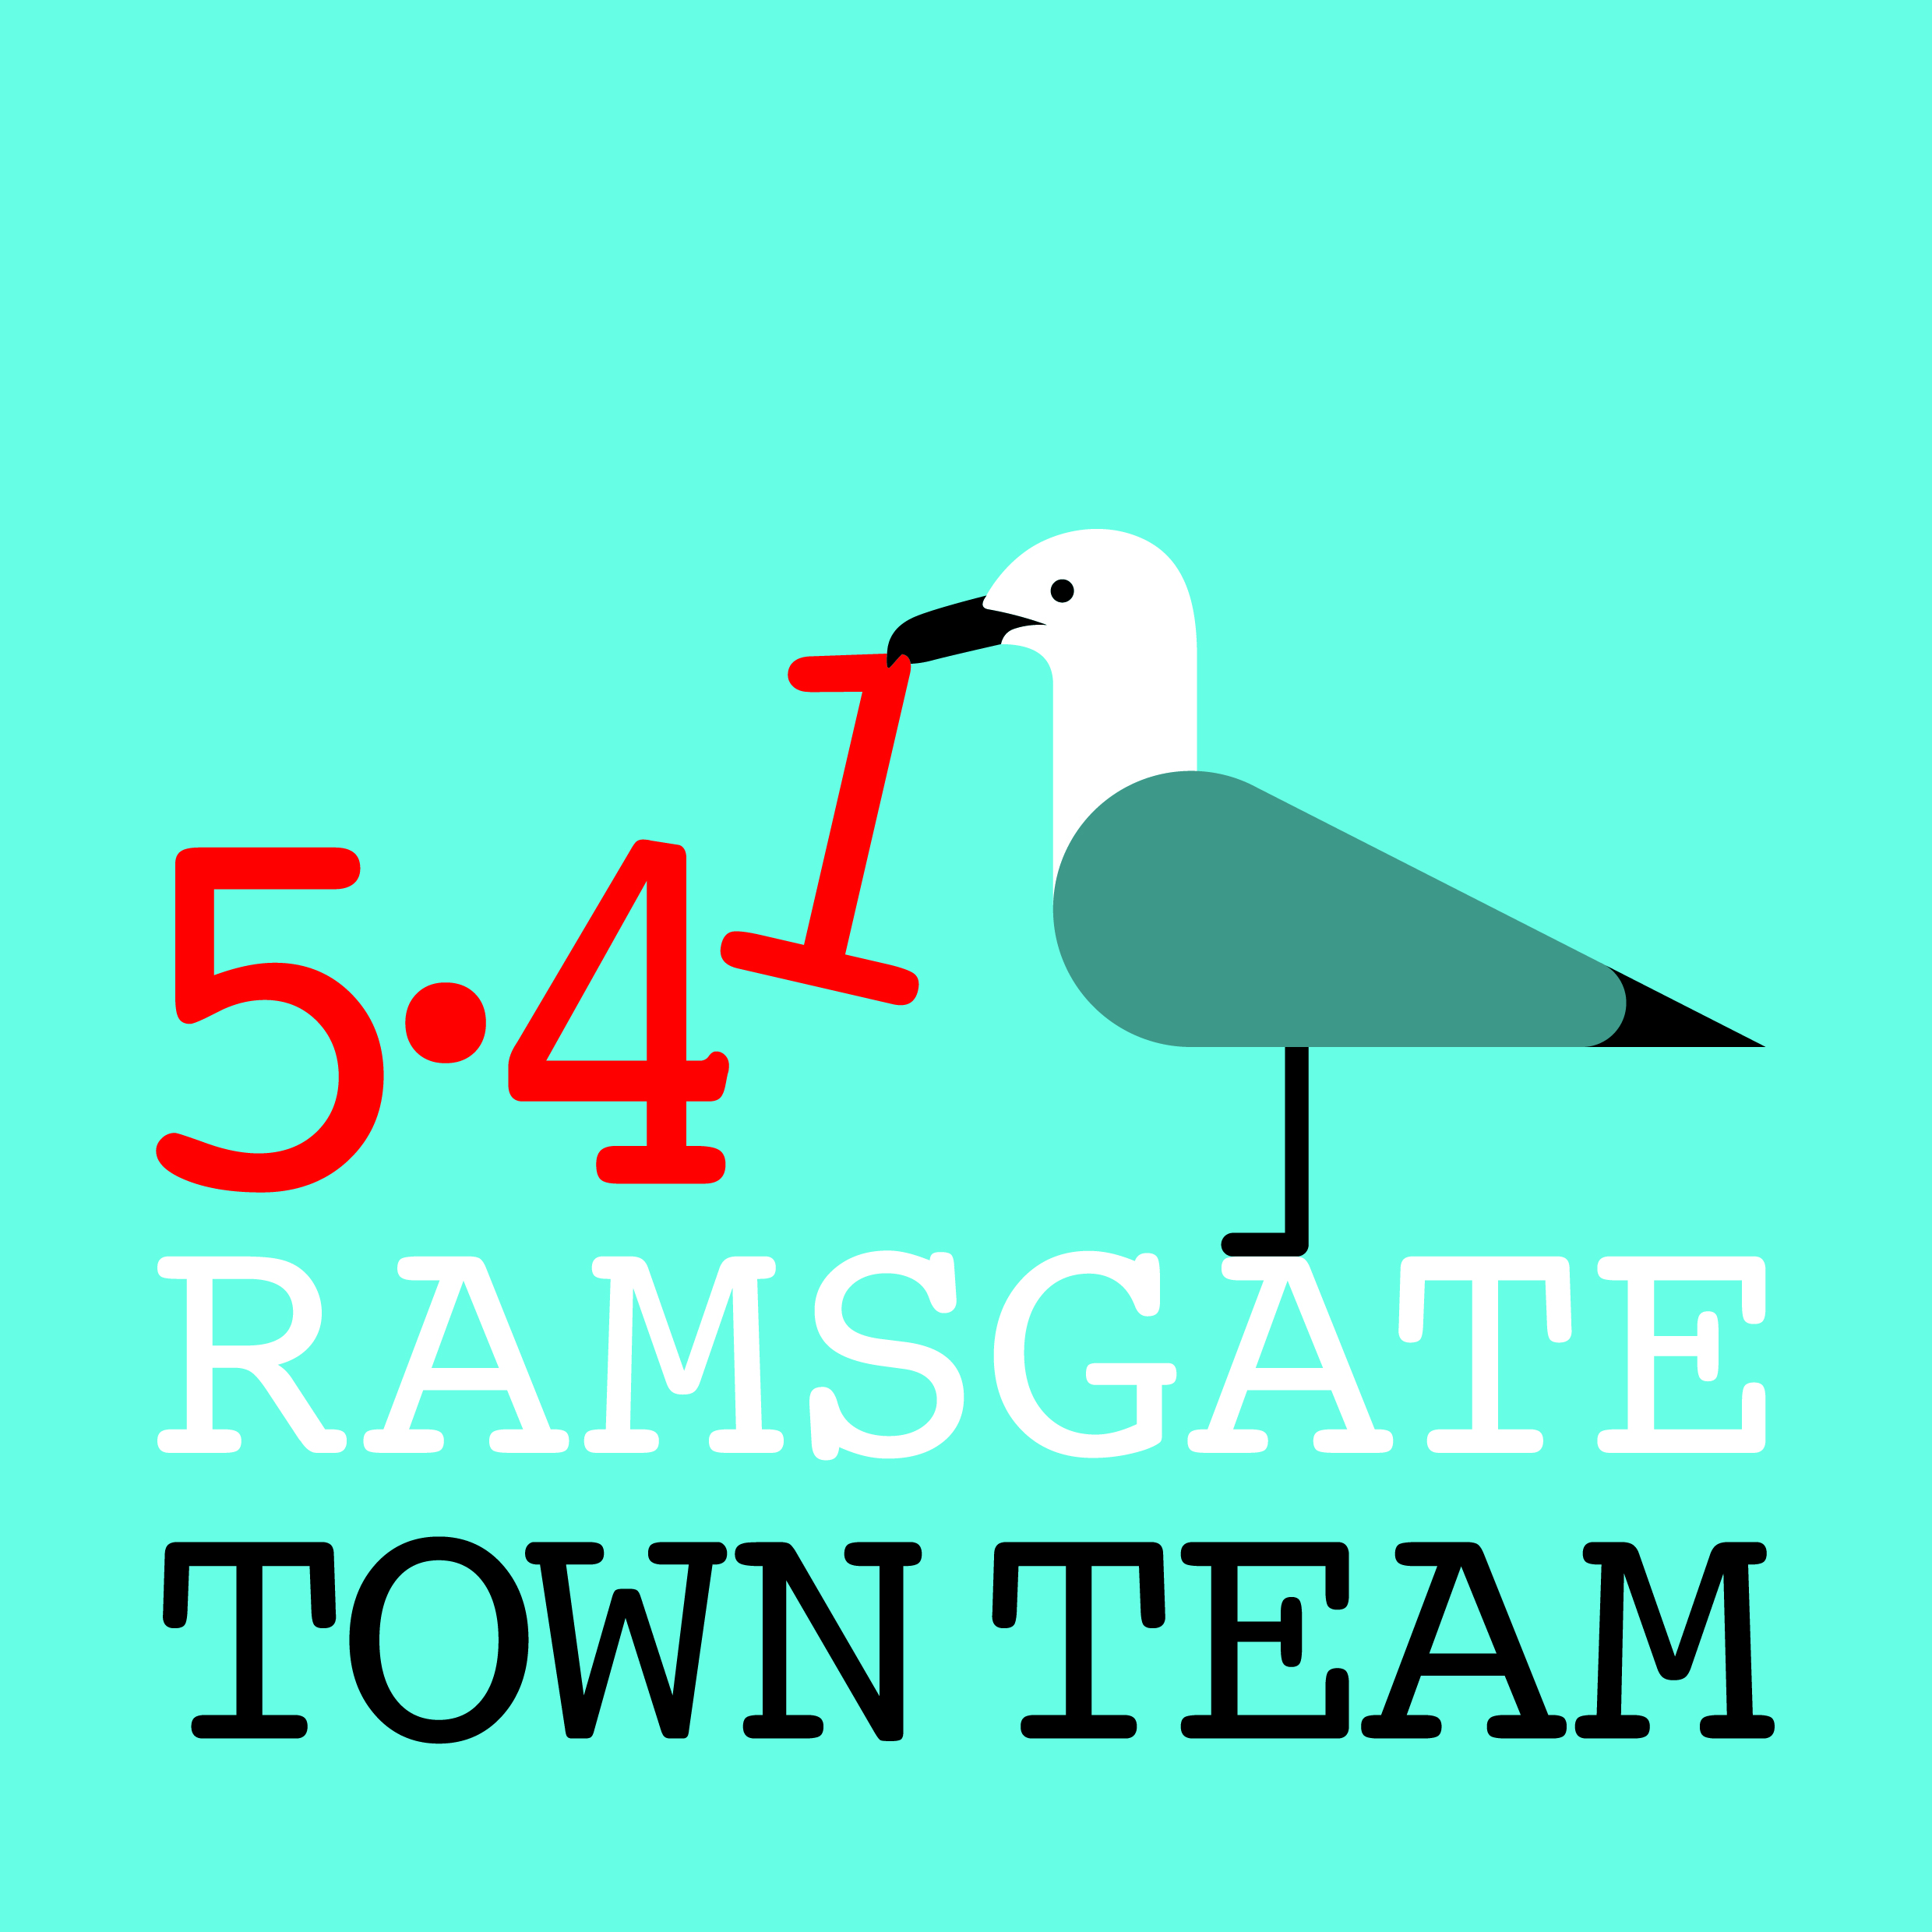

NOTES FROM ANNUAL GENERAL MEETING 140319
Present: Rebekah Smith (Chair), Sue Hall, Pat Makinson, Tricia Hartley, Bev Perkins, Chris Barton, John Walker, Jo Hanchett, Steve Coombes, Madeline Wright, Denise Blunn, Adam Littlefield, Julia Rogers, Viv Yankah, Raushan Ara, Becky Wing, Lucia Xavier, Pat Chick, John Davis, Rachel Bouden, Suzy Humphries, Susan Kennedy

Apologies for absence: Maria Gavin, Richard Styles, Brian Whitehead, Maryan Afsahi, Dominic Murphy, Sandra Ferguson, Ben Morton, Gary Storer, Louisa Hrabowy, Jaye Joubert, Roy Crowder, Jenny Rath, David Stephens, Chris Scutt
The meeting began with introductions. Rebekah then talked members through a short PowerPoint presentation on the TT’s work over the past year, including public realm works, wayfinding signage, litter /waste management and community events.
She pointed members to the 2018-19 Annual Report for more details. The Annual Report would be lodged on the Ramsgate Town Council website, along with Executive Committee meeting minutes.
The final slides highlighted the Town Team’s plans for 2019-20, which include:
- the Great Ramsgate Spring Clean with 12+ clean-ups during Keep Britain Tidy’s Spring Clean month (22nd March – 23rd April) – see Great Ramsgate Spring Clean Facebook group for details.
- a new Pugin tiles project on Kent Steps supported by Heritage England
- a new scheme funded by Ramsgate Town Council to install traditional Victorian-style ‘Welcome to Ramsgate’ black metal planters at key entrance points to the town
- refurbishment of the Augusta/ Rainbow Steps, with new posters already created by local primary school children and repainting of the steps planned in May
- a range of Easter events with Looping the Loop, Ramsgate Arts and Arts in Ramsgate, including a Rainbow Parade to celebrate the refurbished steps
Rebekah and Tricia also outlined their involvement in Thanet District Council’s current Future High Streets Fund bid, for which a sub-committee of Councillors has selected Ramsgate’s town centre as the focus. Our proposal focuses on buying up several large empty properties in Harbour St and High St for various uses, including art studios, a health & wellbeing centre and an advice hub, alongside public realm improvements and work to improve the crossing between harbour and town. The recommended size of the bid is between £5m and £10m. They stressed that we are only at the Expression of Interest stage of a two-stage process and that competition will be fierce. If successful, the earliest we could expect to receive any funds would be the summer of 2020.

Members agreed that Future High Streets could offer a good opportunity for Ramsgate. The following questions and discussion followed:
- Suzy asked if the community uses envisaged in the Future High Streets proposal might duplicate the facilities planned at the Fire Station in Effingham St by Ramsgate Town Council. Rebekah responded that the Fire Station is envisaged as a community centre with meeting and display space for local community groups, whereas the High Street centre would offer accessible hot-desking and private interview facilities for public-facing organisations such as the Citizens’ Advice Bureau and Age UK.

- Julia mentioned the lack of provision for young people in Ramsgate. She highlighted the potential for young people to use their skills and creativity to assist in improving the appearance of the town centre – eg window dressing and public realm design.

- She also expressed concern that young graffiti artists might lose out from the use of graffiti-proof paint mentioned in the presentation. Tricia clarified that this was under consideration only for specific spaces where frequent tagging takes place, particularly as the paint is extremely expensive. She mentioned that she had heard the Friends of Ramsgate Seafront were planning a graffiti wall on the Eastern Undercliff. She would check this out and include further information in the minutes. (FOLLOW-UP NOTE: Clara Gibson advises that the last 2 Eastern Undercliff shelters were deliberately left blank for graffiti. FORS would like to see the large blank wall at the back of the Eastern Undercliff car park used as a graffiti wall and have made some enquiries about doing this.)

- Suzy and others pointed out the unused potential of the surfaces in the town for future work. This might include building-based wayfaring signage, information on the town’s history or decorative work on places such as the alleyway to Charlotte Court to spark interest and draw people in.

- Discussion also followed about facilities for young families in Ramsgate. Rebekah noted that the Future High Streets fund bid would allow for a facility in the town centre – eg soft play area or similar – but this would depend on an operator being willing to take this on.

- Becky mentioned Addington Street’s new initiative, Cosi Van Tutti (Cosy Van for All), a refurbished caravan which will be available for use at local events by creatives/ young people/ community groups. Work is taking place on the caravan now and it is hoped it will be ready by the summer.

- Lucia raised the possibility of introducing local discount cards. Tricia confirmed that this is something that has been considered in the past. At present Ageless Thanet offers discount cards to members over 50 which may cause complications. It was agreed that this would be reconsidered at the next Town Team Committee meeting.

