No. 2433 (Ramsgate and Manston) Squadron
Royal Air Force Air Cadets

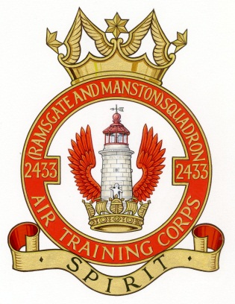
Anniversary Concert and Parade DETAILS
and Reply Form

I have the honour to extend the invitation of the Cadets, Staff and Civilian Committee to our Concert and Parade which will take place on Sunday 11th October 2015 at the Defence Fire Training & Development Centre, Manston and begin at 2pm.

The event will comprise a full ceremonial parade by the Cadets to welcome the Guest of Honour, including a drum-head service of Thanksgiving and Re-dedication which will be followed by refreshments.

The second half of the event will comprise a musical ‘proms’ style concert by championship Medway Band, featuring The Manston Band of No. 2433 Squadron.

The Parade and Concert are free but we do ask for a £10 donation to No. 2433 Squadron for each person attending. Dress for uniformed personnel is No. 1 SD with medals and gloves. For non-uniformed guests, dress is lounge suit with decorations and equivalent for ladies. The concert will be held indoors, so don’t let the time of year put you off.

We hope to make this a very special occasion both for the Squadron Anniversary and the Battle of Britain, in which Manston played such an important role. We do hope you will be able to join us. For further information, or to book in advance of sending your form, please email 2433@aircadets.org or call us on (01843) 825194. Groups and families are welcome to join us. Please use the form below to book your places. We look forward to seeing you.

G R E Hobbs-East
Flight Lieutenant RAFVR(T)
Officer Commanding

2433 (Ramsgate and Manston) Squadron, Royal Air Force Air Cadets
Anniversary Parade and Concert

Reply Form

I/we would like to attend the Anniversary Parade and Concert. The names of those attend are as follows:

Rank / title: ……………........ Name: ……………………..………………………..……………………………………………………
Rank / title: ……………........ Name: ……………………………..………………..……………………………………………………
Rank / title: ……………........ Name: ……………………………..………………..……………………………………………………
Rank / title: ……………........ Name: …………………………..…………………..……………………………………………………
Please add any extra names overleaf

If you are driving please provide the following information for security purposes:

Vehicle Registration Number: ………………….... Make: ………………………..………. Model and colour: …………….…………

Cheques should be made payable to 2433 Ramsgate Sqn ATC with a £10 donation per person attending. Please send cheques to: PMC, c/o 1 Midlothian Cottages, Stanley Place, Ramsgate, Kent, CT11 7NX.

Please supply your email address or phone number in case we need to contact you in relation to this event only:

……………………………………………………………………………………..…………………………..

